Lesson 11: Saree Silk Stories: Necklaces and Bracelets
- Let’s solve story problems about length.

Warm-up: Notice and Wonder: Take From
What do you notice? What do you wonder?
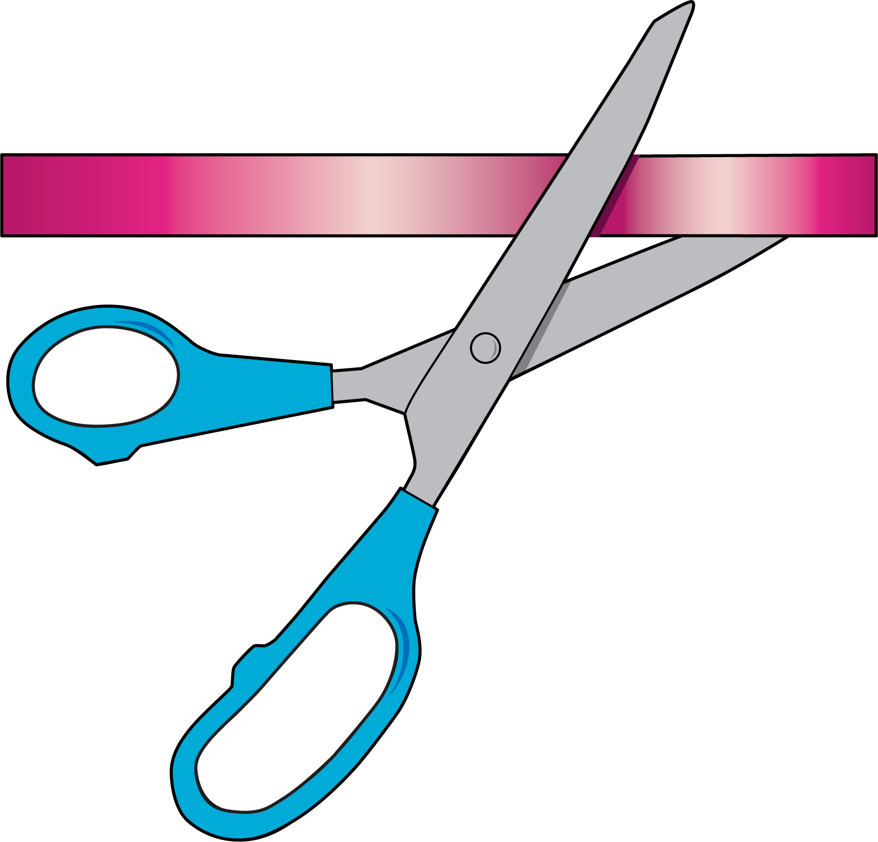
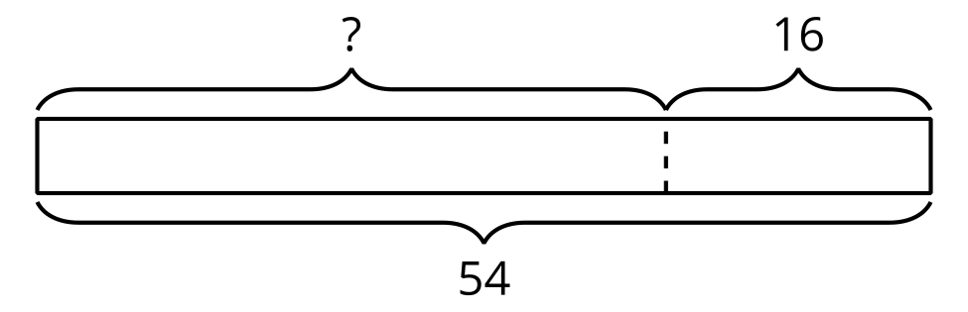
$54−16=?$

11.1: Saree Silk Ribbon Necklaces
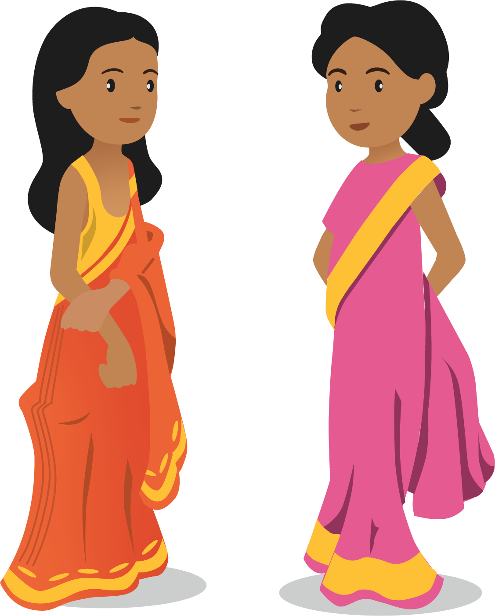
What do you notice? What do you wonder?
Priya had a ribbon that was 44 inches long. She cut off 18 inches. How long is Priya’s ribbon now?
Andre drew this diagram to help him think about the problem.
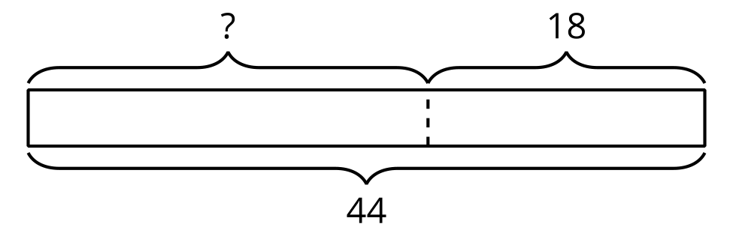
- What does the “?” represent in the story?
- Why do you think there is a dotted line between the parts?
- Find the unknown value. Show your thinking.
- Priya’s ribbon is __________________ long.

11.2: Saree Silk Ribbon Projects
Label the diagram. Find the unknown value. Show your thinking and don’t forget the units.
- Elena started with 58 inches of ribbon. She gave Clare 27 inches of ribbon. How much ribbon did Elena keep for herself?
- 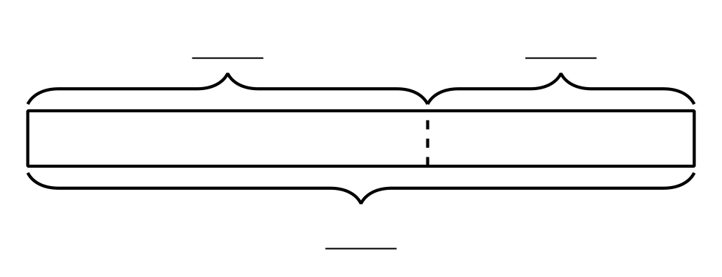
- Han had a piece of ribbon that was 64 inches long. He cut off 28 inches to make a necklace for his sister. How much ribbon is left?
- Priya cut off 25 inches of ribbon. She has 38 inches of ribbon left. How much ribbon did Priya start with?
© CC BY 2021 Illustrative Mathematics®

