Unit 4 Lesson 13: Represent Story Problems

WU Notice and Wonder: Compare Representations (Warm up)

Student Task Statement
What do you notice? What do you wonder?
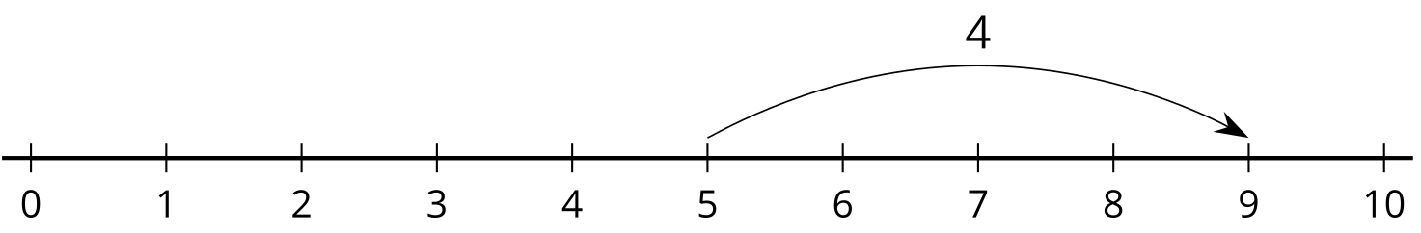
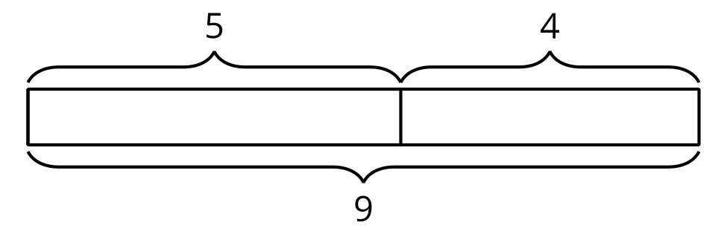

1 Card Sort: Represent Stories

Student Task Statement

2 All Kinds of Representations

Student Task Statement
Solve each problem. Show your thinking. Use a number line or diagram if it helps.
- Clare started with 24 cubes and added on some more. Clare made a train with 42 cubes. How many cubes did Clare add on?
- 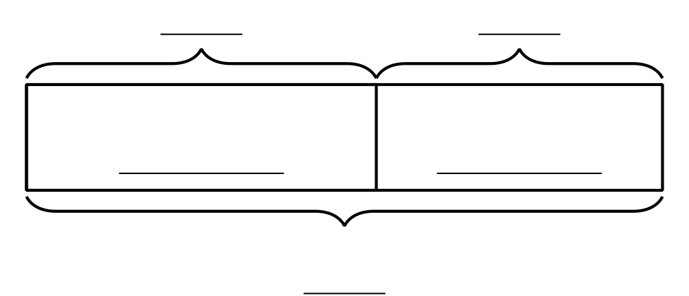
- Andre had 37 cubes. Then he added 39 more to make the train longer. How many cubes did Andre use?
- Mai wanted her train to be 55 cubes long. So far she has 47. How many more cubes does Mai need?
© CC BY 2021 Illustrative Mathematics®

