Lesson 17: Connecting Cube Sculptures
- Let’s build with connecting cubes and figure out how many we have.

Warm-up: How Many Do You See: Connecting Cube Flash
How many do you see?
How do you see them?
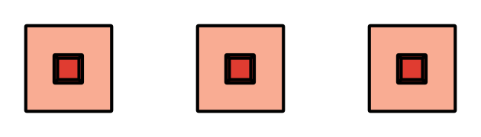
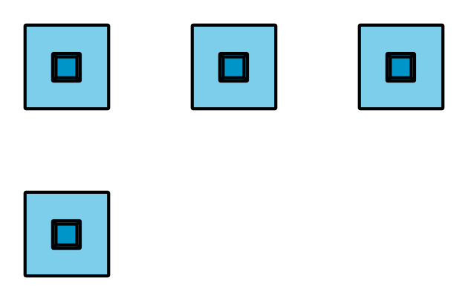
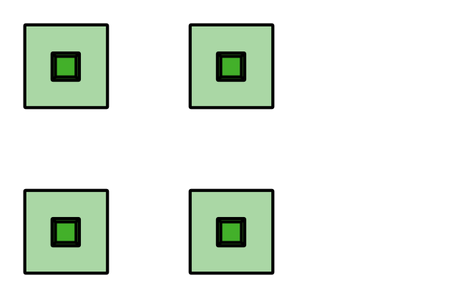
© CC BY 2021 Illustrative Mathematics®

