Unit 7 Lesson 3: Questions and Stories About Shapes

WU Notice and Wonder: Mai’s Shape (Warm up)

Student Task Statement
Mai used pattern blocks to make this shape.
What do you notice?
What do you wonder?
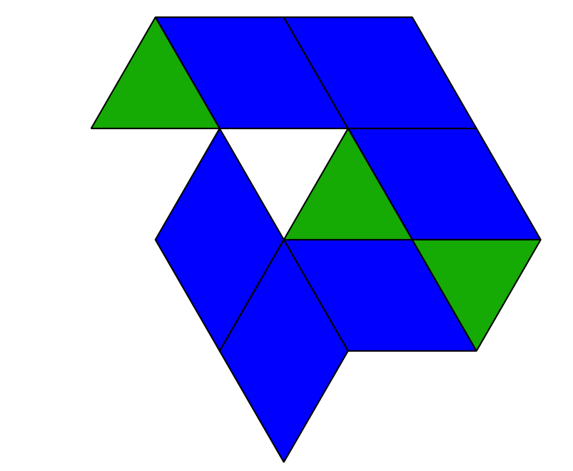

1 Ask Math Questions About Shapes

Student Task Statement

2 Tell Math Stories About Shapes

Student Task Statement

3 Introduce Pattern Blocks, Build and Draw

Student Task Statement
Choose a center.
Pattern Blocks
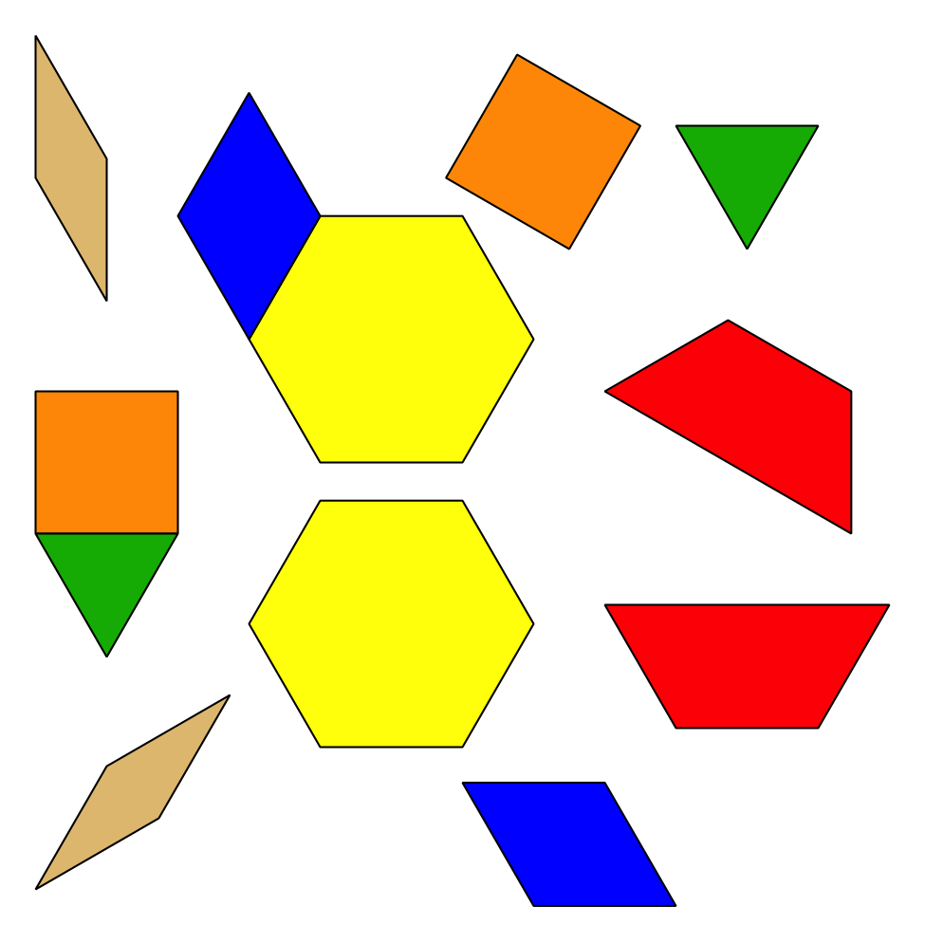
Geoblocks
Grab and Count
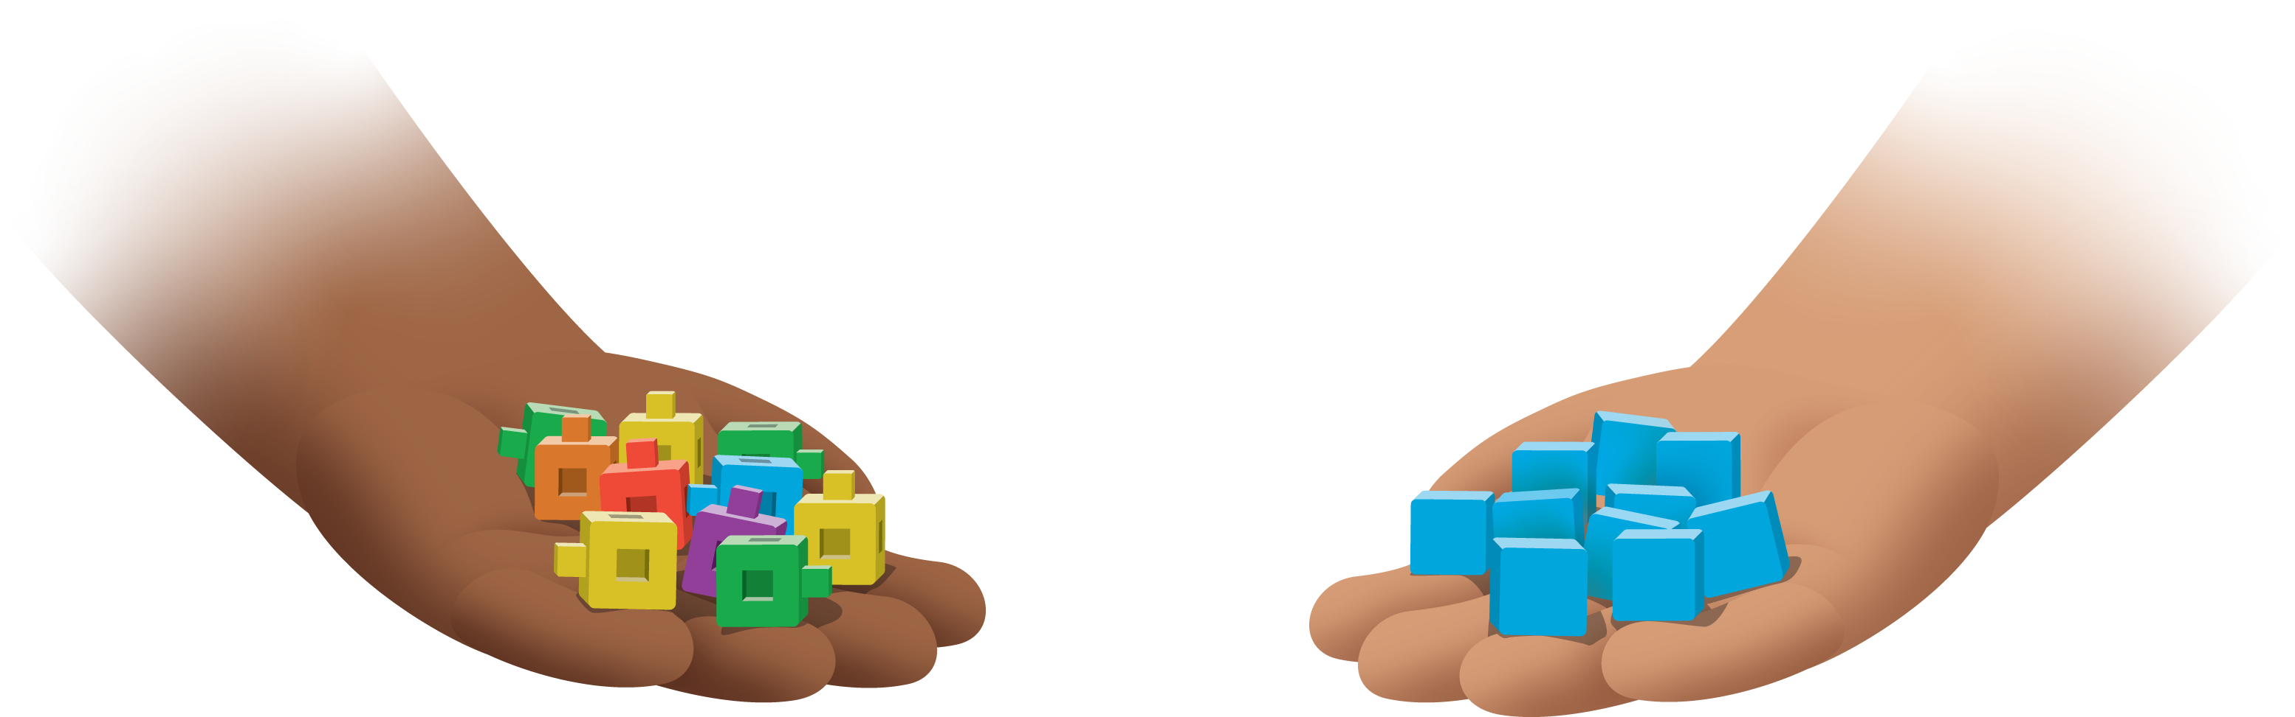
Find the Pair
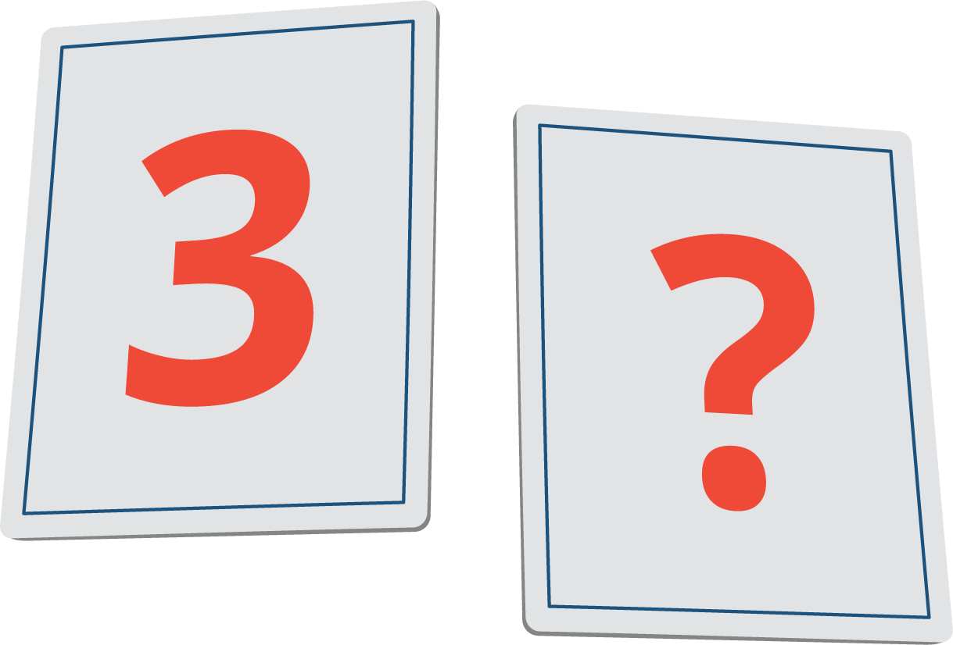
© CC BY 2021 Illustrative Mathematics®

