Lesson 5: Comparing Speeds and Prices

5.1: Closest Quotient
Is the value of each expression closer to $\frac{1}{2}$, 1, or $1\frac{1}{2}$?
- $20÷18$
- $9÷20$
- $7÷5$

5.2: More Treadmills
Some students did treadmill workouts, each one running at a constant speed. Answer the questions about their workouts. Explain or show your reasoning.
- Tyler ran 4,200 meters in 30 minutes.
- Kiran ran 6,300 meters in $\frac{1}{2}$ hour.
- Mai ran 6.3 kilometers in 45 minutes.
- What is the same about the workouts done by:
  - Tyler and Kiran?
  - Kiran and Mai?
  - Mai and Tyler?
- At what rate did each of them run?
- How far did Mai run in her first 30 minutes on the treadmill?

Are you ready for more?
Tyler and Kiran each started running at a constant speed at the same time. Tyler ran 4,200 meters in 30 minutes and Kiran ran 6,300 meters in $\frac{1}{2}$ hour. Eventually, Kiran ran 1 kilometer more than Tyler. How much time did it take for this to happen?

5.3: The Best Deal on Beans
Four different stores posted ads about special sales on 15-oz cans of baked beans.
- Which store is offering the best deal? Explain your reasoning.
- 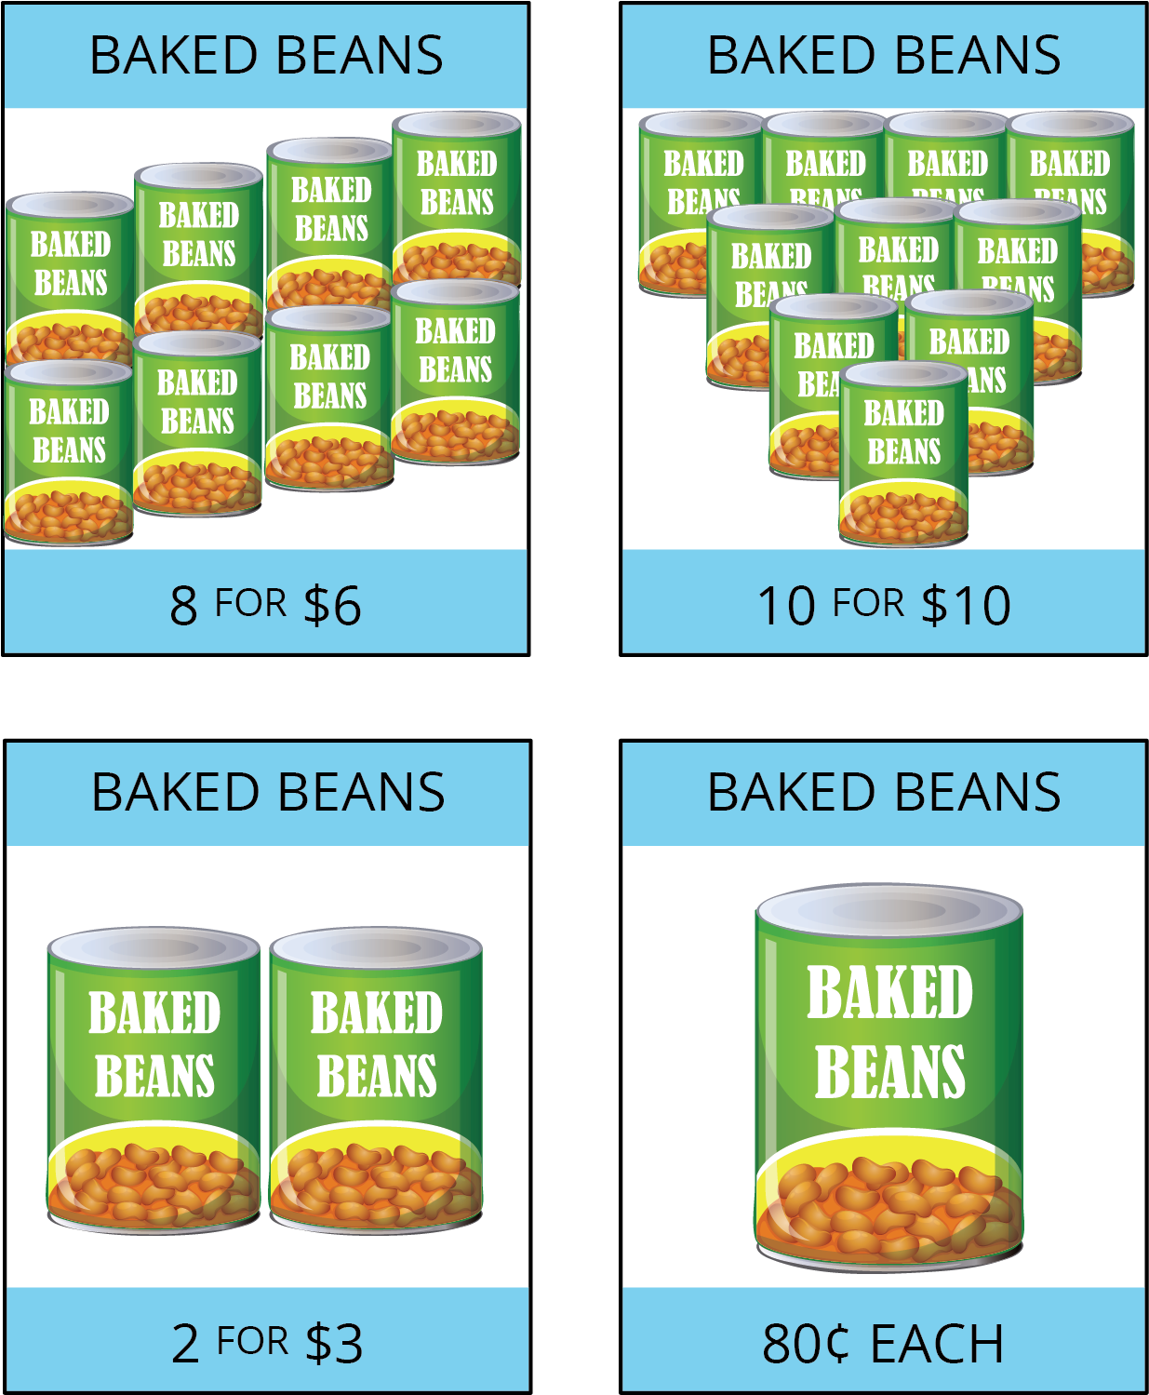
- The last store listed is also selling 28-oz cans of baked beans for $1.40 each. How does that price compare to the other prices?

Lesson 5 Summary
Diego ran 3 kilometers in 20 minutes. Andre ran 2,550 meters in 17 minutes. Who ran faster? Since neither their distances nor their times are the same, we have two possible strategies:
- Find the time each person took to travel the same distance. The person who traveled that distance in less time is faster.
- Find the distance each person traveled in the same time. The person who traveled a longer distance in the same amount of time is faster.
- It is often helpful to compare distances traveled in 1 unit of time (1 minute, for example), which means finding the speed such as meters per minute.
Let’s compare Diego and Andre’s speeds in meters per minute.
distance (meters) | time (minutes)
3,000 | 20
1,500 | 10
150 | 1
distance (meters) | time (minutes)
2,550 | 17
150 | 1
Both Diego and Andre ran 150 meters per minute, so they ran at the same speed.
Finding ratios that tell us how much of quantity $A$ per 1 unit of quantity $B$ is an efficient way to compare rates in different situations. Here are some familiar examples:
- Car speeds in miles per hour.
- Fruit and vegetable prices in dollars per pound.
© CC BY Open Up Resources. Adaptations CC BY IM.

