Unit 2 Lesson 20: Percentages and Double Number Lines

1 Fundraising Goal (Warm up)

Student Task Statement
Each of three friends—Lin, Jada, and Andre—had the goal of raising $40. How much money did each person raise? Be prepared to explain your reasoning.
- Lin raised 100% of her goal.
- Jada raised 50% of her goal.
- Andre raised 150% of his goal.

Activity Synthesis
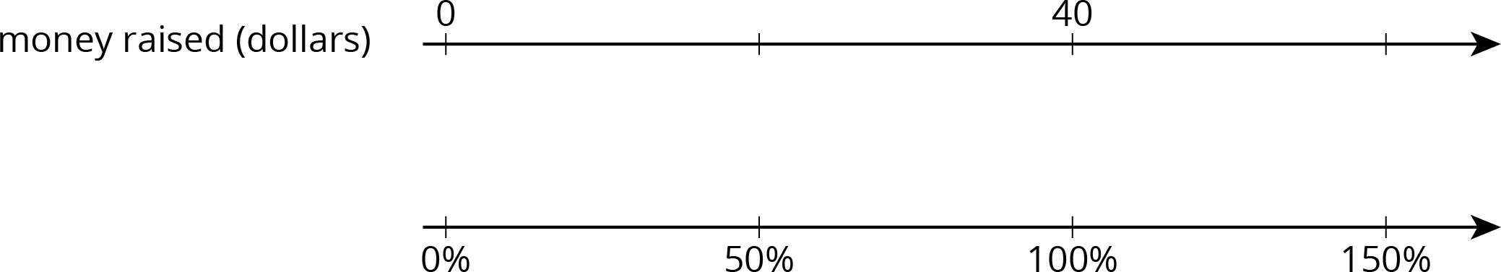

2 Three-Day Biking Trip

Student Task Statement
Elena biked 8 miles on Saturday. Use the double number line to answer the questions. Be prepared to explain your reasoning.
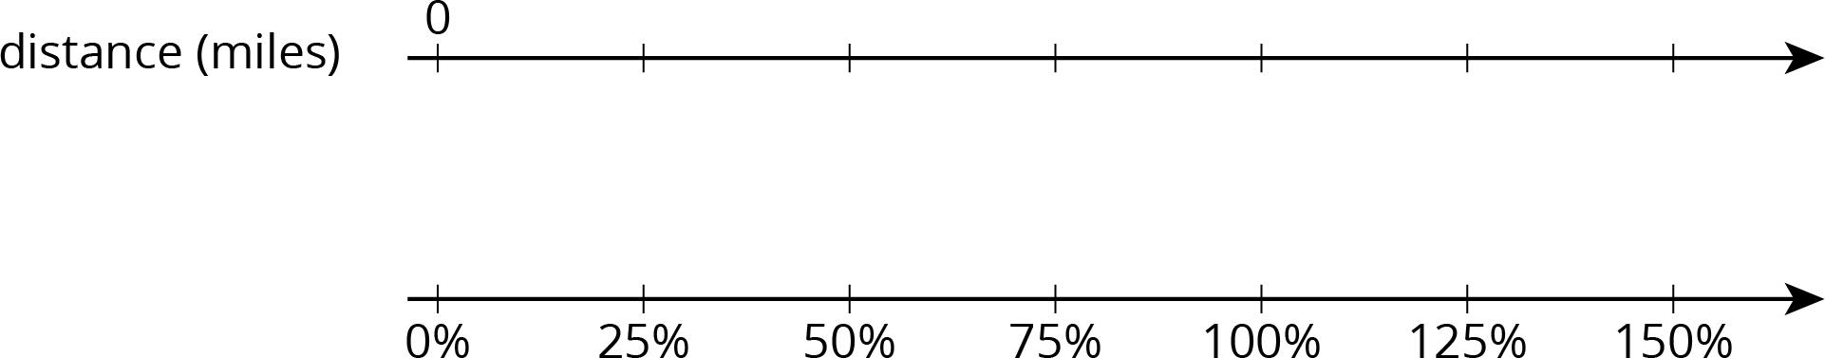
- What is 100% of her Saturday distance?
- On Sunday, she biked 75% of her Saturday distance. How far was that?
- On Monday, she biked 125% of her Saturday distance. How far was that?

3 Puppies Grow Up

Student Task Statement
- Jada has a new puppy that weighs 9 pounds. The vet says that the puppy is now at about 20% of its adult weight. What will be the adult weight of the puppy?
- Andre also has a puppy that weighs 9 pounds. The vet says that this puppy is now at about 30% of its adult weight. What will be the adult weight of Andre’s puppy?
- What is the same about Jada and Andre’s puppies? What is different?

Activity Synthesis
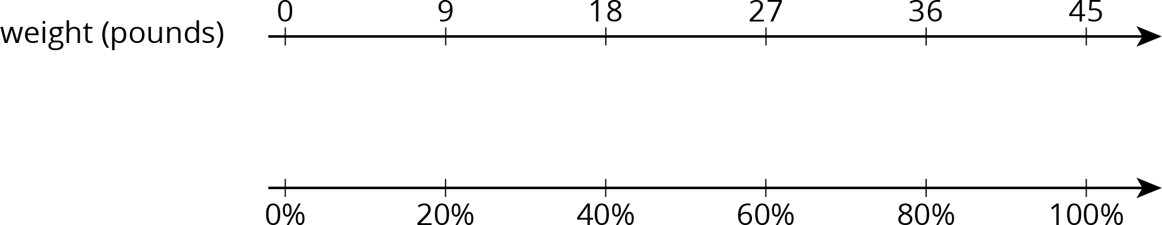

Images for Activity Synthesis
© CC BY Open Up Resources. Adaptations CC BY IM.

