Lesson 15: Explain How You Counted
- Let’s count collections of objects and tell our partners how we counted.

15.3: Centers: Choice Time
Choose a center.
Geoblocks
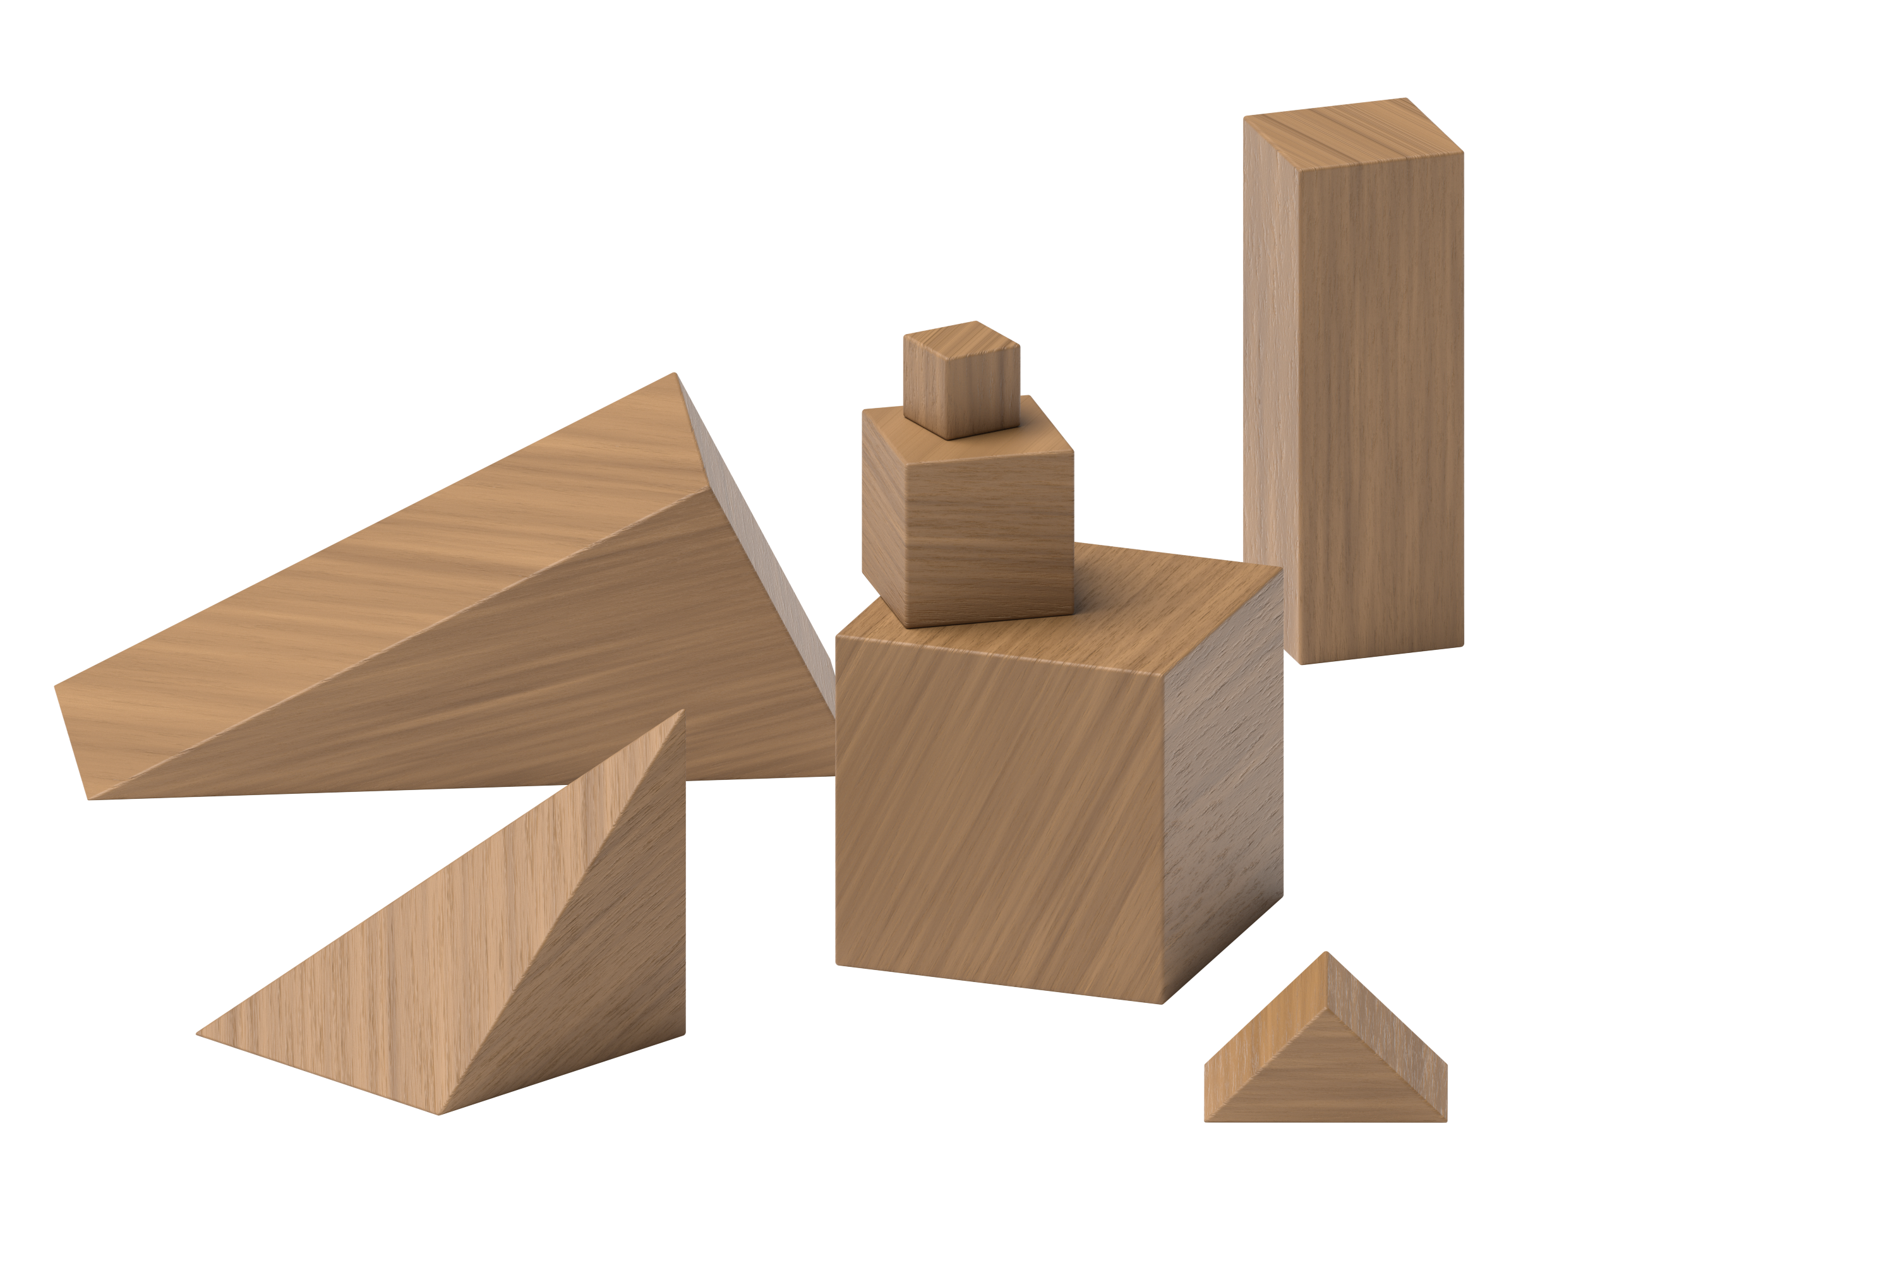
Connecting Cubes
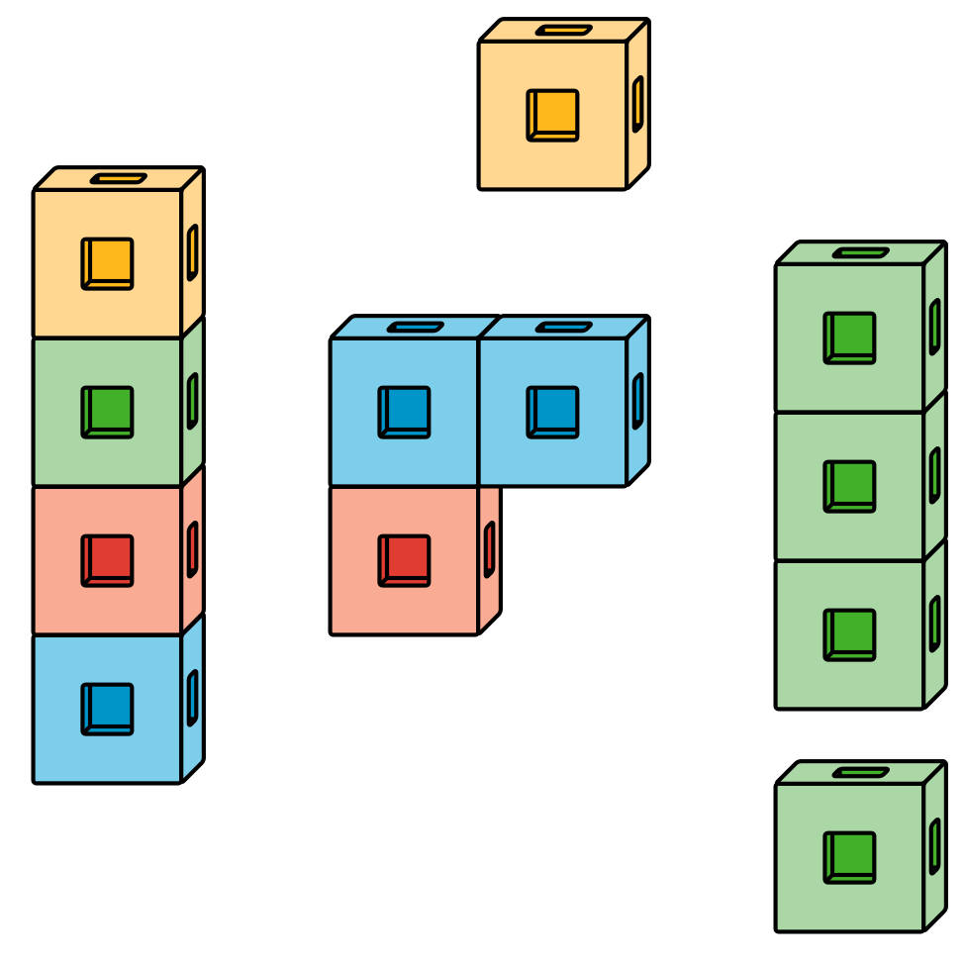
Pattern Blocks
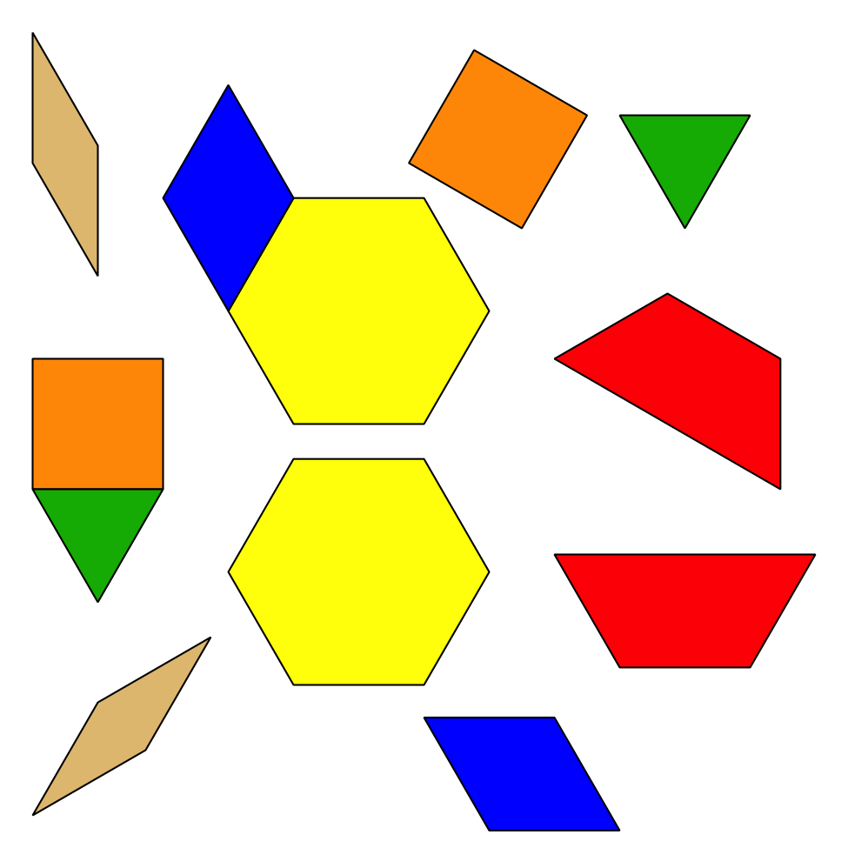
Picture Books
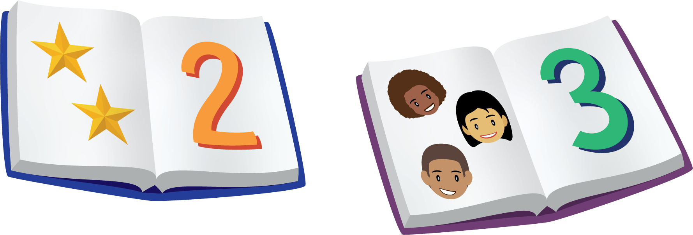
© CC BY 2021 Illustrative Mathematics®

