Unit 7 Lesson 1: Build Shapes

WU How Many Do You See: Triangles (Warm up)

Student Task Statement
How many do you see?
How do you see them?
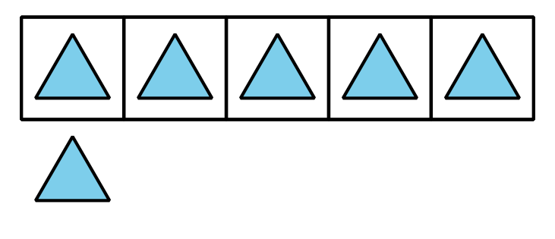
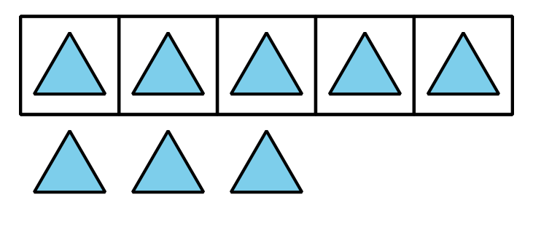
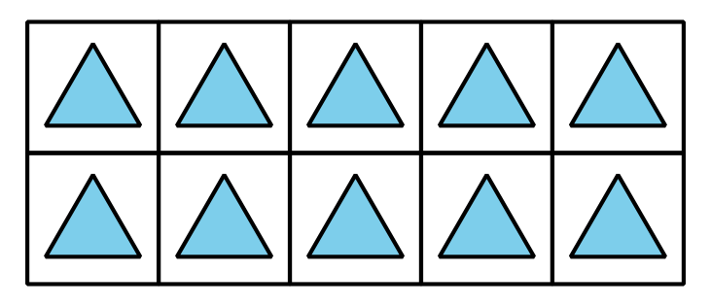
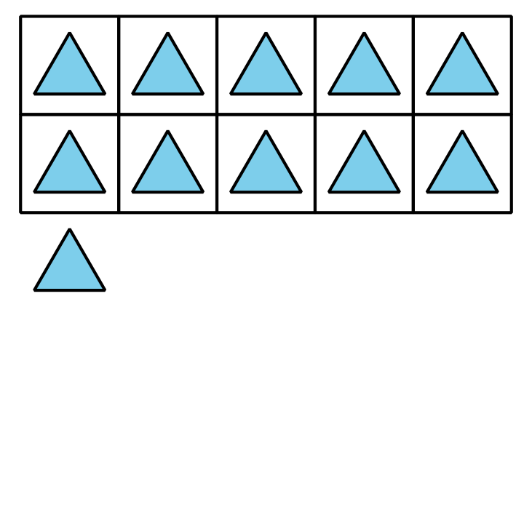

1 Squares, Squares, Squares

Student Task Statement

2 Shape Puzzle

Student Task Statement

3 Centers: Choice Time

Student Task Statement
Choose a center.
Geoblocks
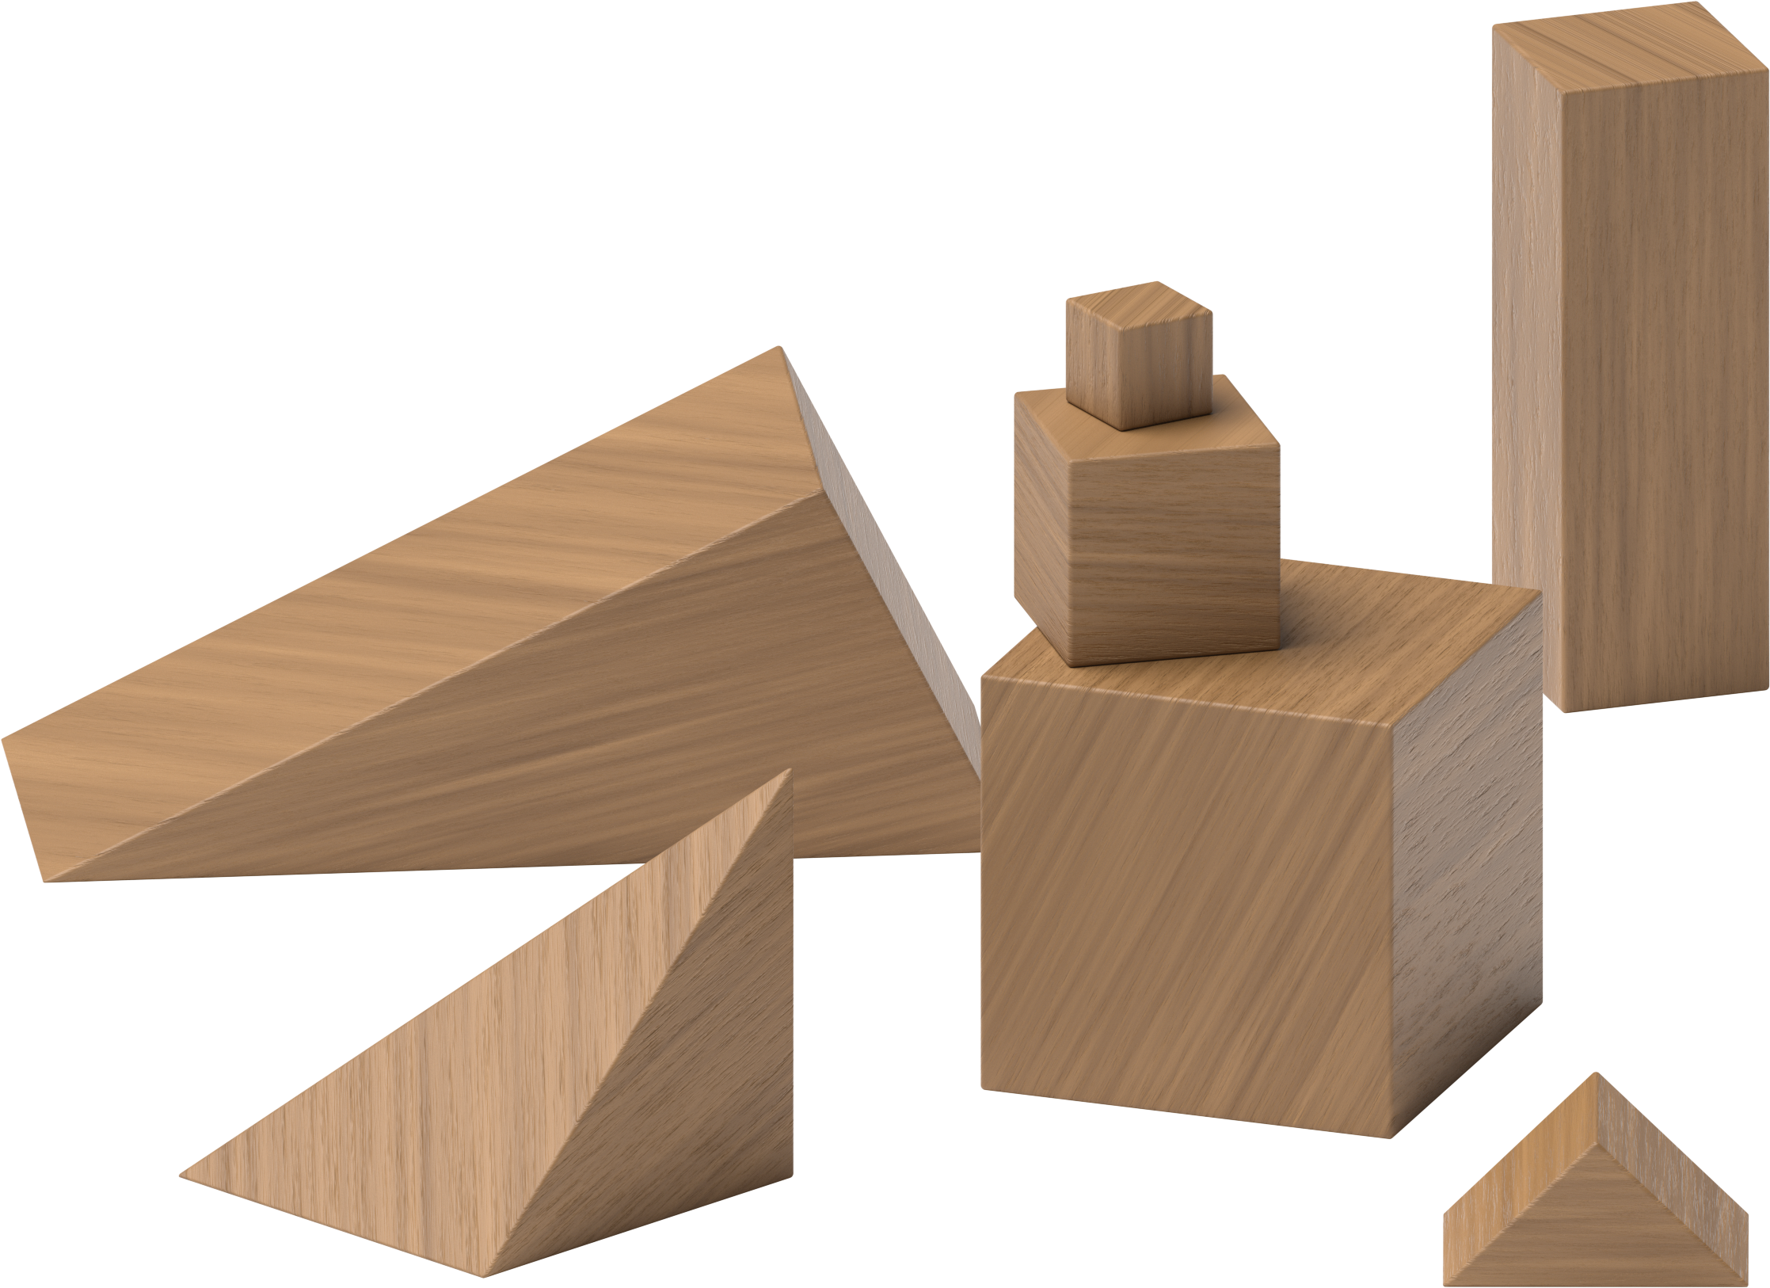
Grab and Count
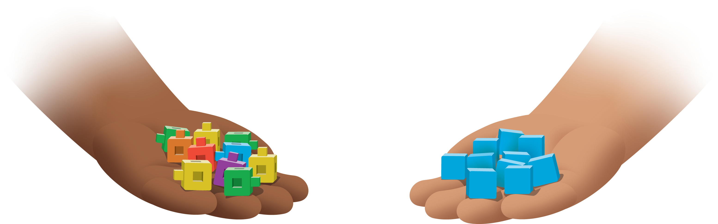
Find the Pair
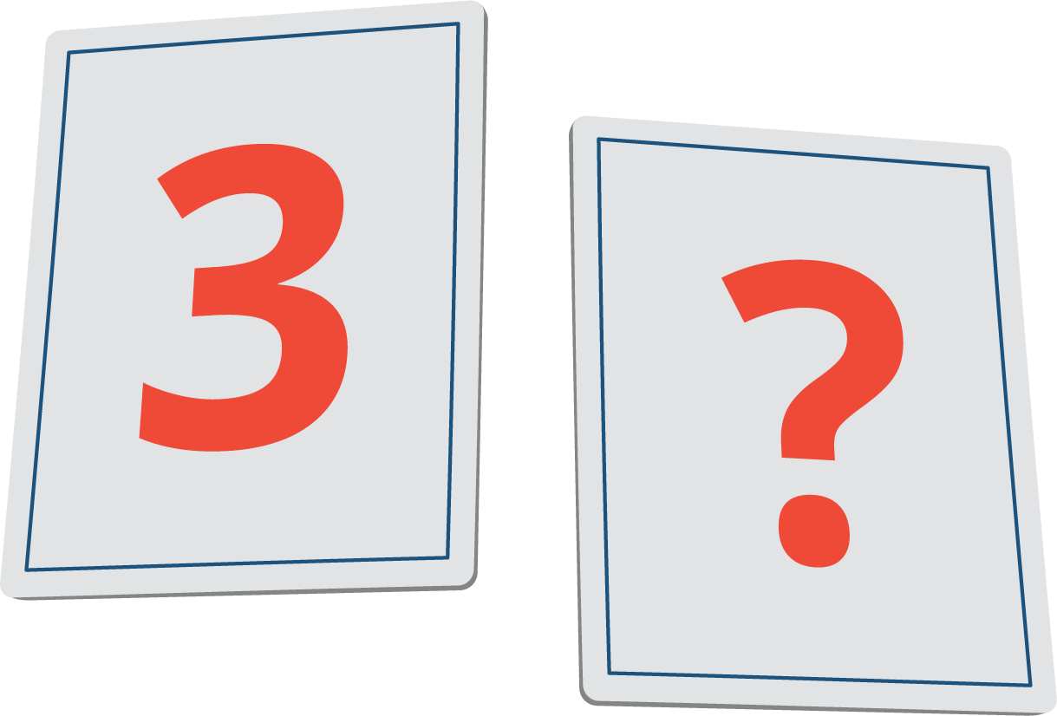
© CC BY 2021 Illustrative Mathematics®

