Unit 6 Lesson 10: Relating Linear Equations and their Graphs

1 Notice and Wonder: Features of Graphs (Warm up)

Student Task Statement
Here are graphs of $y=2x+5$ and $y=5⋅2^{x}$.
What do you notice? What do you wonder?
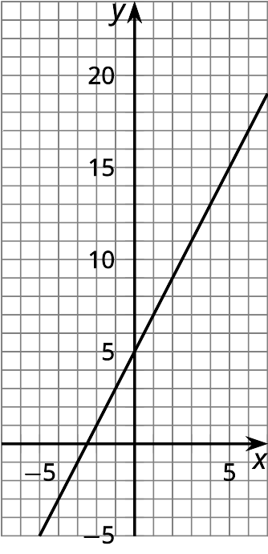
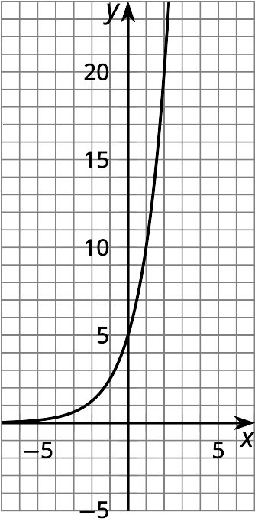

2 Making Connections

Student Task Statement
- Here are some equations and graphs. Match each graph to one or more equations that it could represent. Be prepared to explain how you know.
- 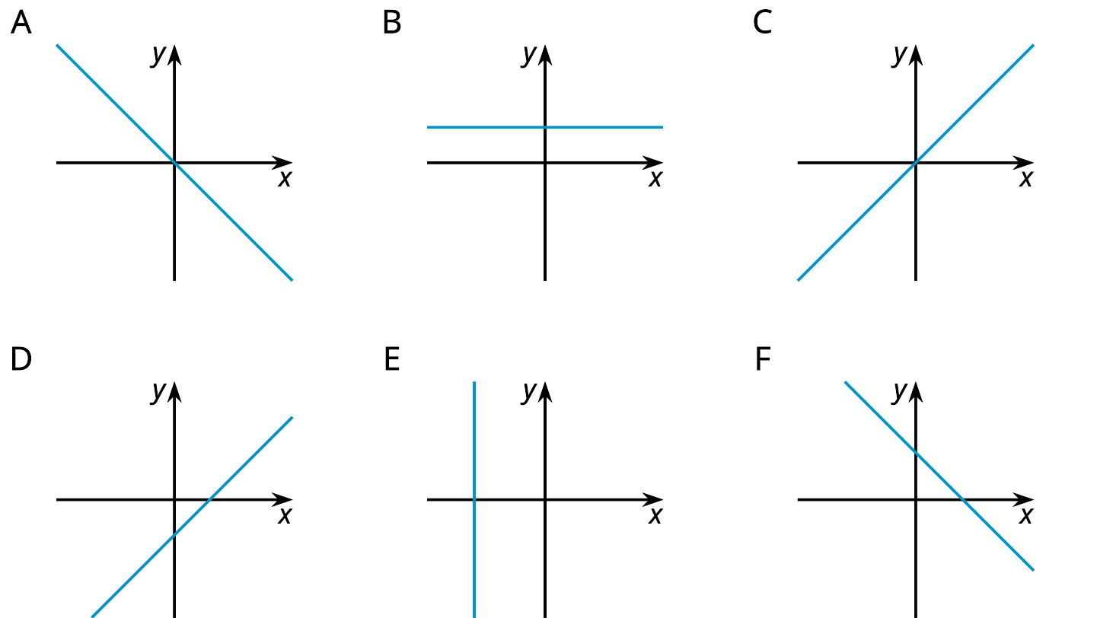
  - $y=8$
  - $y=3x−2$
  - $x+y=6$
  - $0.5x=\text{-}4$
  - $y=x$
  - $\text{-}\frac{2}{3}x=y$
  - $12−4x=y$
  - $x−y=12$
  - $2x+4y=16$
  - $3x=5y$
- Choose either graph D or F. Let $x$ represent hours after noon on a given day and $y$ represent the temperature in degrees Celsius in a freezer.
  - In this situation, what does the $y$-intercept mean, if anything?
  - In this situation, what does the $x$-intercept mean, if anything?

3 Connecting Equations and Graphs

Student Task Statement
- Without substituting any values for $x$ and $y$ or using technology, decide whether graph A could represent each equation, and explain how you know.
  - $4x=y$
  - $x−8=y$
  - $\text{-}5x=10y$
  - $3y−12=0$
- Write a new equation that could be represented by:
  - Graph D
  - Graph F
- On this graph, $x$ represents minutes since midnight and $y$ represents temperature in degrees Fahrenheit.
  - Explain what the intercepts tell us about the situation.
  - Write an equation that relates the two quantities.
  - 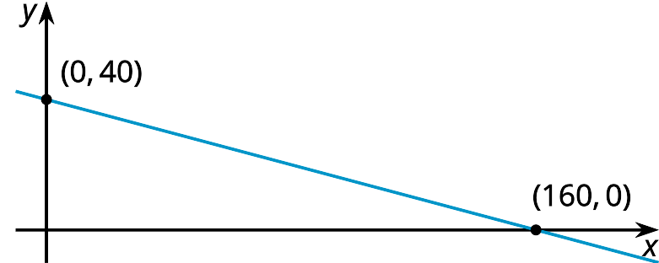
© CC BY 2019 by Illustrative Mathematics

