Unit 3 Lesson 8: Ten as a Unit

WU Which One Doesn’t Belong: Groups of 10 (Warm up)

Student Task Statement
Which one doesn’t belong?
A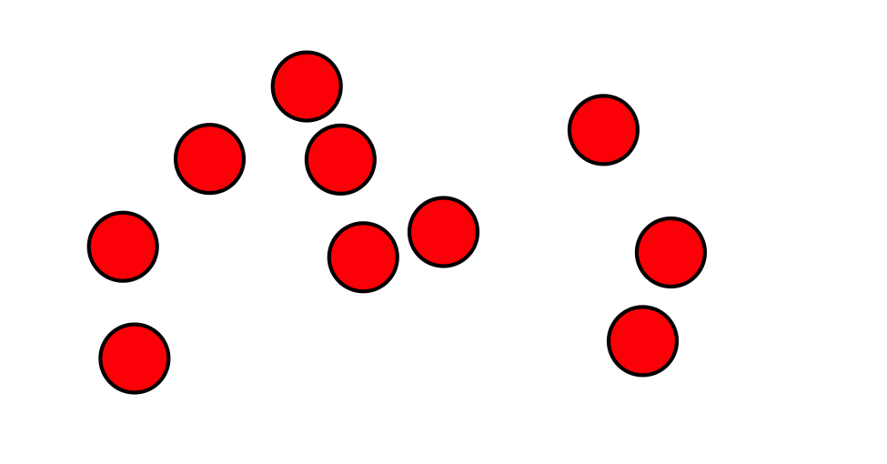
B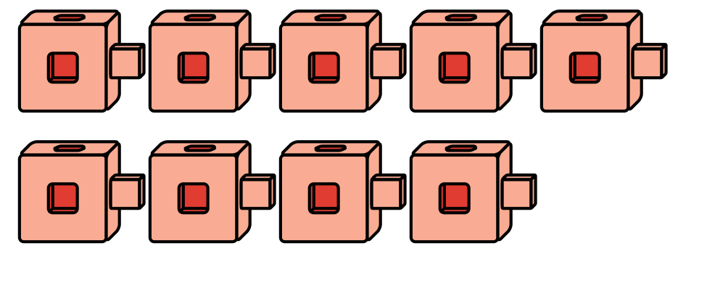
C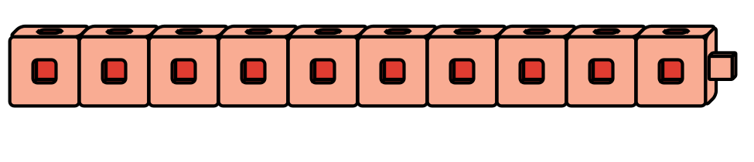
D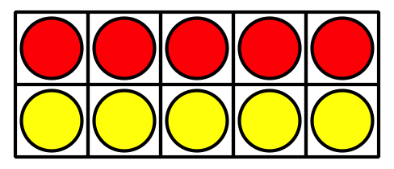

1 Counting Collections: Count and Show How Many

Student Task Statement

2 Building Teen Numbers

Student Task Statement
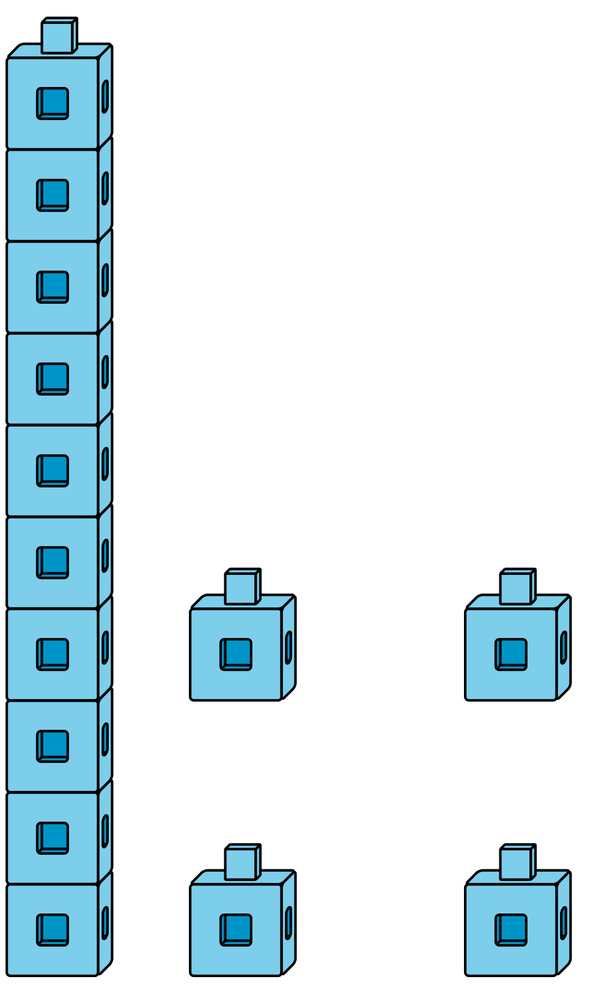
Choose 4 numbers to represent.
Circle them.
10
11
12
13
14
15
16
17
18
19
Use connecting cubes to show each number like Clare did.
What did you notice as you were showing each number?

Images for Activity Synthesis
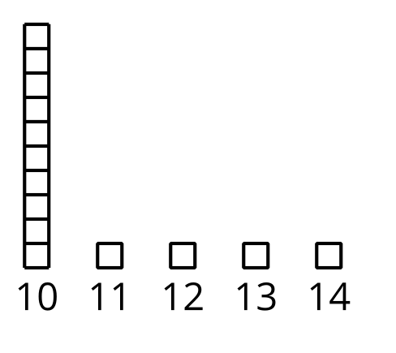
© CC BY 2021 Illustrative Mathematics®

