Lesson 20: Describing Trends in Scatter Plots

20.1: Which One Doesn’t Belong: Scatter Plots
Which one doesn’t belong?
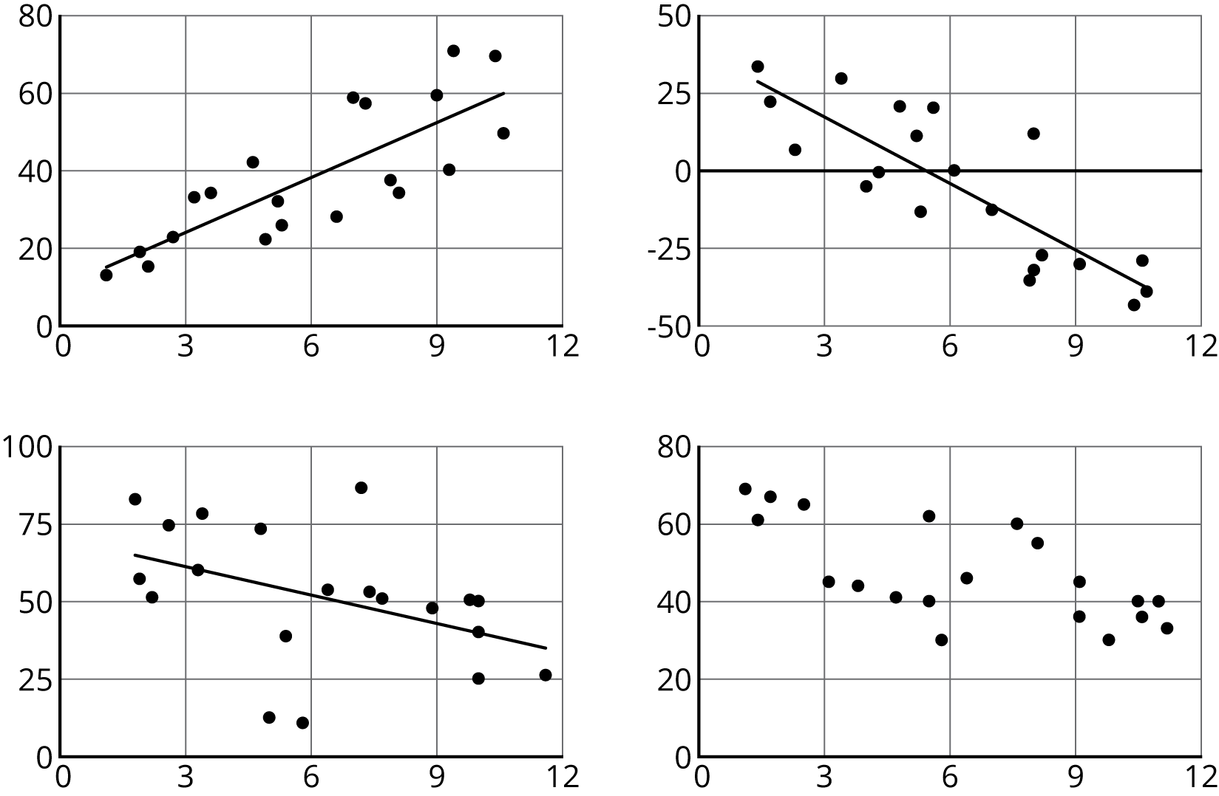

20.2: Fitting Lines
Your teacher will give you a piece of pasta and a straightedge.
- Here are two copies of the same scatter plot. Experiment with drawing lines to fit the data. Pick the line that you think best fits the data. Compare it with a partner’s.
- 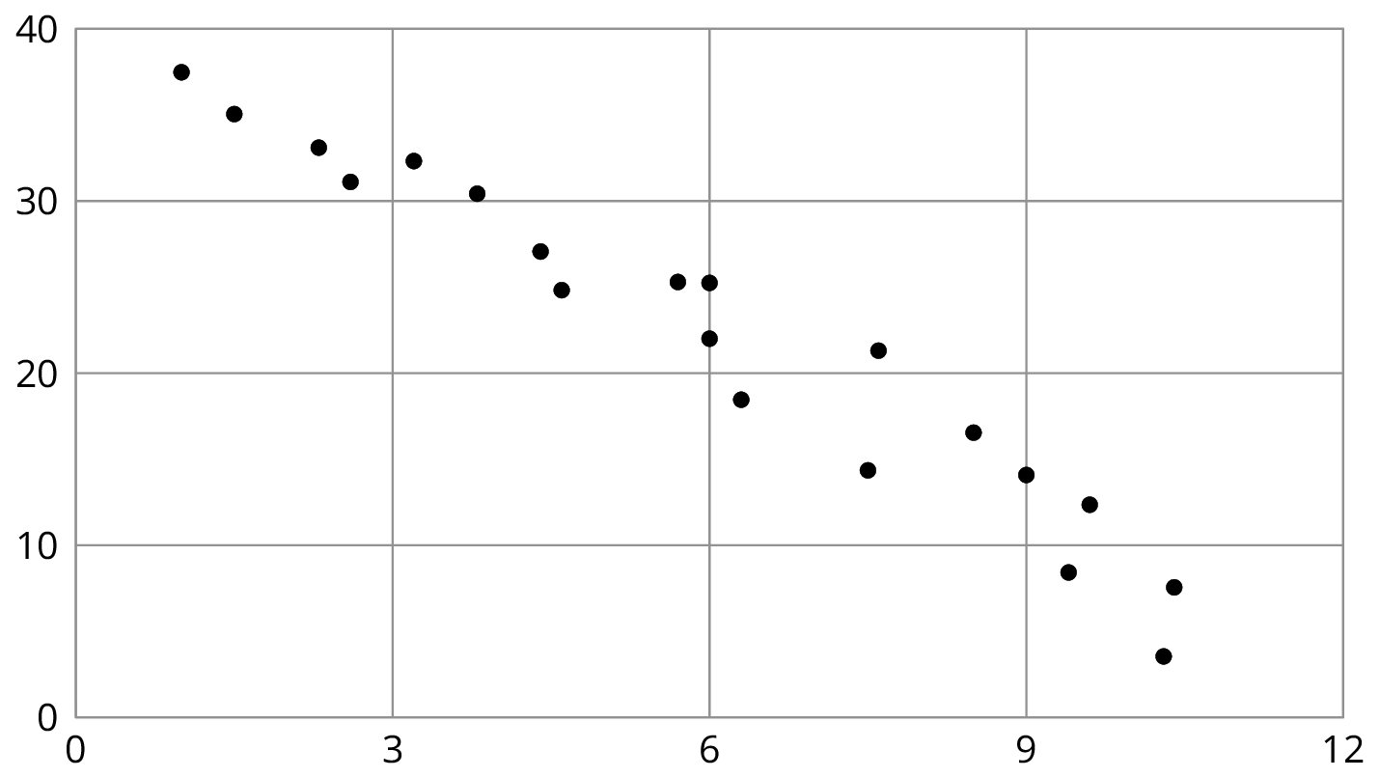
- Here are two copies of another scatter plot. Experiment with drawing lines to fit the data. Pick the line that you think best fits the data. Compare it with a partner’s.
- 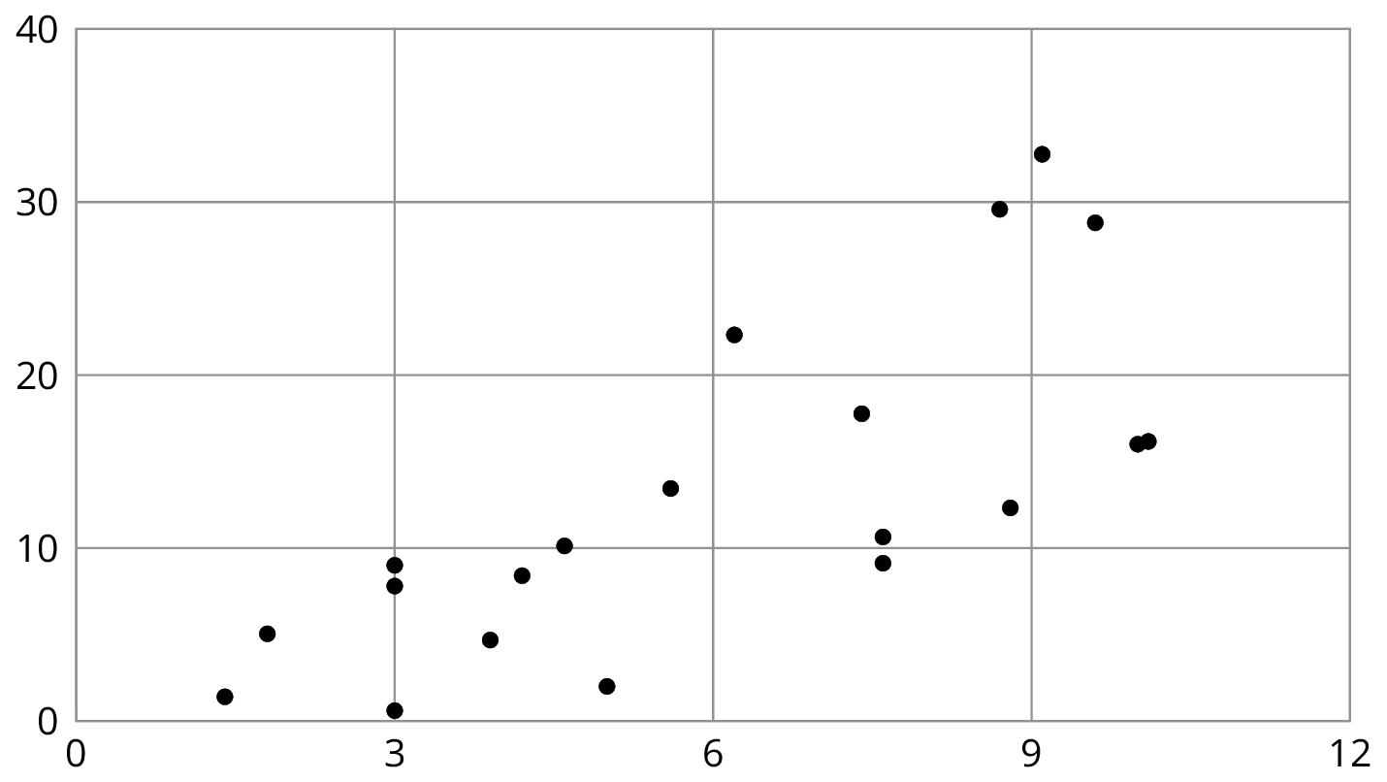
- In your own words, describe what makes a line fit a data set well.

20.3: Good Fit Bad Fit
The scatter plots both show the year and price for the same 17 used cars. However, each scatter plot shows a different model for the relationship between year and price.
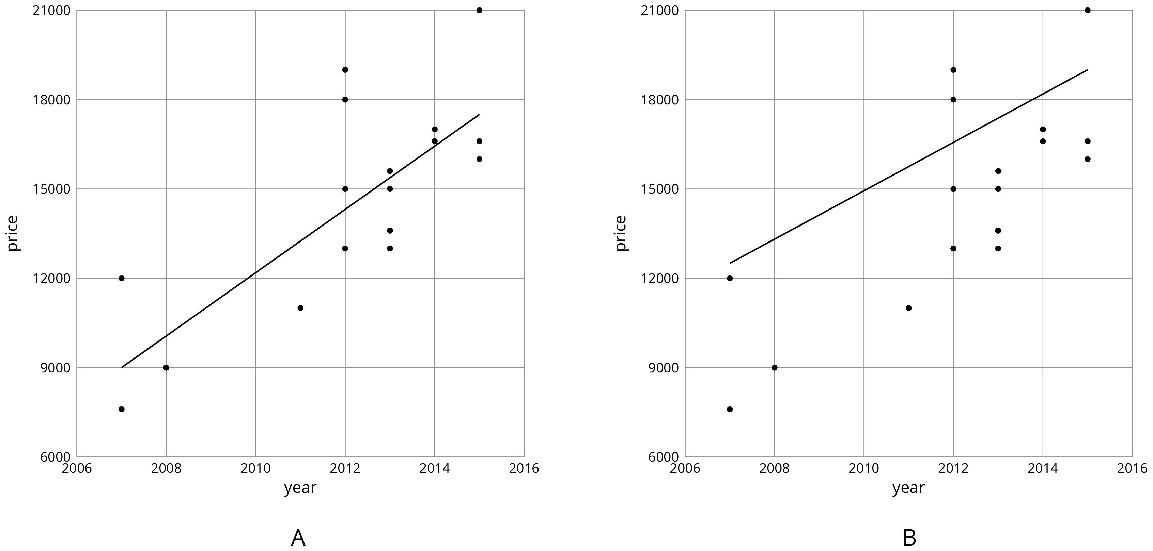
- Look at Diagram A.
  - For how many cars does the model in Diagram A make a good prediction of its price?
  - For how many cars does the model underestimate the price?
  - For how many cars does it overestimate the price?
- Look at Diagram B.
  - For how many cars does the model in Diagram B make a good prediction of its price?
  - For how many cars does the model underestimate the price?
  - For how many cars does it overestimate the price?
- For how many cars does the prediction made by the model in Diagram A differ by more than $3,000? What about the model in Diagram B?
- Which model does a better job of predicting the price of a used car from its year?

20.4: Practice Fitting Lines
- Is this line a good fit for the data? Explain your reasoning.
- 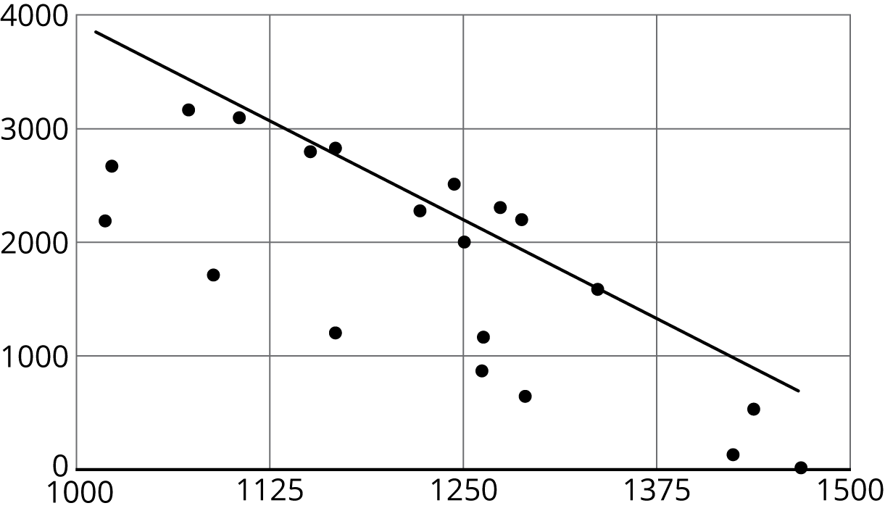
- Draw a line that fits the data better.
- 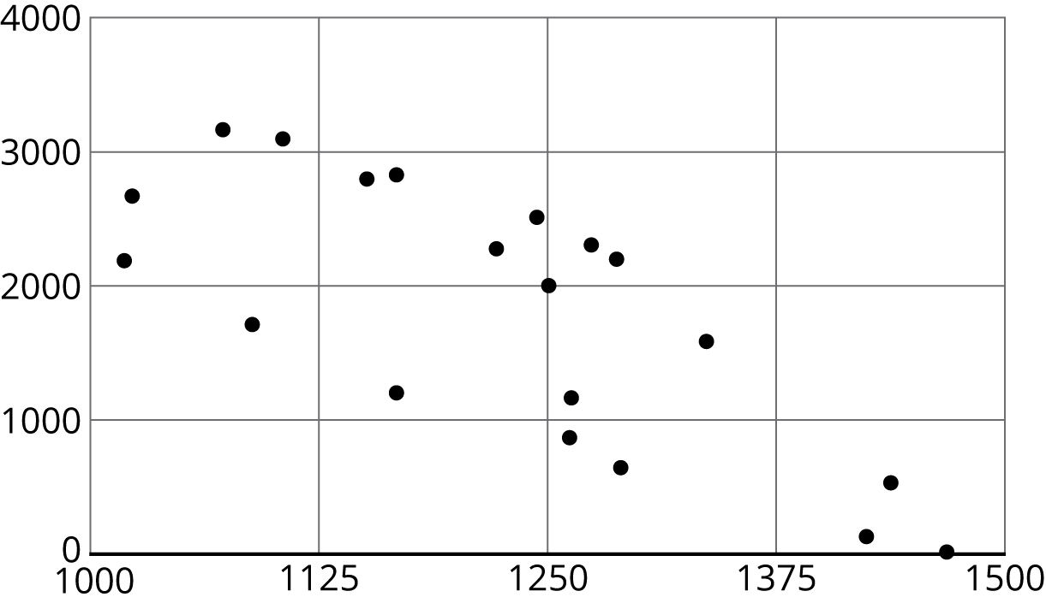
- Is this line a good fit for the data? Explain your reasoning.
- 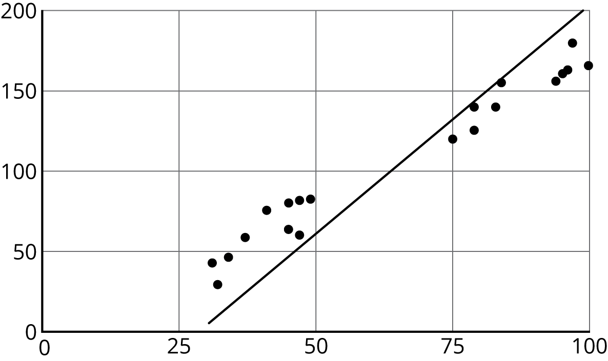
- Draw a line that fits the data better.
- 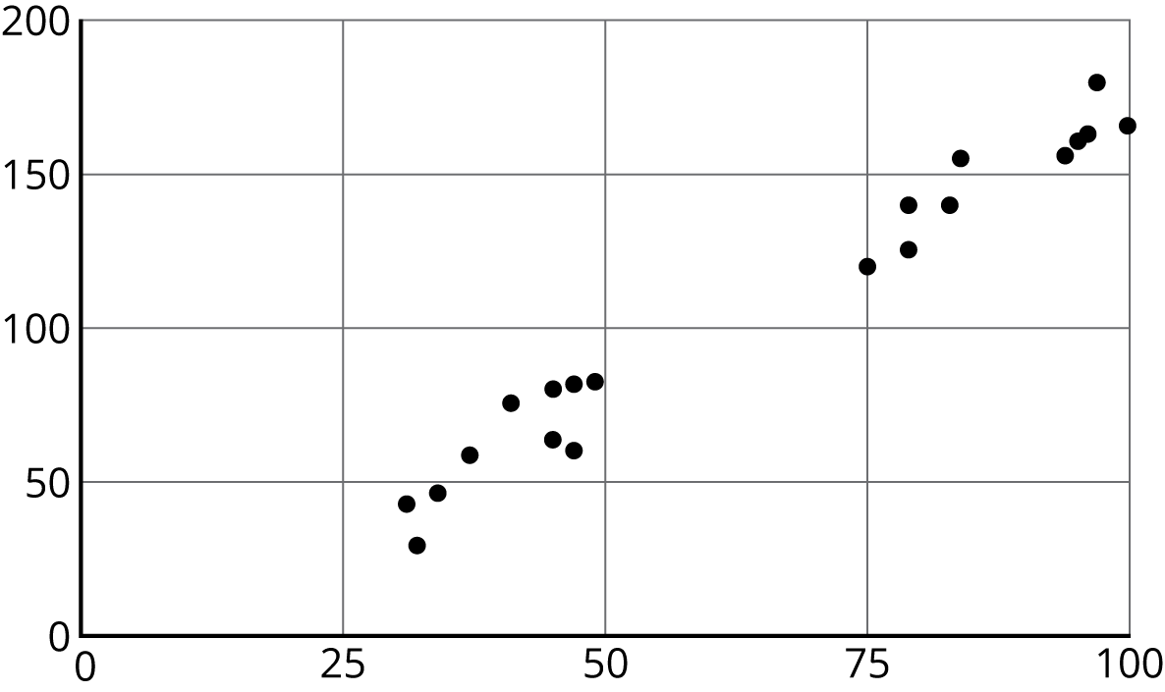

Are you ready for more?
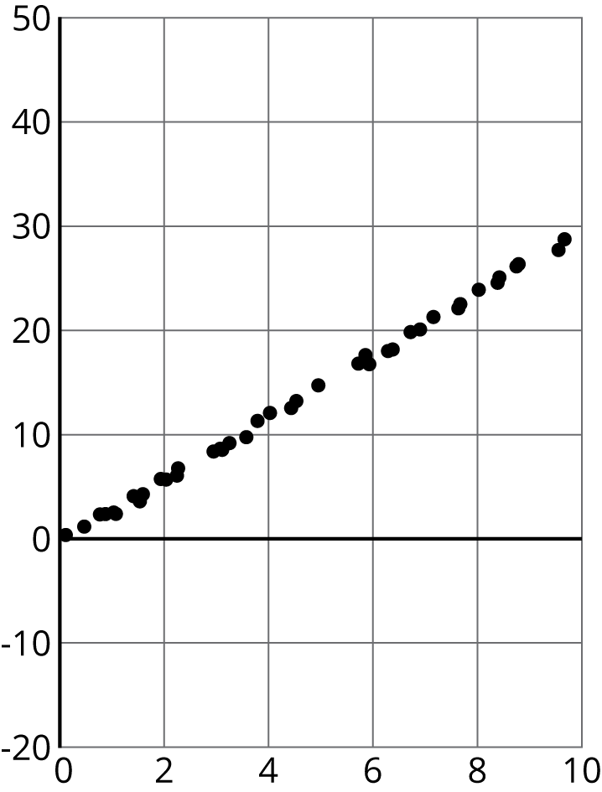
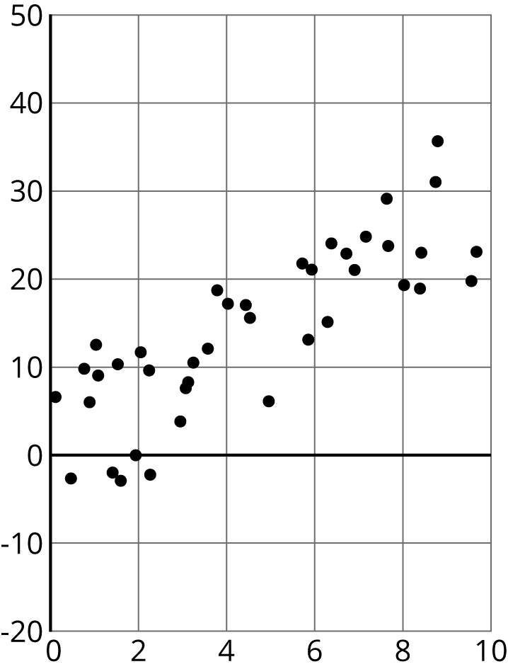
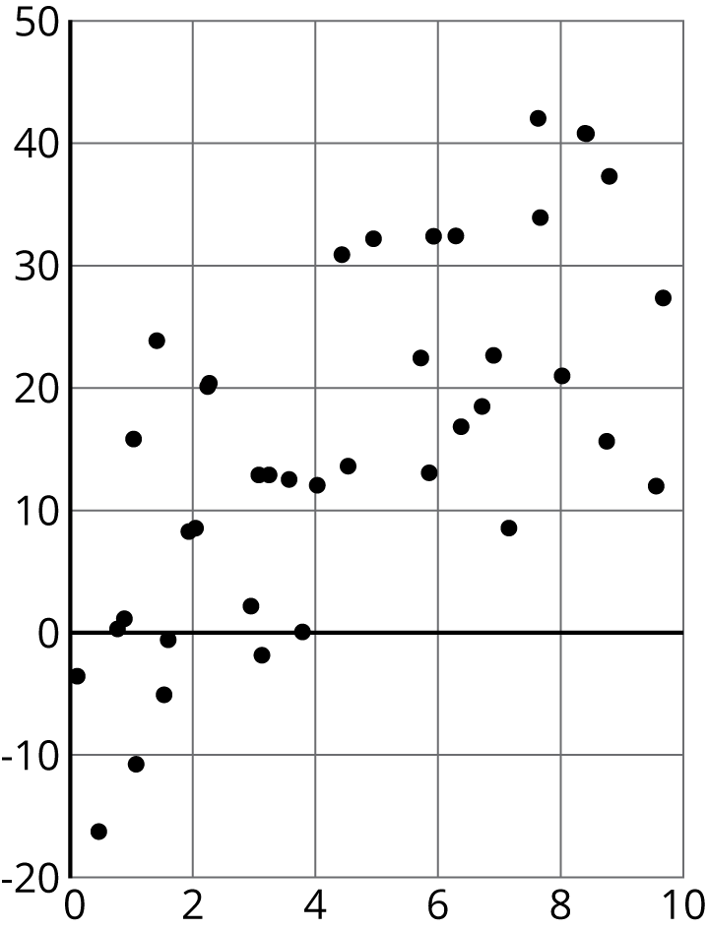
These scatter plots were created by multiplying the $x$-coordinate by 3 then adding a random number between two values to get the $y$-coordinate. The first scatter plot added a random number between -0.5 and 0.5 to the $y$-coordinate. The second scatter plot added a random number between -2 and 2 to the $y$-coordinate. The third scatter plot added a random number between -10 and 10 to the $y$-coordinate.
- For each scatter plot, draw a line that fits the data.
- Explain why some were easier to do than others.

Lesson 20 Summary
When a linear function fits data well, we say there is a linear association between the variables. For example, the relationship between height and weight for 25 dogs with the linear function whose graph is shown in the scatter plot.
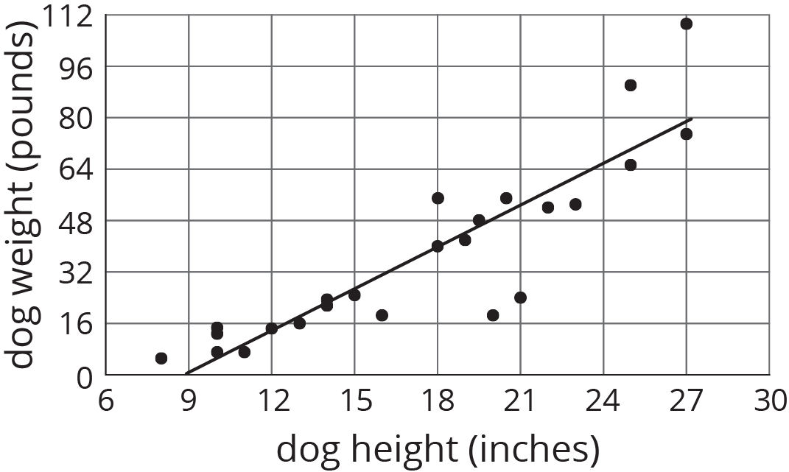
Because the model fits the data well and because the slope of the line is positive, we say that there is a positive association between dog height and dog weight.
What do you think the association between the weight of a car and its fuel efficiency is?
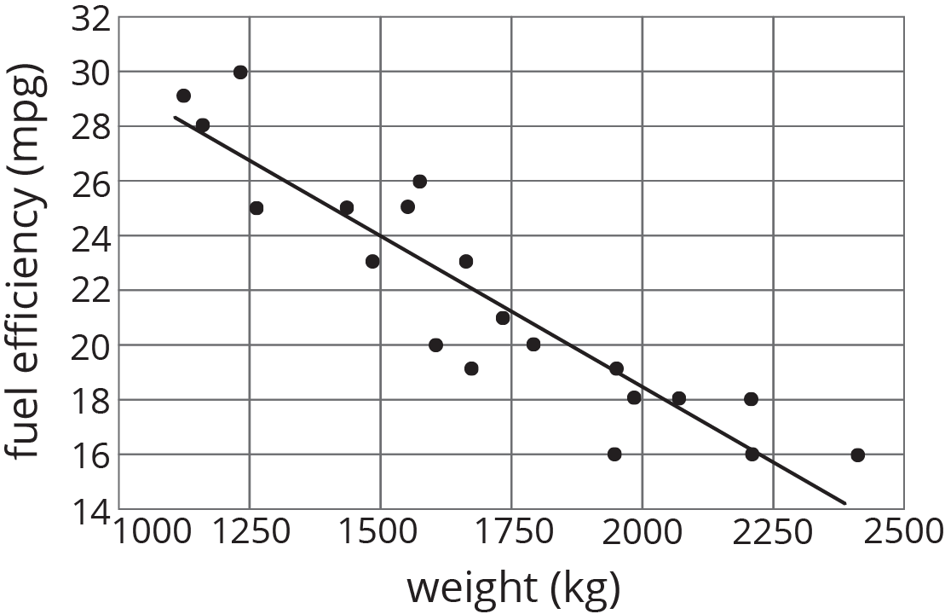
Because the slope of a line that fits the data well is negative, we say that there is a negative association between the fuel efficiency and weight of a car.
© CC BY Open Up Resources. Adaptations CC BY IM.

