Unit 2 Lesson 21: Percentages and Tape Diagrams

1 Notice and Wonder: Tape Diagrams (Warm up)

Student Task Statement
What do you notice? What do you wonder?
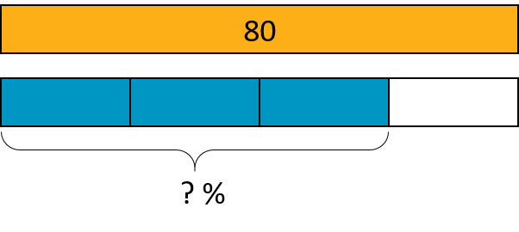

2 Revisiting Jada's Puppy

Student Task Statement
Jada has a new puppy that weighs 9 pounds. It is now at about 20% of its adult weight.
- Here is a diagram that Jada drew about the weight of her puppy.
- 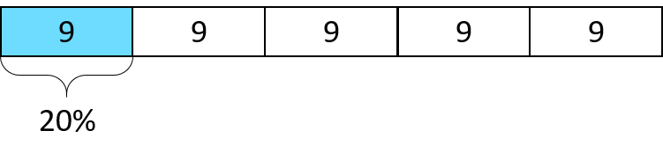
  - The adult weight of the puppy will be 45 pounds. How can you see that in the diagram?
  - What fraction of its adult weight is the puppy now? How can you see that in the diagram?
- Jada’s friend has a dog that weighs 90 pounds. Here is a diagram Jada drew that represents the weight of her friend’s dog and the weight of her puppy.
- 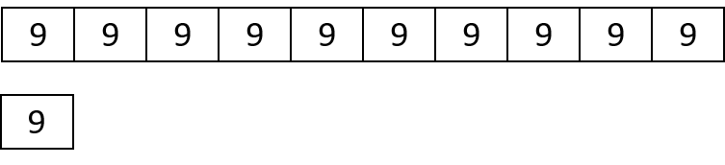
  - How many times greater is the dog’s weight than the puppy’s?
  - Compare the weight of the puppy and the dog using fractions.
  - Compare the weight of the puppy and the dog using percentages.

Activity Synthesis

3 5 Dollars

Student Task Statement
Noah has $5.

  - Elena has 40% as much as Noah. How much does Elena have?
  - Compare Elena’s and Noah’s money using fractions. Draw a diagram to illustrate.

  - Diego has 150% as much as Noah. How much does Diego have?
  - Compare Diego’s and Noah’s money using fractions. Draw a diagram to illustrate.

Activity Synthesis
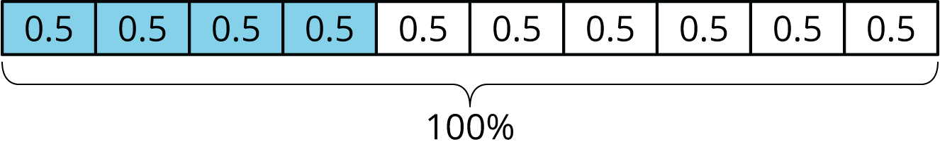
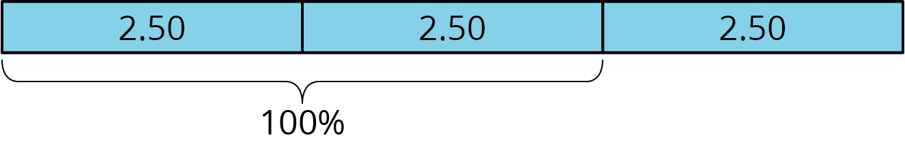

4 Staying Hydrated (Optional)

Student Task Statement
During the first part of a hike, Andre drank 1.5 liters of the water he brought.
- If this is 50% of the water he brought, how much water did he bring?
- If he drank 80% of his water on his entire hike, how much did he drink?
© CC BY Open Up Resources. Adaptations CC BY IM.

