Lesson 16: Represent Our Collections
- Let’s count collections of objects and show how we counted.

16.1: Counting Collections: Show How Many
Show how many objects are in your collection.

16.3: Centers: Choice Time
Choose a center.
Geoblocks
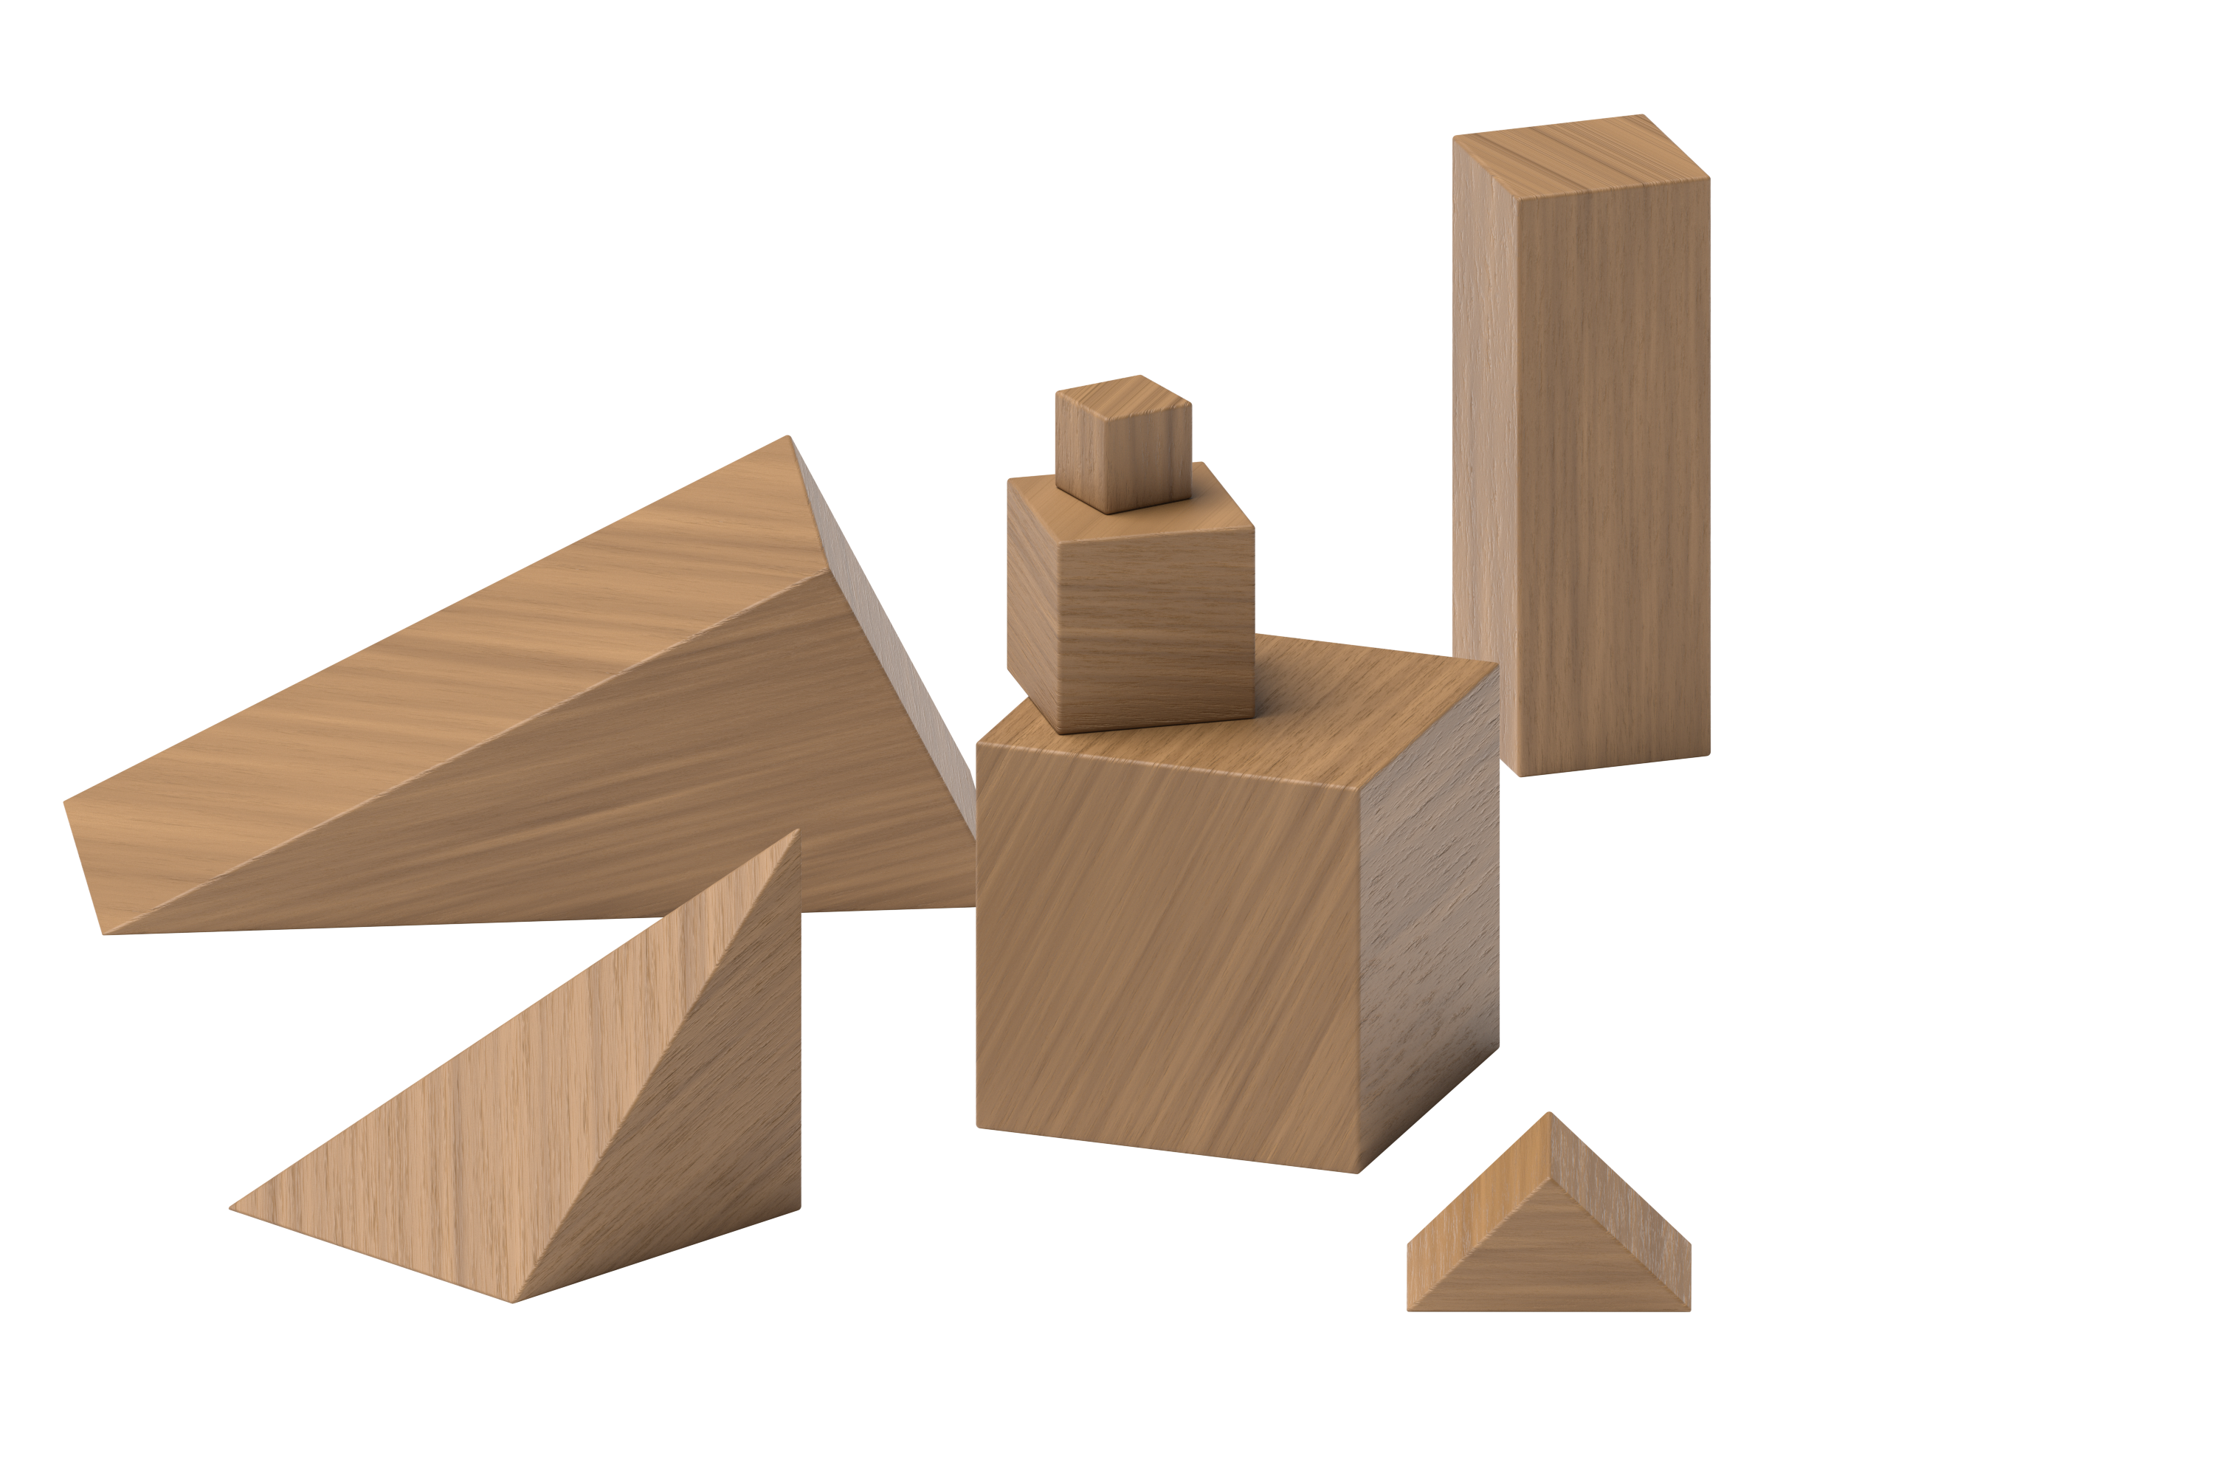
Connecting Cubes
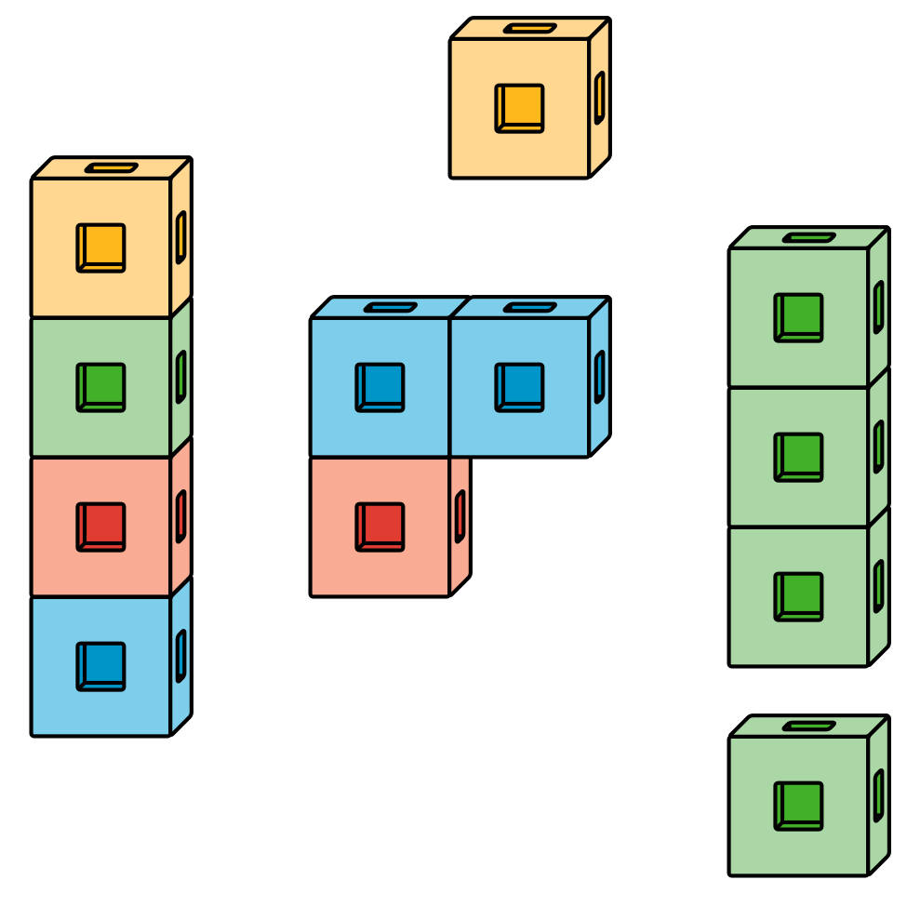
Pattern Blocks
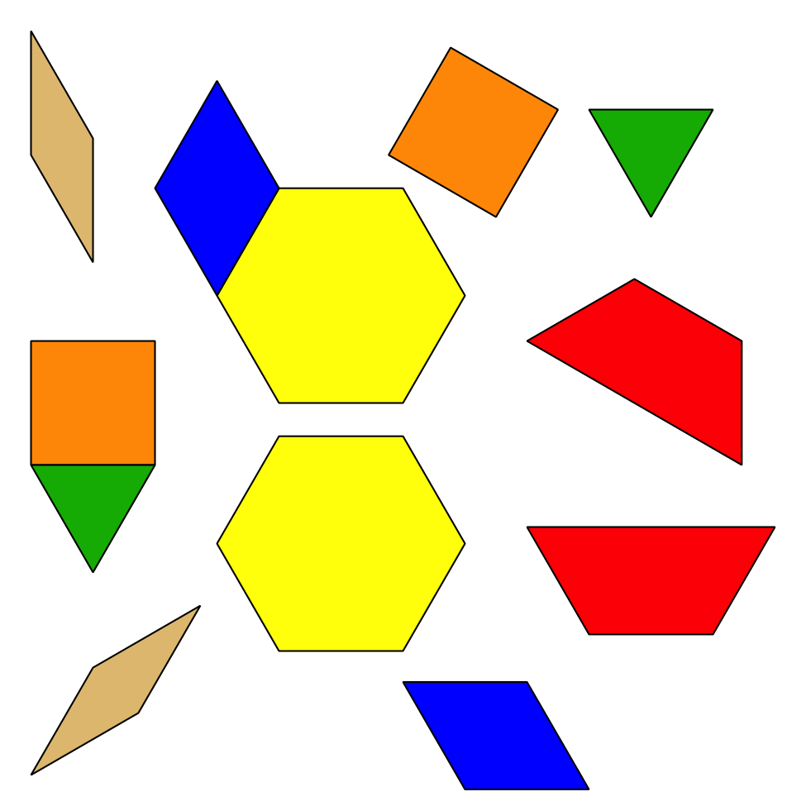
Picture Books
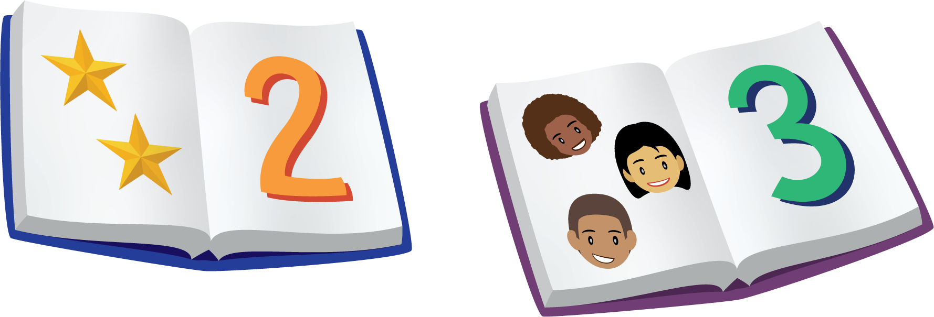

Section Summary
Section Summary
In this section, we counted collections of objects.
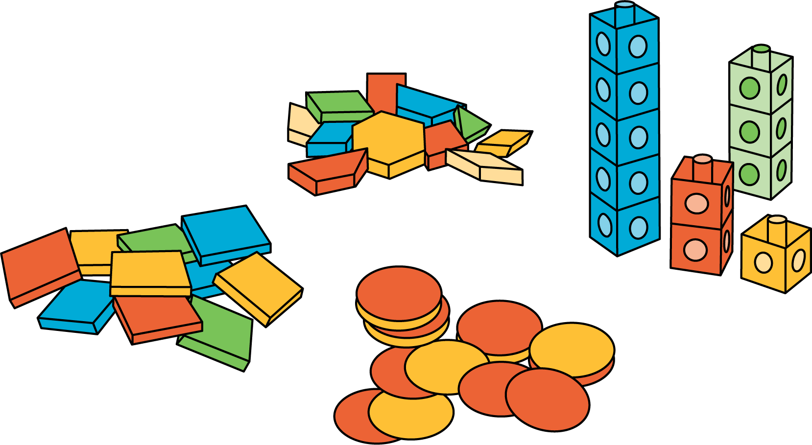
We counted each object and kept track of which objects we’ve counted. We used 5-frames and counting mats to help us.
We said a number to tell how many objects there are.
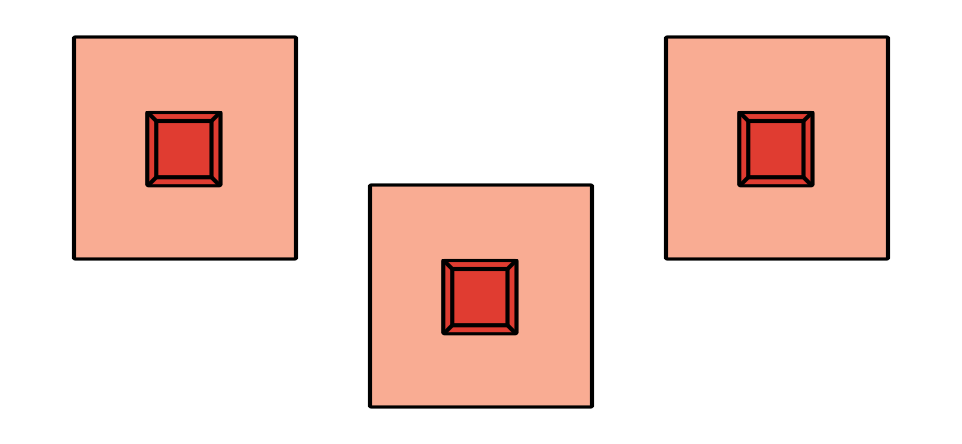
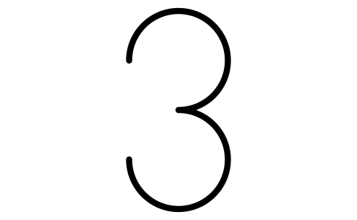
© CC BY 2021 Illustrative Mathematics®

