Unit 7 Lesson 2: More or Fewer Pattern Blocks

WU Choral Count: Count by 10 (Warm up)

Student Task Statement

1 Quack Quack

Student Task Statement

2 Make a Y

Student Task Statement

3 Introduce Pattern Blocks, Place the Last Pattern Block

Student Task Statement
Choose a center.
Pattern Blocks
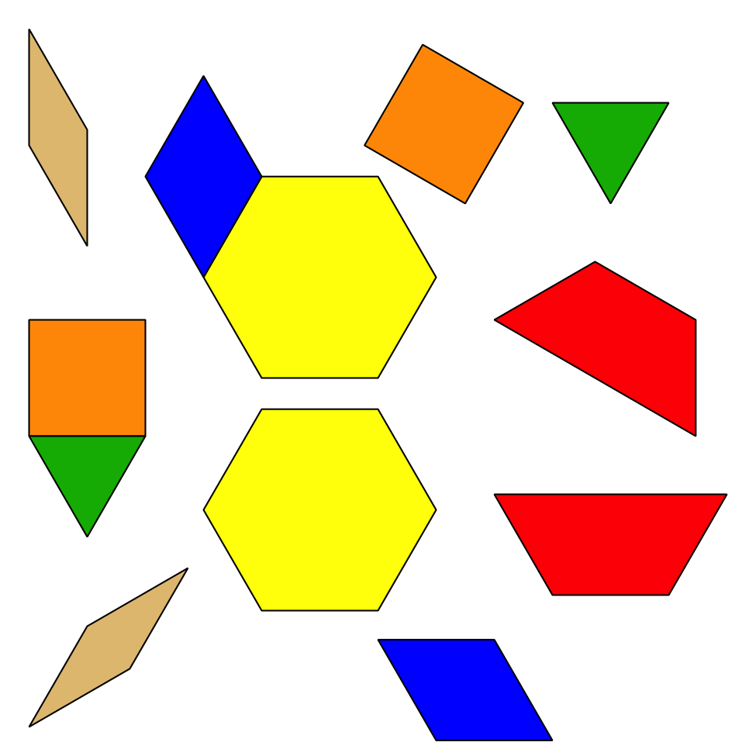
Geoblocks
Grab and Count
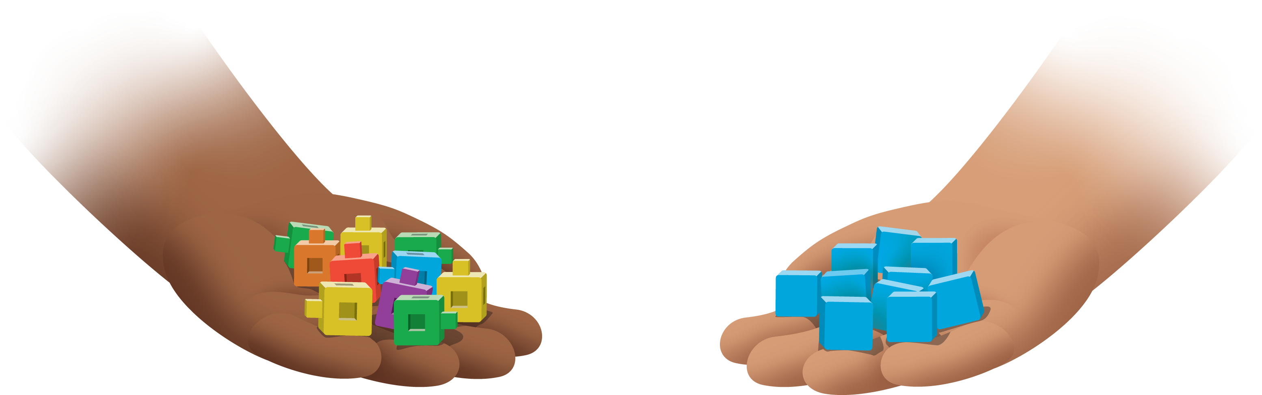
Find the Pair
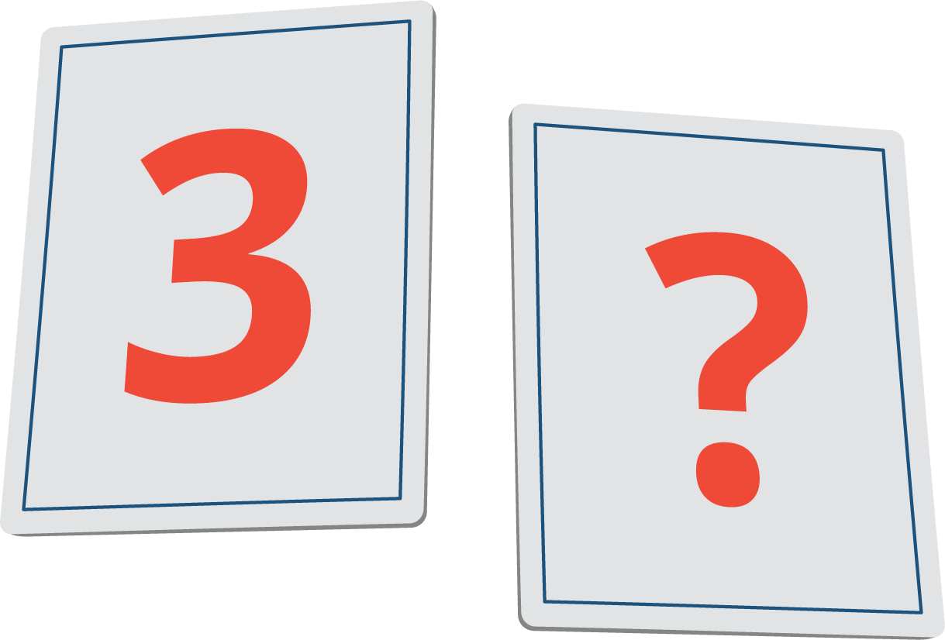

Activity Synthesis
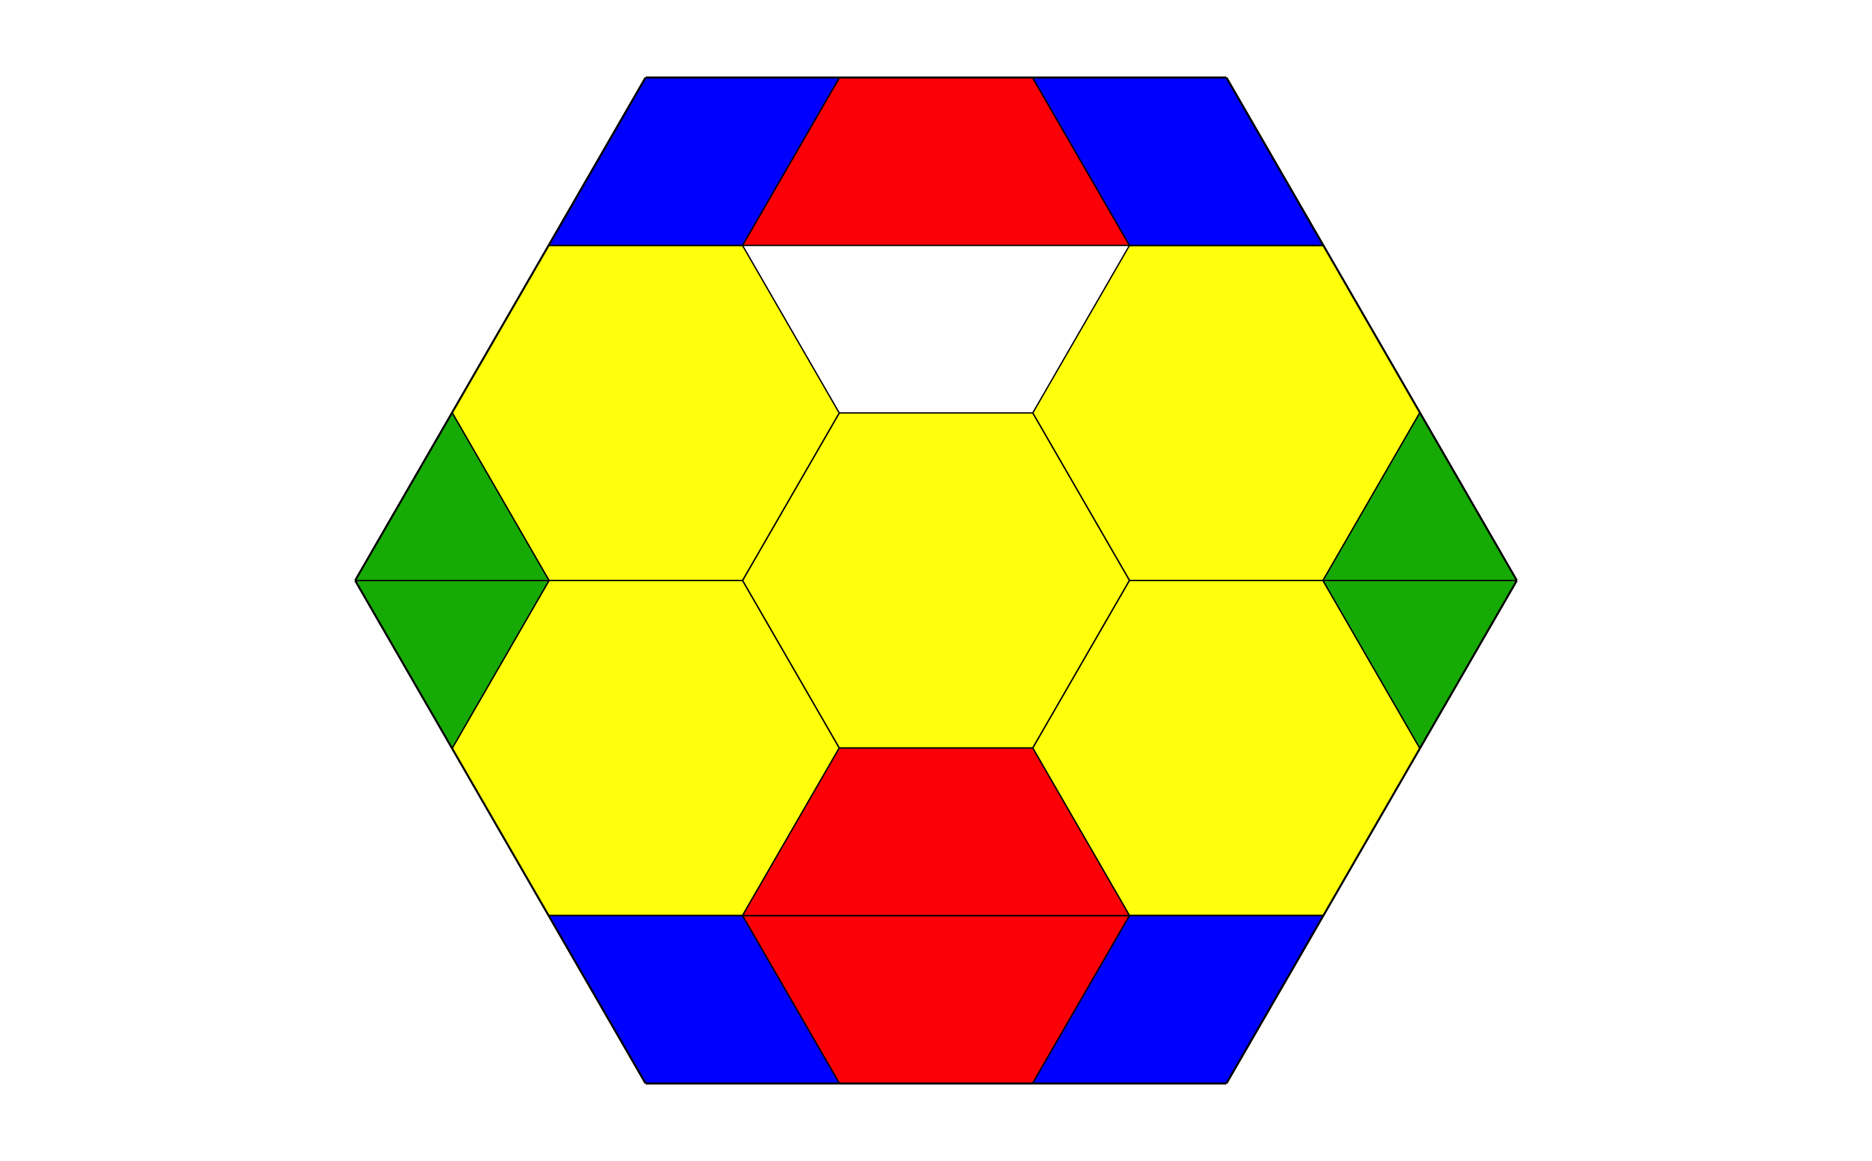

Images for Activity Synthesis
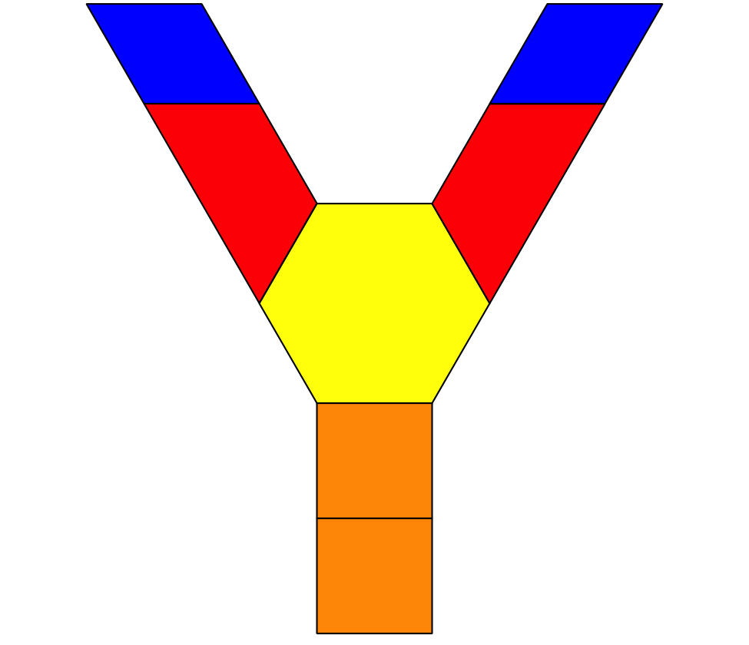
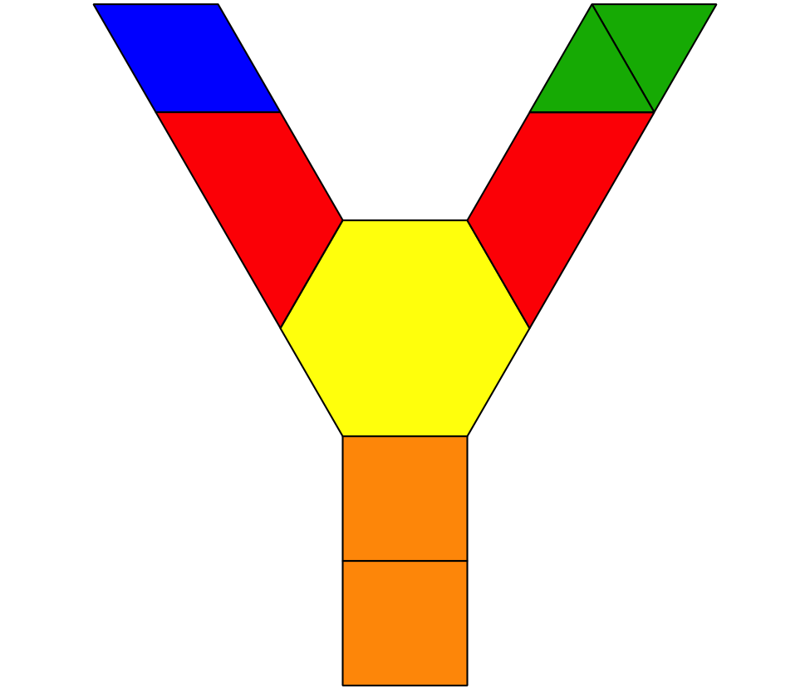
© CC BY 2021 Illustrative Mathematics®

