## Unit 5 Lesson 12: How Many Are Missing?

### Which One Doesn’t Belong: 10-frames (Warm up)

#### Student Task Statement

Which one doesn’t belong?

A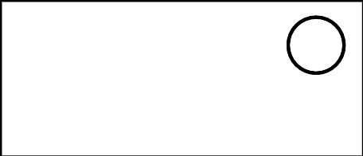

B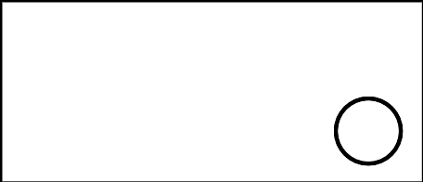

C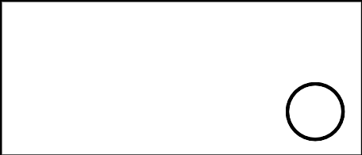

D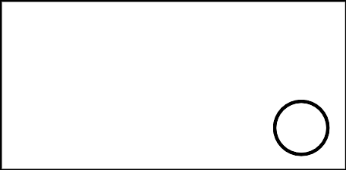

### 1 Shake, Spill, and Arrange with 10

#### Student Task Statement



### 2 How Many to Fill the 10-frame?

#### Student Task Statement



* 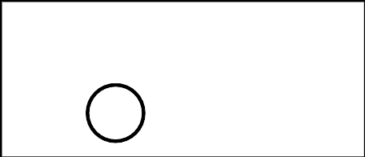
* _______________



* 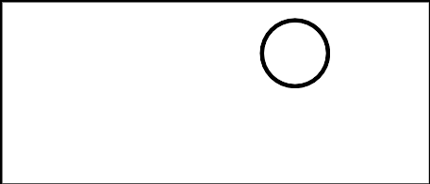
* _______________



* 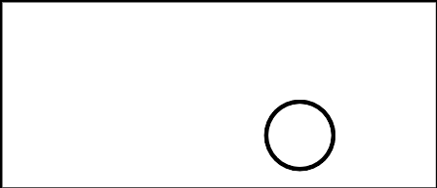
* _______________



* 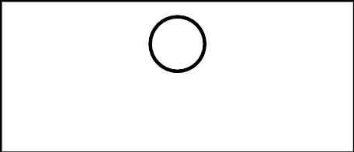
* _______________



* 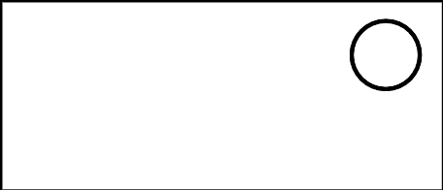
* _______________



* 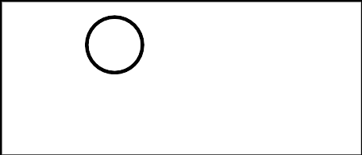
* _______________

### 3 Centers: Choice Time

#### Student Task Statement

Choose a center.

Shake and Spill



Counting Collections

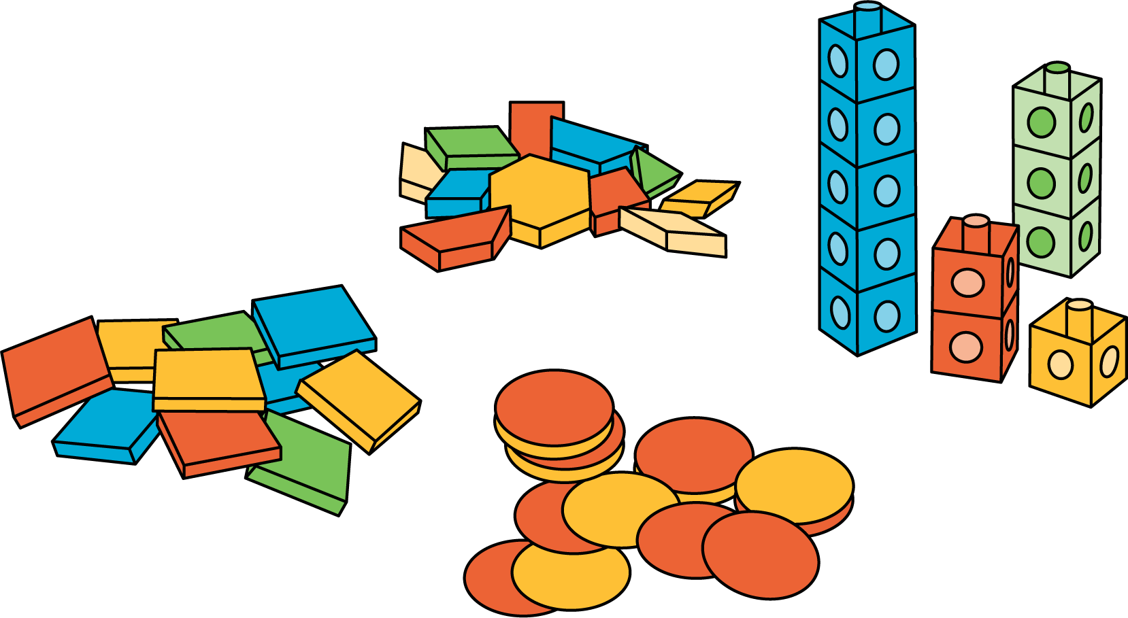

Roll and Add

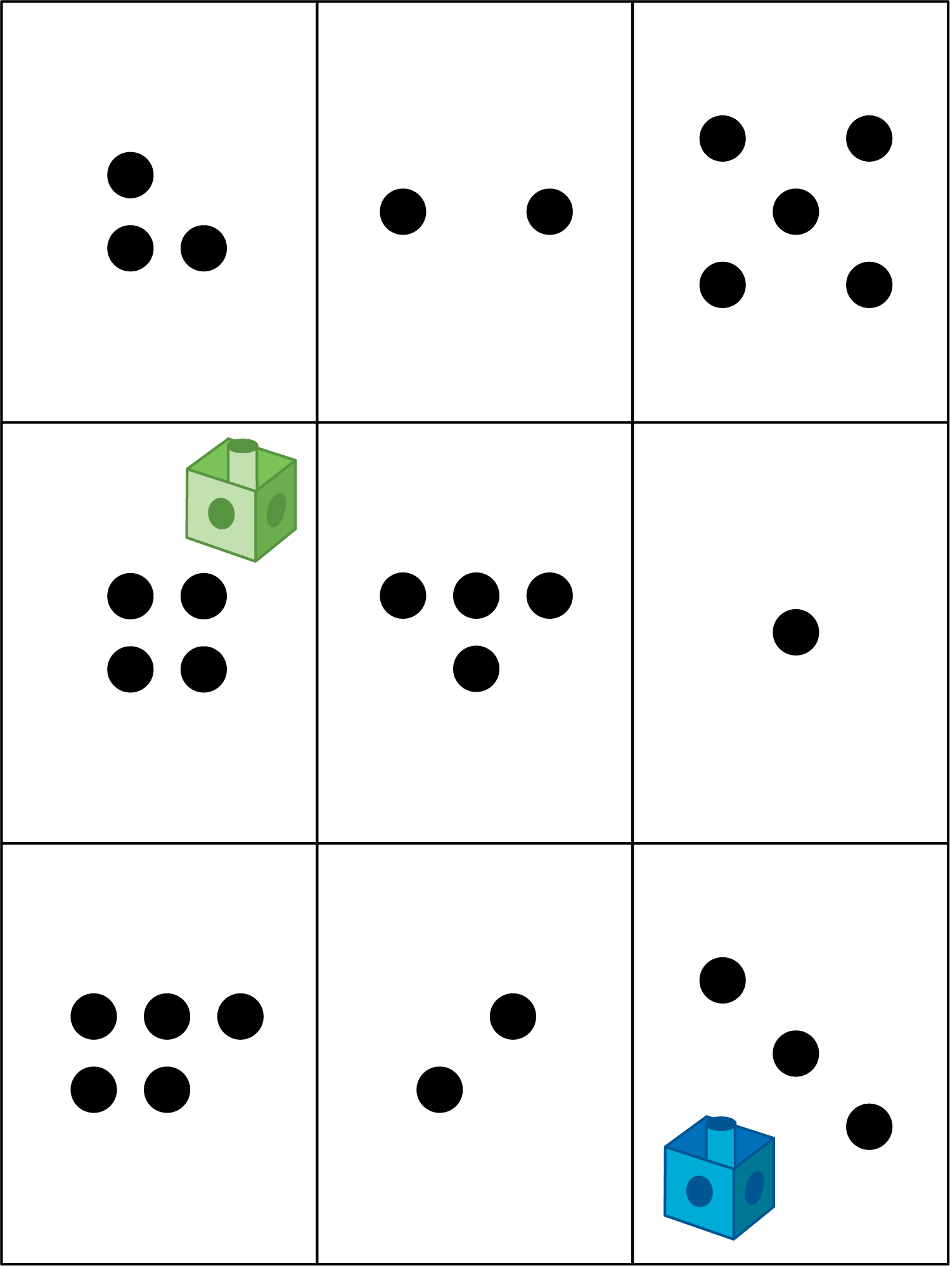

#### Images for Activity Synthesis

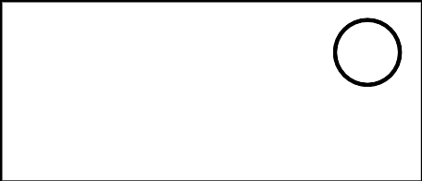

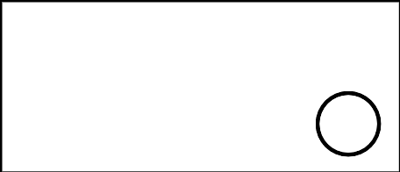



© CC BY 2021 Illustrative Mathematics®