Curated Practice Problem Set

Unit 5 Lesson 11 Cumulative Practice Problems
- A line $ℓ$ is defined by the equation $f(x)=2x−3$.
  - Line $m$ is the same as line $l$, but shifted 1 unit right. What is an equation for a function $g$ that defines the line $m$?
  - Line $n$ is the same as line $m$, but shifted 2 units up. What is an equation for a function $h$ that defines the line $n$?
  - What is the relationship between $f$ and $h$?
- (From Unit 5, Lesson 2.)
- The functions $g$ and $f$ are related by the equation $g(x)=f(\text{-}x)+3$. Which sequence of transformations will take the graph of $f$ to the graph of $g$?
- (From Unit 5, Lesson 4.)
- The function $f$ is linear. Can $f$ be an odd function? Explain how you know
- (From Unit 5, Lesson 5.)
- Technology required. The function $f$ is given by $f(x)=x^{3}+1$. Kiran says that $f$ is odd because $(\text{-}x)^{3}=\text{-}x^{3}$.
  - Do you agree with Kiran? Explain your reasoning.
  - Graph $f$, and use the graph to decide whether or not $f$ is an odd function.
- (From Unit 5, Lesson 6.)
- Here are graphs of three functions $f$, $g$, and $h$ given by $f(x)=(x−1)^{2}$, $g(x)=2(x−1)^{2}$ and $h(x)=3(x−1)^{2}$.
- 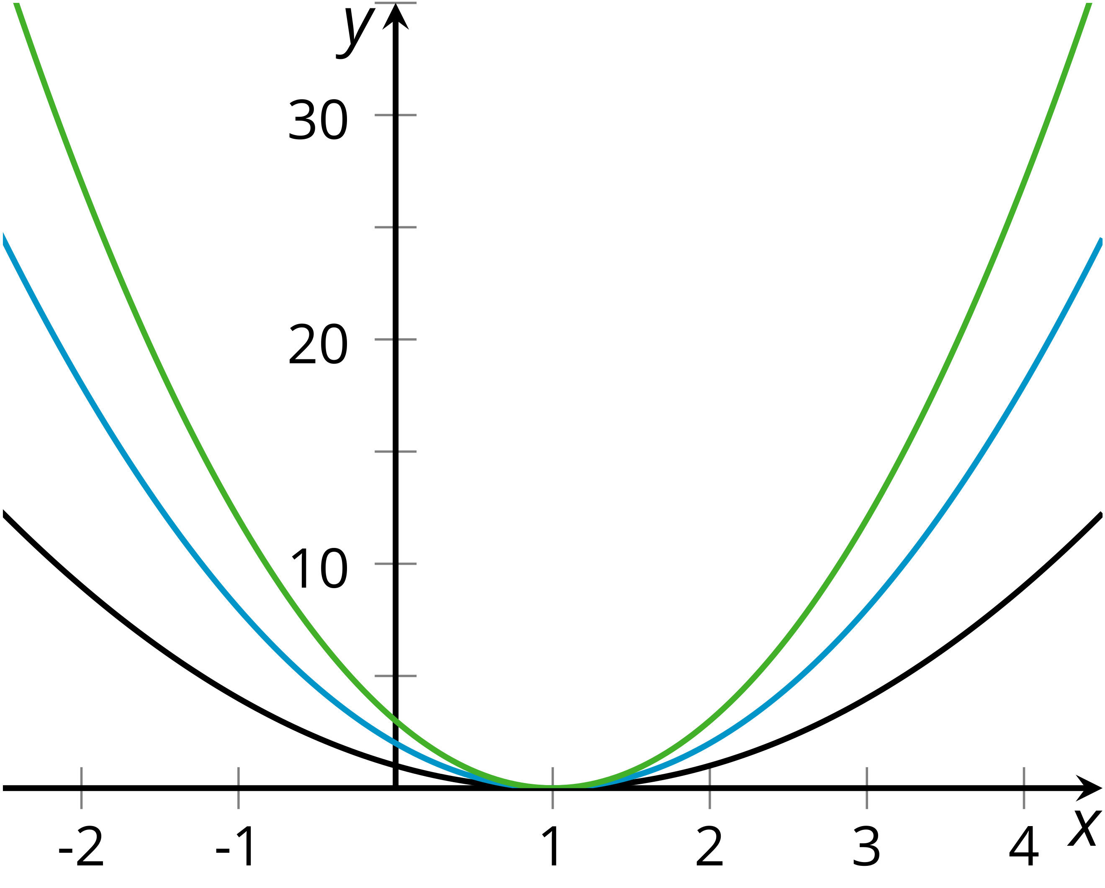
- Identify which function matches each graph. Explain how you know.
- (From Unit 5, Lesson 8.)
- Technology required. Describe how to transform the graph of $f(x)=x^{2}$ into the graph of $g(x)=4(3x−1)^{2}+5$. Check your response by graphing $f$ and $g$.
- (From Unit 5, Lesson 9.)
- Let $p$ be the price of a T-shirt, in dollars. A company expects to sell $f(p)$ T-shirts a day where $f(p)=50−4p$. Write a function $r$ giving the total revenue received in a day.
- (From Unit 5, Lesson 10.)
- A population of 80 single-celled organisms is tripling every hour. The population as a function of hours since it is measured, $h$, can be represented by $g(h)=80⋅3^{h}$.
- Which equation represents the population 10 minutes after it is measured?
  - $g(10)=80⋅3^{10}$
  - $g(0.1)=80⋅3^{0.1}$
  - $g(\frac{1}{6})=80⋅3^{\frac{1}{6}}$
  - $g(6)=80⋅3^{6}$
- (From Unit 4, Lesson 3.)
© CC BY 2019 by Illustrative Mathematics

