Unit 6 Lesson 11: Zeros of Functions and Intercepts of Graphs

1 Which Output is 0? (Warm up)

Student Task Statement
Which of these functions have an output of 0 when the input is -4?
- $v(x)=4x$
- $w(x)=\text{-}4x$
- $y(x)=8+2x$
- $z(x)=2x−8$

2 Intercept Detective

Student Task Statement
Here are the definitions of some functions, followed by some possible inputs for the functions.
$a(x)=x−5$
$b(x)=x+5$
$c(x)=x−3$
$d(x)=x+1$
$f(x)=3x−6$
$g(x)=3x+6$
$h(x)=(x+5)(x+3)$
$m(x)=(x+1)(x−3)$
$n(x)=(3x−6)(x−5)$
Possible inputs: -5, -4, -3, -2, -1, 0, 1, 2, 3, 4, and 5.
- For each function, decide which input or inputs would give an output of 0.
- Here are graphs of $b$, $f$, and $m$. Label each intercept with its coordinates, and be prepared to explain how you know.
- 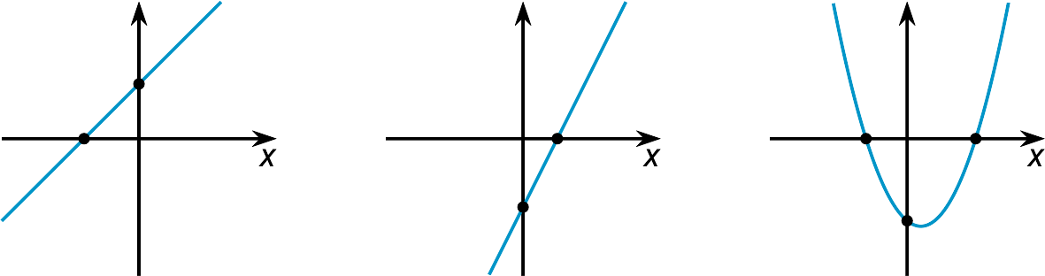

3 Making More Connections

Student Task Statement
- For each function, identify the input that would give an output of 0.
  - $p(x)=x+10$
  - $q(x)=x−10$
  - $r(x)=8−x$
  - $s(x)=\text{-}8−x$
  - $t(x)=2x−8$
  - $u(x)=2x+8$
- Match each graph to a function in the previous question. Be prepared to explain your matches.
- 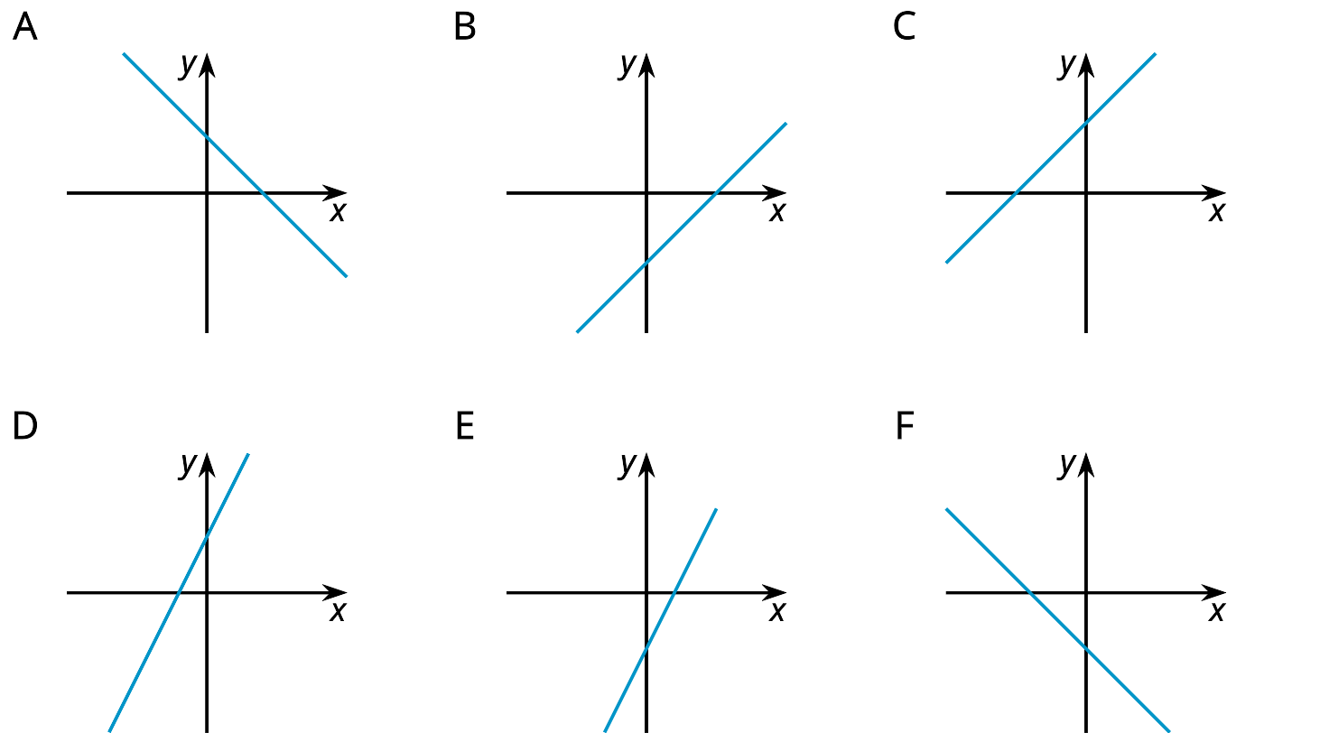
- Label the intercepts on each graph with their coordinates.
- For each function, identify the inputs that would give an output of 0.
  - $v(x)=(x+10)(2x−8)$
  - $w(x)=(2x+8)(10−x)$
- Create three different functions whose output is 0 when the input is 7. At least one of your functions must be quadratic.
© CC BY 2019 by Illustrative Mathematics

