Unit 5 Lesson 18: Design With Fractions

WU Notice and Wonder: Between 0 and 1 (Warm up)

Student Task Statement
What do you notice? What do you wonder?
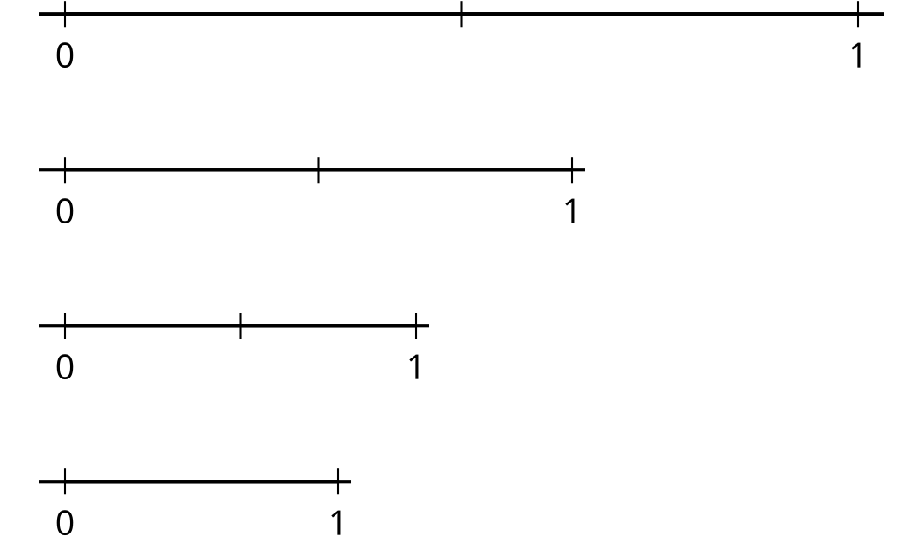

1 Design With $\frac{1}{2}$

Student Task Statement
- Here is a square. On each side, mark a point to show $\frac{1}{2}$ of its length.
- Connect each point to the point on the two sides next to it. What shape did you create?
- Look at the new shape you created. On each side, mark a point to show $\frac{1}{2}$ of its length. Connect the points again. What shape did you create?
- Repeat the steps you just did at least two more times. Make some observations about the design you just created.

2 Design With $\frac{1}{4}$

Student Task Statement
- Here is another square. On each side, mark a point to show $\frac{1}{4}$ of its length.
- Connect each point to the point on the two sides next to it. What shape did you create?
- Look at the new shape you created. On each side, mark a point to show $\frac{1}{4}$ of its length. Connect the points again. What shape did you create?
- Repeat the steps you just did at least two more times. Make some observations about the design you just created.
© CC BY 2021 Illustrative Mathematics®

