Unit 3 Lesson 9: Addition With a Ten

WU Notice and Wonder: Teen Numbers (Warm up)

Student Task Statement
What do you notice?
What do you wonder?
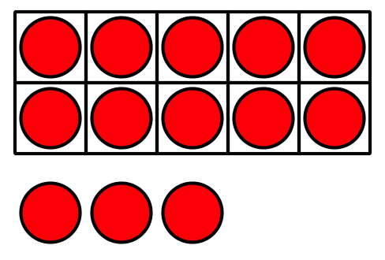
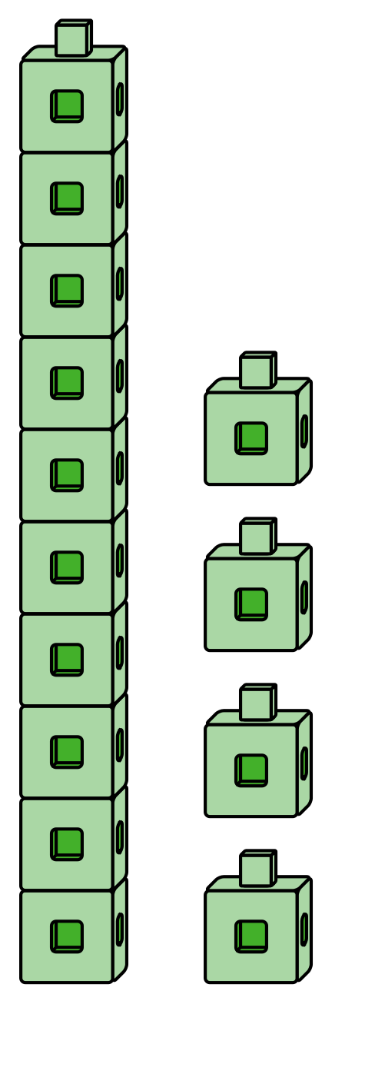

1 Make It: Teen Numbers and 10-Frames

Student Task Statement
Use your 10-frames to build teen numbers.
Write an equation that matches the teen number.
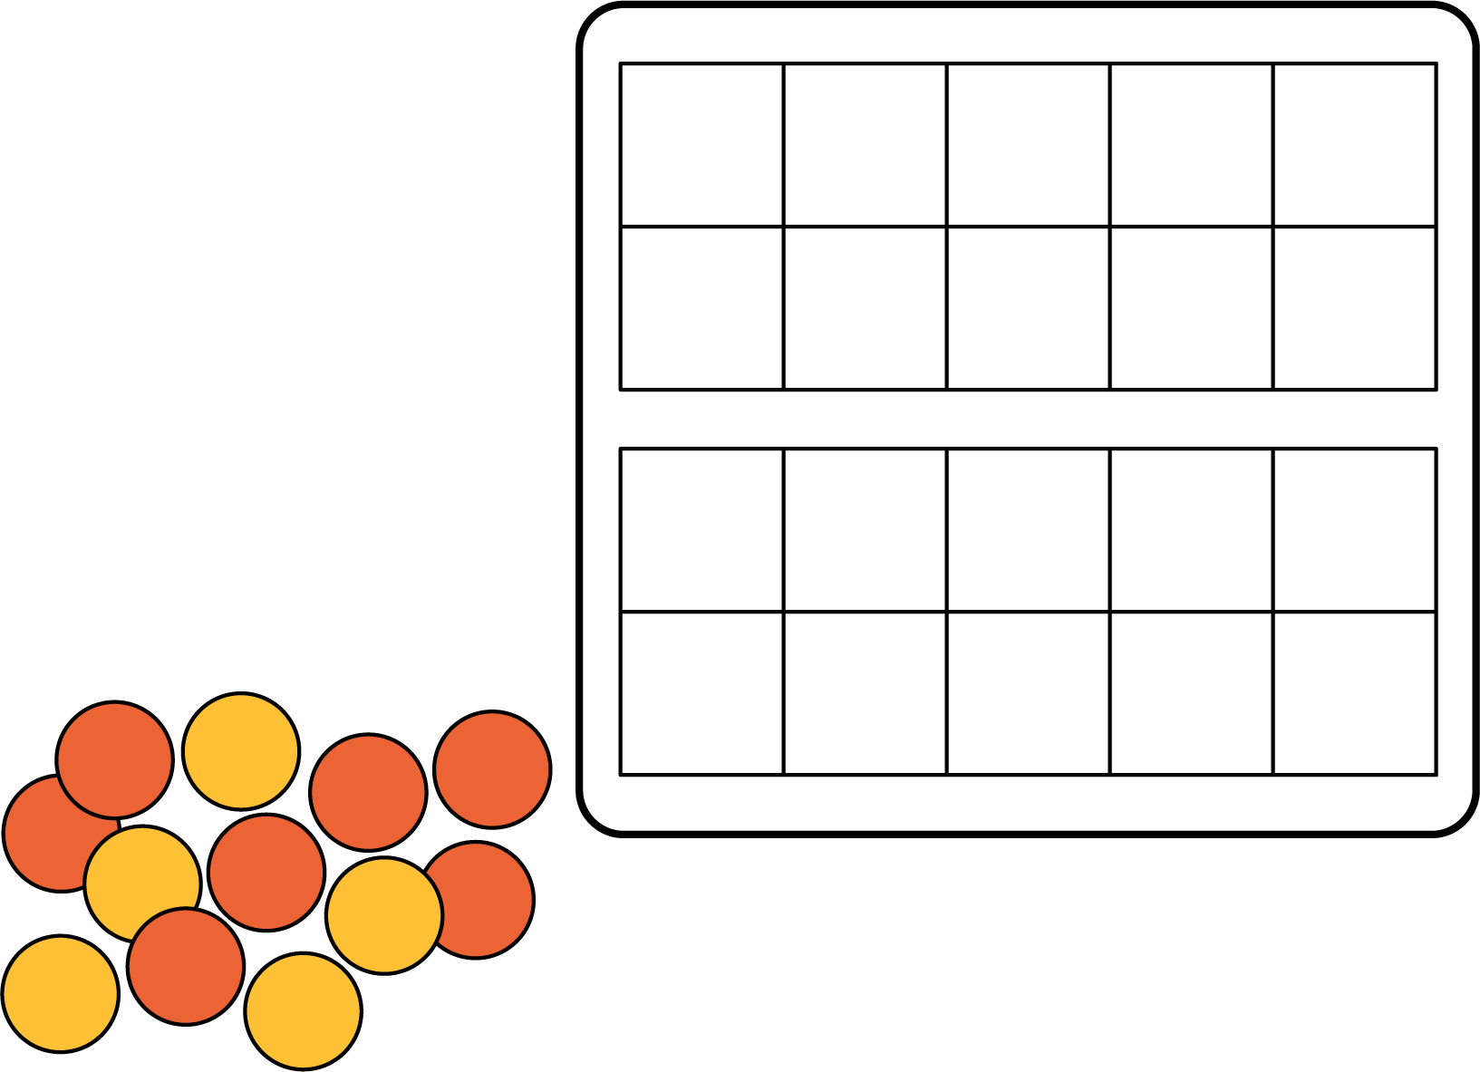
teen number | equation
If you have time, write another equation for each of the teen numbers.

2 Equations With a Ten

Student Task Statement
Find the number that makes each equation true.
Show your thinking using drawings, numbers, or words.
- 14=10+aaaiaaai
- 10+5=aaaiaaai
- 16=aaaiaaai+6
- 10+aaaiaaai=12
- aaaiaaai+3=13
- 13=aaaiaaai+10
© CC BY 2021 Illustrative Mathematics®

