Lesson 5: More Multiples
- Let’s solve problems that involve factors and multiples.

Warm-up: Estimation Exploration: Banquet Seating
About how many chairs are in the room?
Record an estimate that is:
too low | about right | too high

5.1: Choose the Right Tables
Students are preparing for a party. The school has tables where 6 people can sit and tables where 8 people can sit.
The students can only choose one type of table and they want to avoid having empty seats.
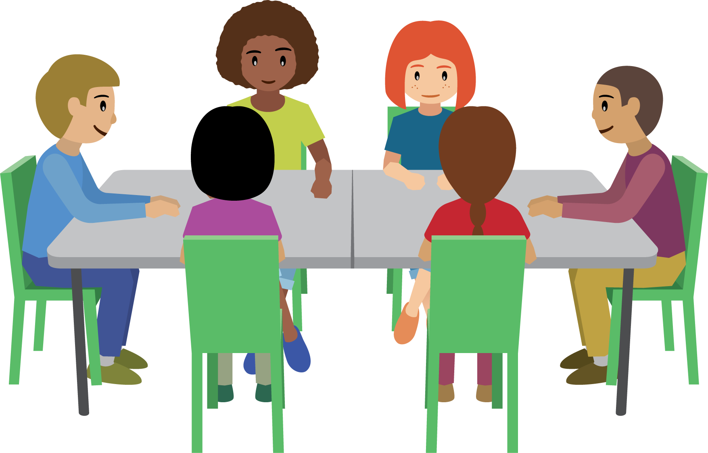
- Jada’s class has 18 students. Which tables would you choose for Jada’s class? Explain or show your reasoning.
- Noah’s class has 30 students. Which tables would you choose for Noah’s class? Explain or show your reasoning.
- Which tables would you choose for Noah’s and Jada’s classes together? Can you find more than one option? Explain or show your reasoning.
- If you also want places for Noah’s teacher and Jada’s teacher to sit, which tables would you choose? Explain or show your reasoning.

5.2: Hot Dogs and Buns
Each package of hot dogs has 10 hot dogs. Each package of hot dog buns has 8 buns.
- Lin expects to need 50 hot dogs for a class picnic.
  - How many packages of hot dogs should Lin get? Explain or show your reasoning.
  - Can Lin get exactly 50 hot dog buns? How many packages of hot dog buns should Lin get? Explain or show your reasoning.
- Diego expects to need 72 hot dogs for a class picnic.
  - How many packages of hot dogs should Diego get? Explain or show your reasoning.
  - How many packages of hot dog buns should Diego get? Explain or show your reasoning.
- Is it possible to buy exactly the same number of hot dogs and buns? If you think so, what would that number be? If not, explain your reasoning.
© CC BY 2021 Illustrative Mathematics®

