Lesson 11: Subtract Fractions Flexibly
- Let’s find all kinds of differences.

Warm-up: Which One Doesn’t Belong: Fractional Values
Which one doesn’t belong?
A. ​​​​​
$2−\frac{3}{5}$
B.
$\frac{10}{5}−\frac{3}{5}$
C.
$1\frac{3}{5}−\frac{1}{5}$
D.
$\frac{10}{5}−1$

11.1: Friendship Bracelets
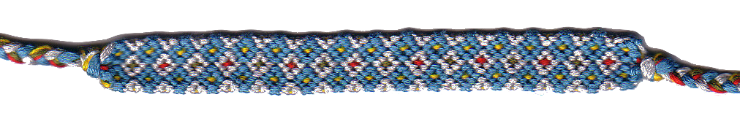
Clare, Elena, and Andre are making macramé friendship bracelets. They’d like their bracelets to be $9\frac{4}{8}$ inches long. For each question, explain or show your reasoning.
- Clare started her bracelet first and has only $\frac{7}{8}$ inch left until she finishes it. How long is her bracelet so far?
- So far, Elena’s bracelet is $5\frac{1}{8}$ inches long and Andre’s is $3\frac{5}{8}$ inches long. How many more inches do they each need to reach $9\frac{4}{8}$ inches?
- How much longer is Elena’s bracelet than Andre’s at the moment?

11.2: Multiple Ways to Subtract
Here are four expressions that you may have written about the friendship bracelets.
$9\frac{4}{8}−\frac{7}{8}$
$9\frac{4}{8}−5\frac{1}{8}$
$9\frac{4}{8}−3\frac{5}{8}$
$5\frac{1}{8}−3\frac{5}{8}$
- Here is one way to find the value of the first expression. Analyze the calculation. Talk to your partner about why $9\frac{4}{8}$ is written as different sums.
- 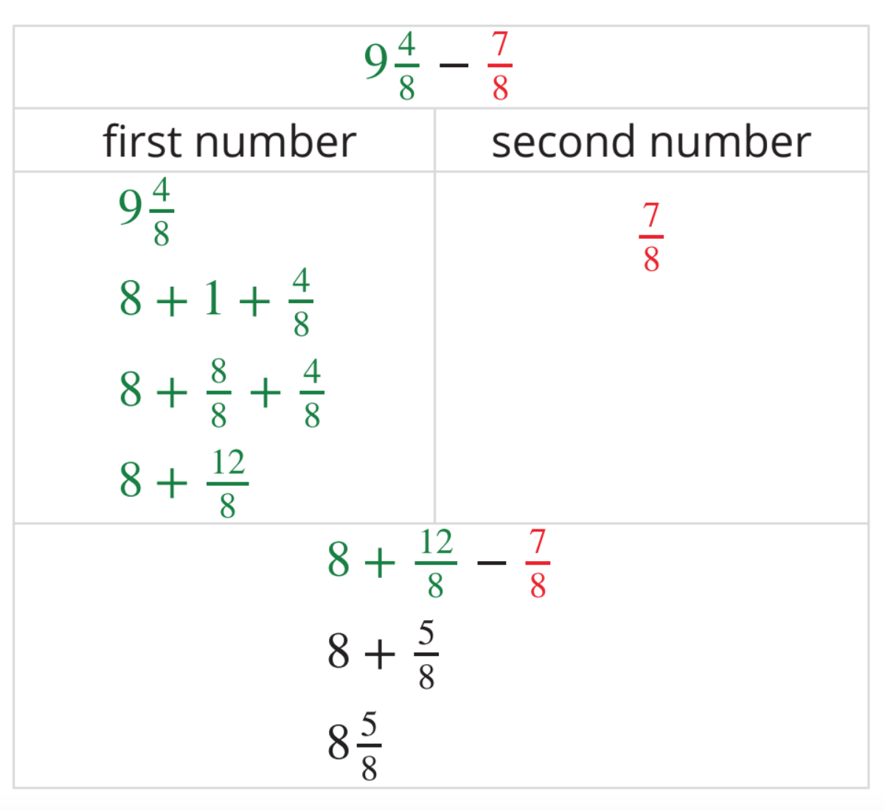
- Here are some unfinished calculations. Complete them to find the value of each difference.

  - 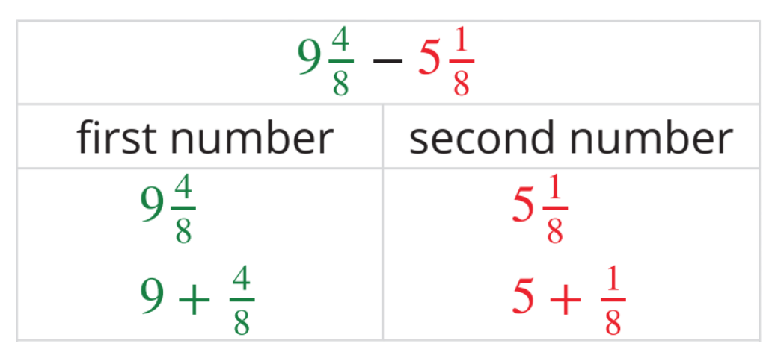

  - 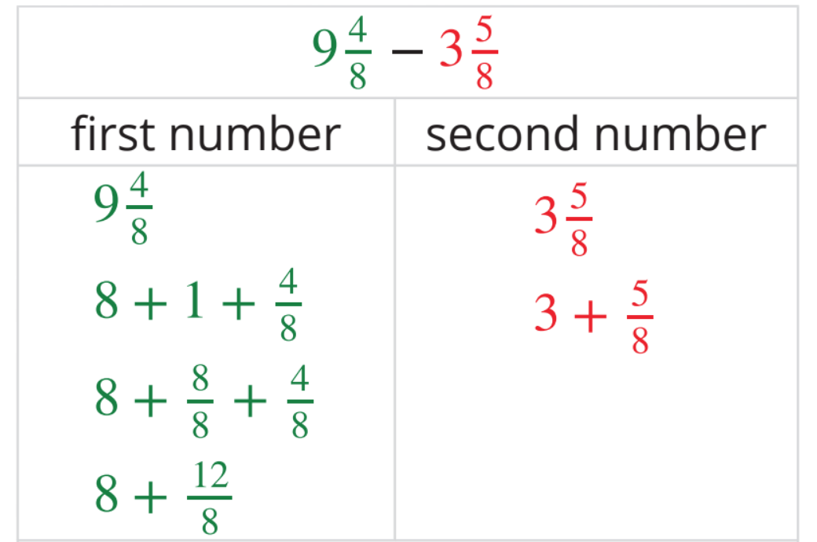

  - 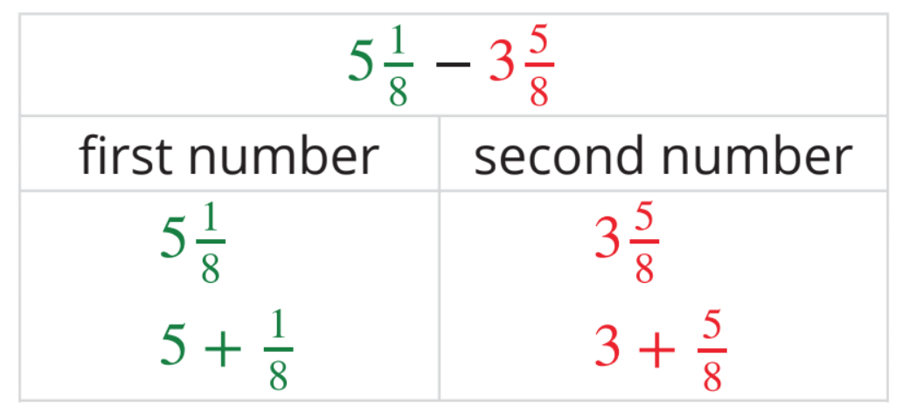
© CC BY 2021 Illustrative Mathematics®

