### Lesson 6 Practice Problems

1. Solve each of these equations. Explain or show your reasoning.
2. Solve each equation and check your solution.
3. Elena said the equation has no solutions because is greater than . Do you agree with Elena? Explain your reasoning.
4. The table gives some sample data for two quantities, and , that are in a proportional relationship.
   1. Complete the table.
   2. Write an equation that represents the relationship between and shown in the table.
   3. Graph the relationship. Use a scale for the axes that shows all the points in the table.

|  |  |
| --- | --- |
| * 14 | * 21 |
| * 64 |  |
|  | * 39 |
| * 1 |  |

* 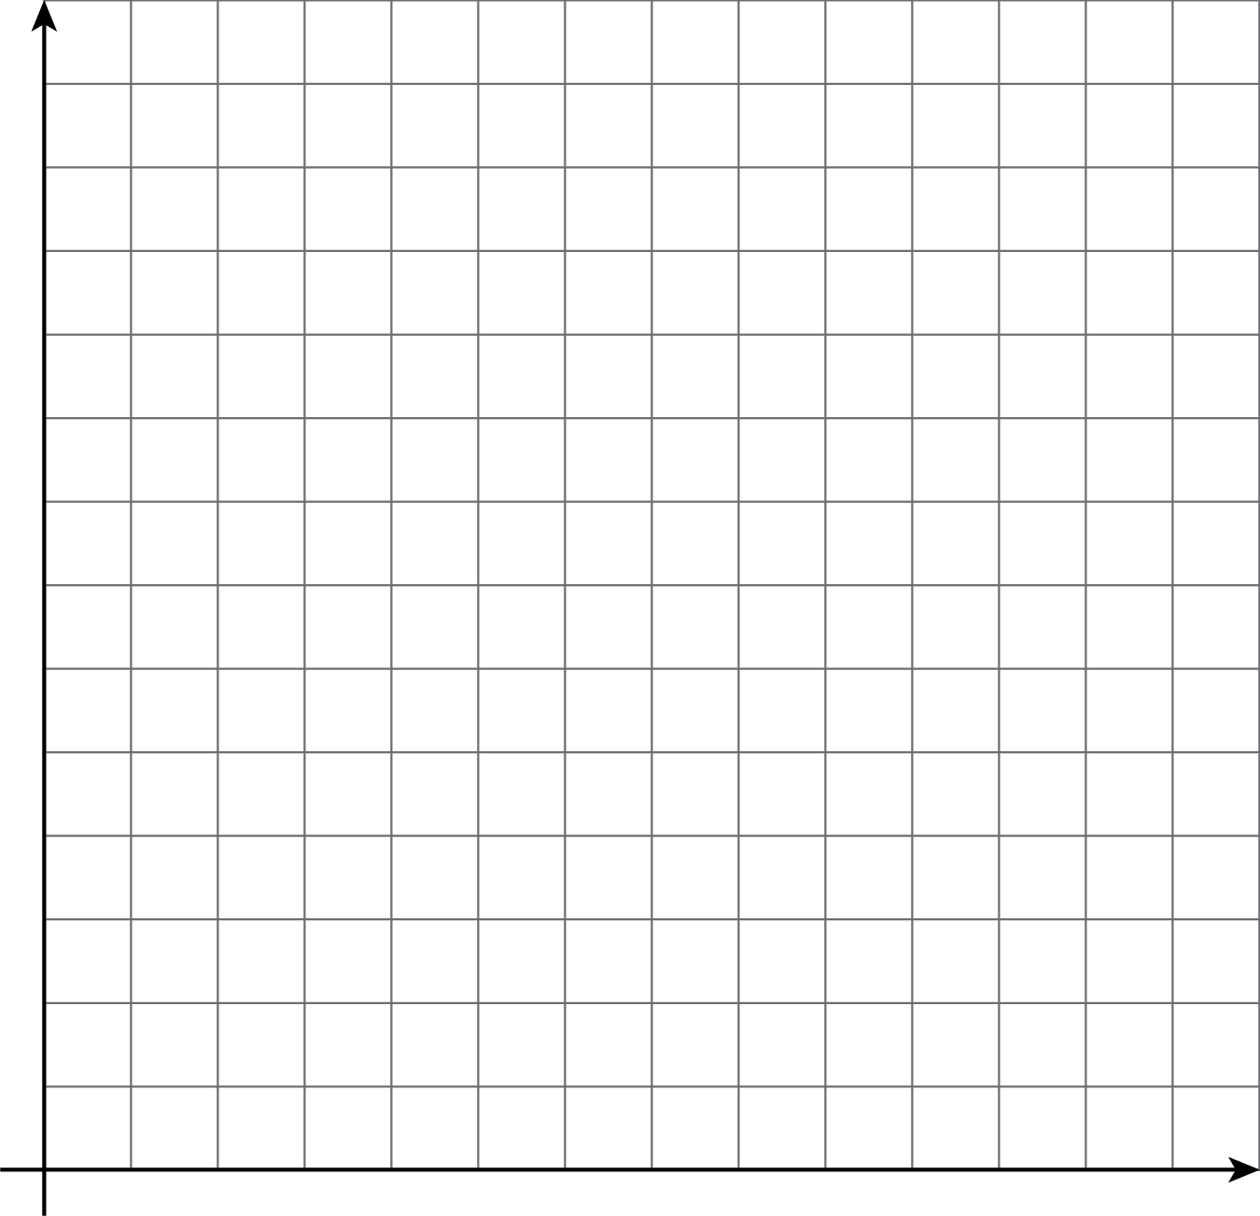
* (From Unit 3, Lesson 3.)



© CC BY Open Up Resources. Adaptations CC BY IM.