Lesson 8: Writing and Graphing Inequalities

8.1: Estimate Heights of People
- Here is a picture of a man.
- 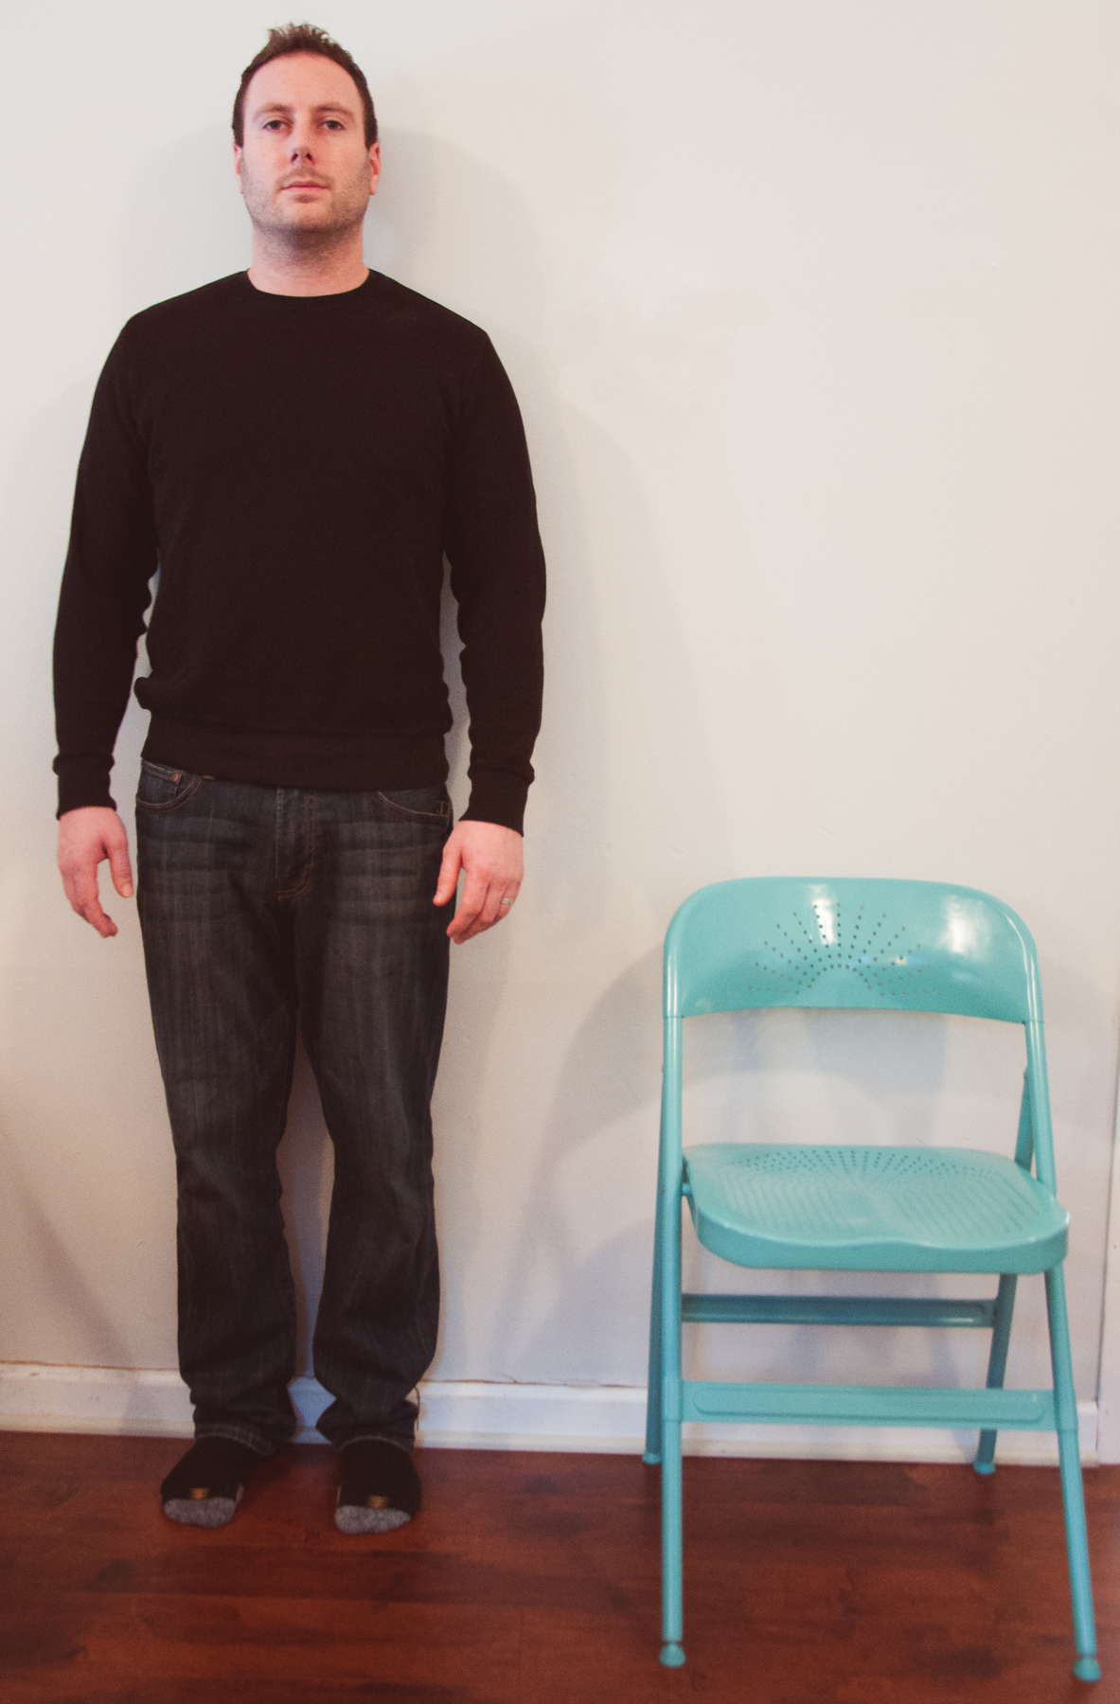
  - Name a number, in feet, that is clearly too high for this man’s height.
  - Name a number, in feet, that is clearly too low for his height.
  - Make an estimate of his height.
- Pause here for a class discussion.
- Here is a picture of the same man standing next to a child.
- 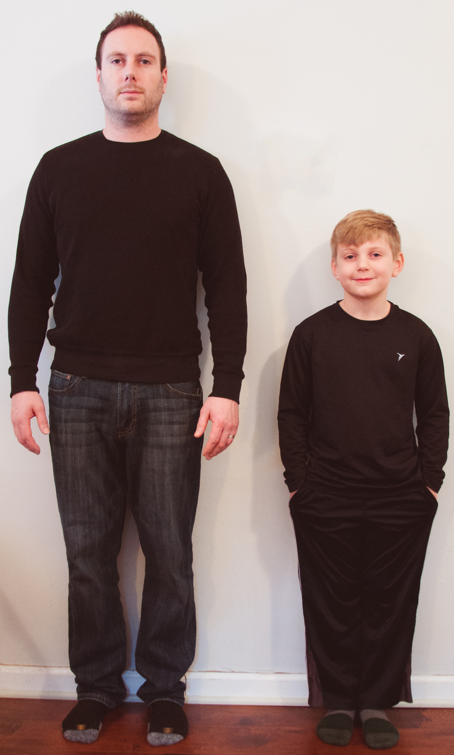
- If the man’s actual height is 5 feet 10 inches, what can you say about the height of the child in this picture?
- Be prepared to explain your reasoning.

8.2: Stories about 9
- Your teacher will give you a set of paper slips with four stories and questions involving the number 9. Match each question to three representations of the solution: a description or a list, a number line, or an inequality statement.
- Compare your matching decisions with another group's. If there are disagreements, discuss until both groups come to an agreement. Then, record your final matching decisions here.
  - A fishing boat can hold fewer than 9 people. How many people ($x$) can it hold?
    - Description or list:
    - Number line:
    - Inequality:
  - Lin needs more than 9 ounces of butter to make cookies for her party. How many ounces of butter ($x$) would be enough?
    - Description or list:
    - Number line:
    - Inequality:
  - A magician will perform her magic tricks only if there are at least 9 people in the audience. For how many people ($x$) will she perform her magic tricks?
    - Description or list:
    - Number line:
    - Inequality:
  - A food scale can measure up to 9 kilograms of weight. What weights ($x$) can the scale measure?
    - Description or list:
    - Number line:
    - Inequality:

8.3: How High and How Low Can It Be?
Here is a picture of a person and a basketball hoop. Based on the picture, what do you think are reasonable estimates for the maximum and minimum heights of the basketball hoop?
- Complete the first blank in each sentence with an estimate, and the second blank with “taller” or “shorter.”
- 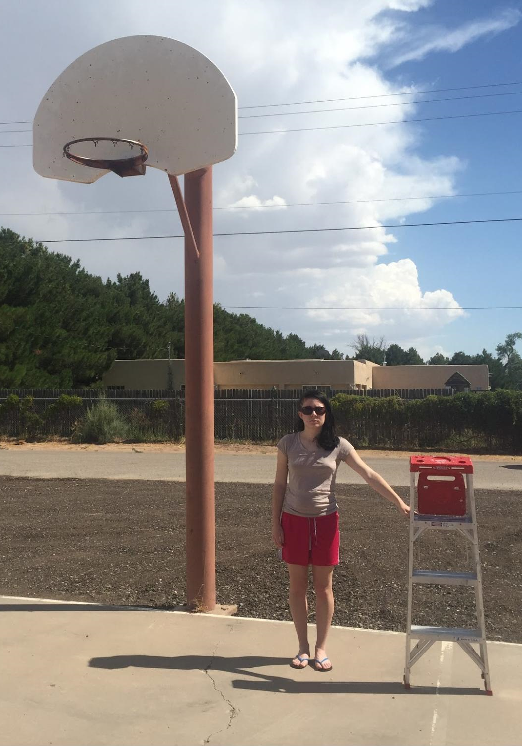
  - I estimate the minimum height of the basketball hoop to be _________ feet; this means the hoop cannot be _____________ than this height.
  - I estimate the maximum height of the basketball hoop to be _________ feet; this means the hoop cannot be _____________ than this height.
- Write two inequalities—one to show your estimate for the minimum height of the basketball hoop, and another for the maximum height. Use an inequality symbol and the variable $h$ to represent the unknown height.
- Plot each estimate for minimum or maximum value on a number line.
  - Minimum:
  - Maximum:
- Suppose a classmate estimated the value of $h$ to be 19 feet. Does this estimate agree with your inequality for the maximum height? Does it agree with your inequality for the minimum height? Explain or show how you know.
- Ask a partner for an estimate of $h$. Record the estimate and check if it agrees with your inequalities for maximum and minimum heights.

Are you ready for more?
- Find 3 different numbers that $a$ could be if $|a|<5$. Plot these points on the number line. Then plot as many other possibilities for $a$ as you can.
- 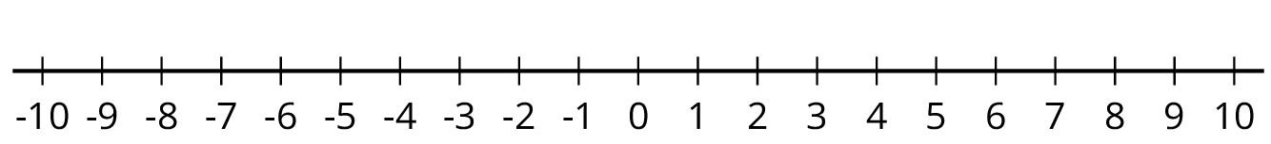
- Find 3 different numbers that $b$ could be if $|b|>3$. Plot these points on the number line. Then plot as many other possibilities for $b$ as you can.

Lesson 8 Summary
An inequality tells us that one value is less than or greater than another value.
Suppose we knew the temperature is less than $3^{∘}\text{F}$, but we don’t know exactly what it is. To represent what we know about the temperature $t$ in $​^{∘}\text{F}$ we can write the inequality: $t<3$
The temperature can also be graphed on a number line. Any point to the left of 3 is a possible value for $t$. The open circle at 3 means that $t$ cannot be equal to 3, because the temperature is less than 3.
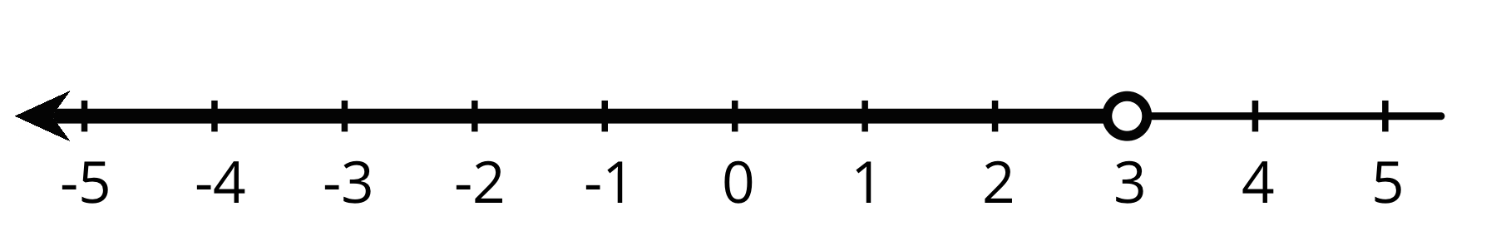
Here is another example. Suppose a young traveler has to be at least 16 years old to fly on an airplane without an accompanying adult.
If $a$ represents the age of the traveler, any number greater than 16 is a possible value for $a$, and 16 itself is also a possible value of $a$. We can show this on a number line by drawing a closed circle at 16 to show that it meets the requirement (a 16-year-old person can travel alone). From there, we draw a line that points to the right.
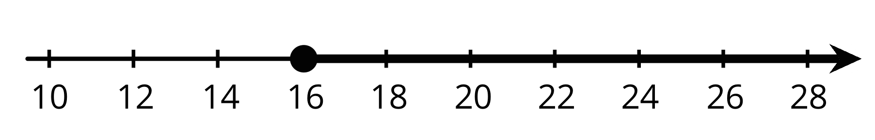
We can also write an inequality and equation to show possible values for $a$: $a>16$ $a=16$
© CC BY Open Up Resources. Adaptations CC BY IM.

