Unit 7 Lesson 16: Dividing Rational Numbers

1 Tell Me Your Sign (Warm up)

Student Task Statement
Consider the equation: $\text{-}27x=\text{-}35$
Without computing:
- Is the solution to this equation positive or negative?
- Are either of these two numbers solutions to the equation?
- $\frac{35}{27}$
- $\text{-}\frac{35}{27}$

2 Multiplication and Division

Student Task Statement
- Find the missing values in the equations
  - $\text{-}3⋅4=\text{?}$
  - $\text{-}3⋅\text{?}=12$
  - $3⋅\text{?}=12$
  - $\text{?}⋅\text{-}4=12$
  - $\text{?}⋅4=\text{-}12$
- Rewrite the unknown factor problems as division problems.
- Complete the sentences. Be prepared to explain your reasoning.
  - The sign of a positive number divided by a positive number is always:
  - The sign of a positive number divided by a negative number is always:
  - The sign of a negative number divided by a positive number is always:
  - The sign of a negative number divided by a negative number is always:
- Han and Clare walk towards each other at a constant rate, meet up, and then continue past each other in opposite directions. We will call the position where they meet up 0 feet and the time when they meet up 0 seconds.
  - Han's velocity is 4 feet per second.
  - Clare's velocity is -5 feet per second.
  - Where is each person 10 seconds before they meet up?
  - When is each person at the position -10 feet from the meeting place?

3 Drilling Down

Student Task Statement
A water well drilling rig has dug to a height of -60 feet after one full day of continuous use.
- Assuming the rig drilled at a constant rate, what was the height of the drill after 15 hours?
- If the rig has been running constantly and is currently at a height of -147.5 feet, for how long has the rig been running?
- Use the coordinate grid to show the drill’s progress.
- 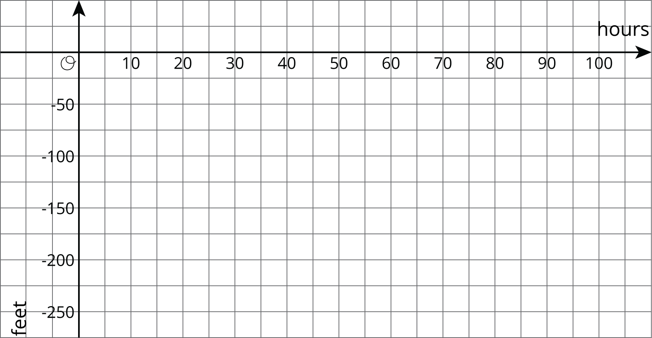
- At this rate, how many hours will it take until the drill reaches -250 feet?
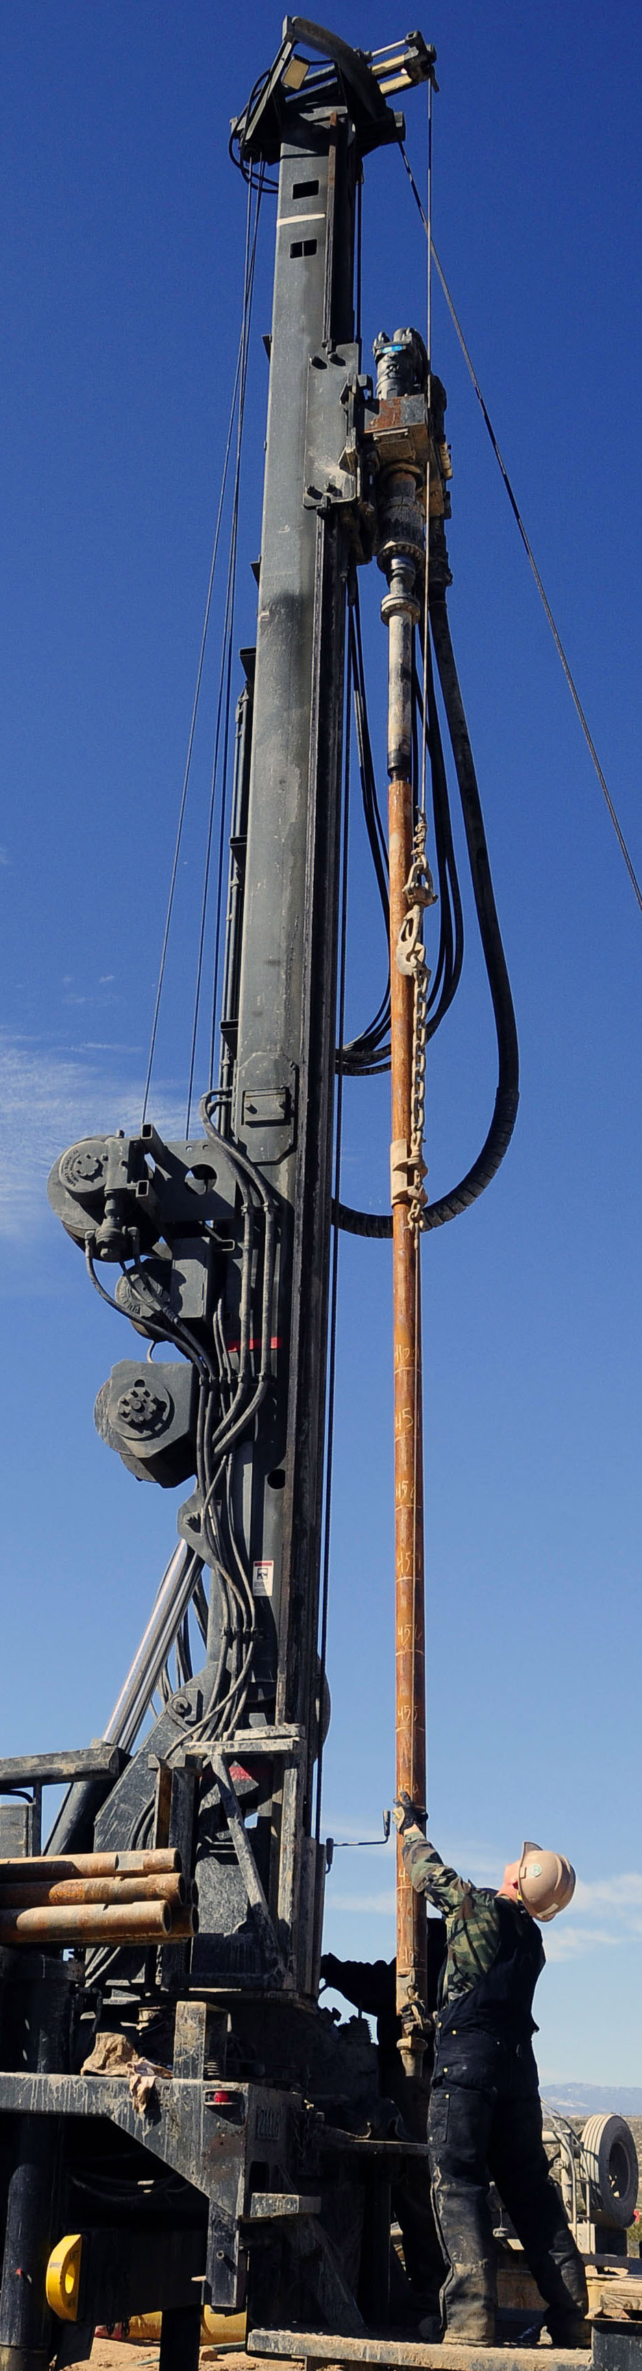

© CC BY Open Up Resources. Adaptations CC BY IM.

