Lesson 5: Explore Math Tools
- Let’s explore our math tools.

Warm-up: Notice and Wonder: Using Different Tools
What do you notice?
What do you wonder?
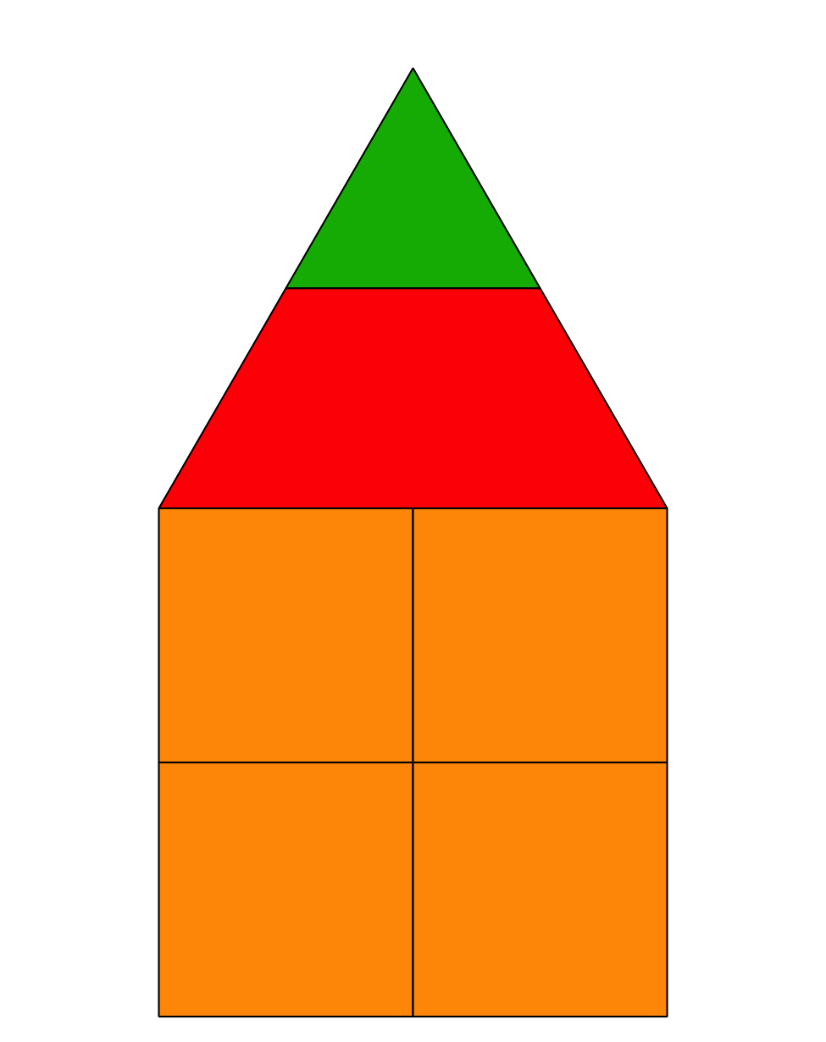
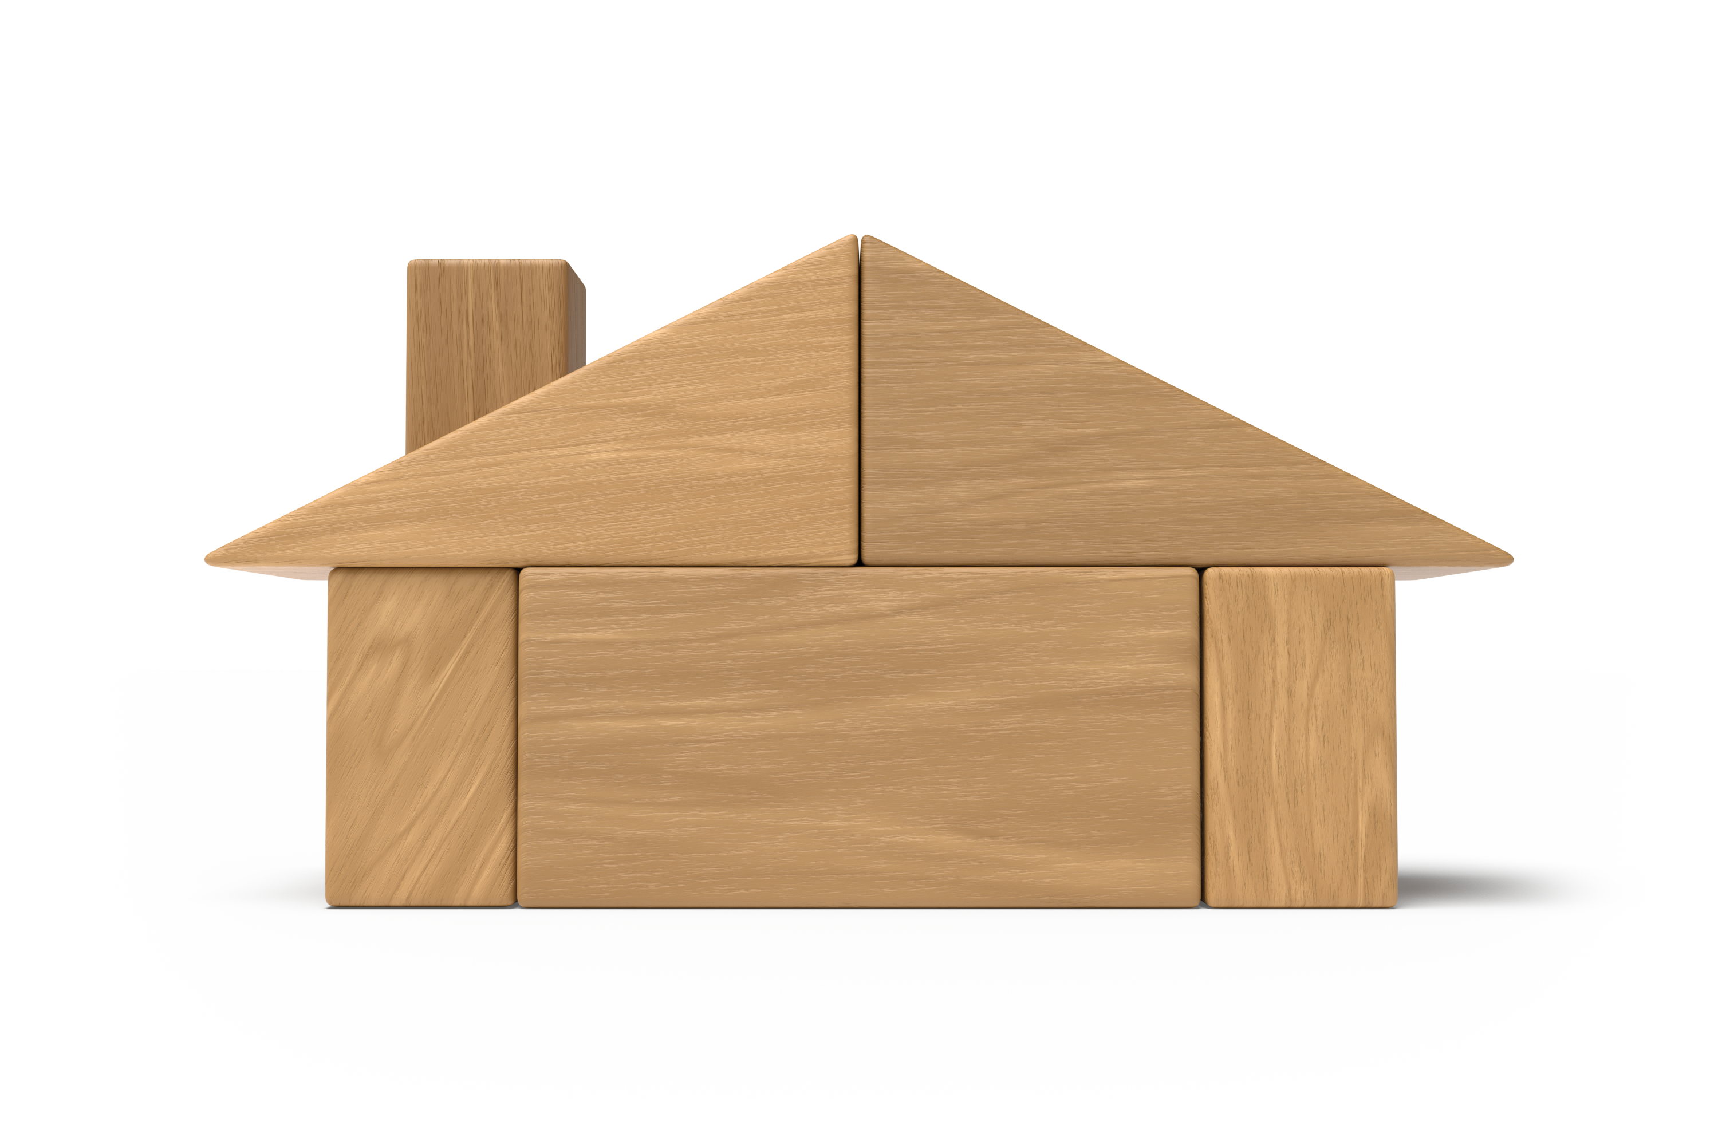
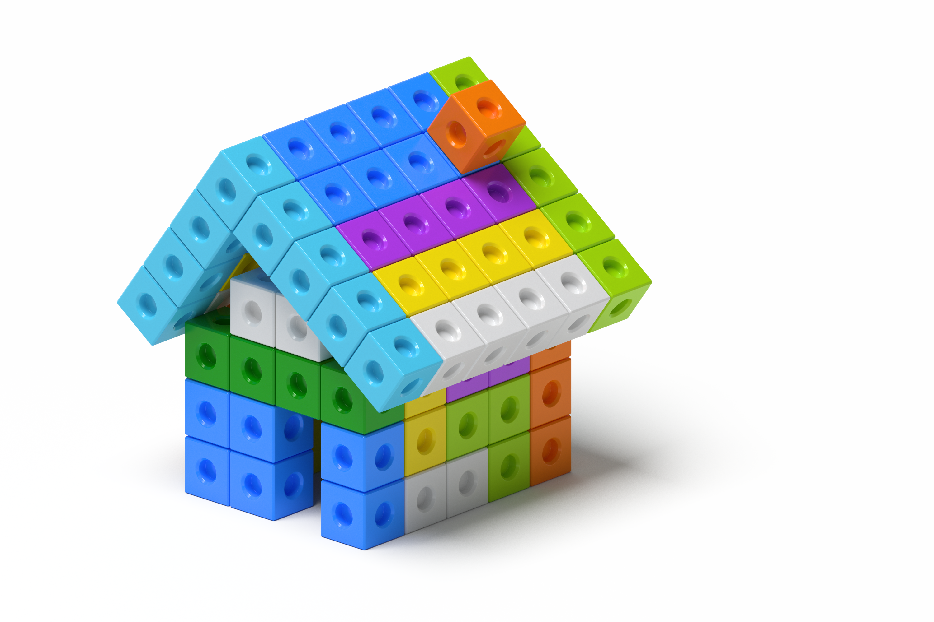

5.1: Introduce Connecting Cubes, Build to Match
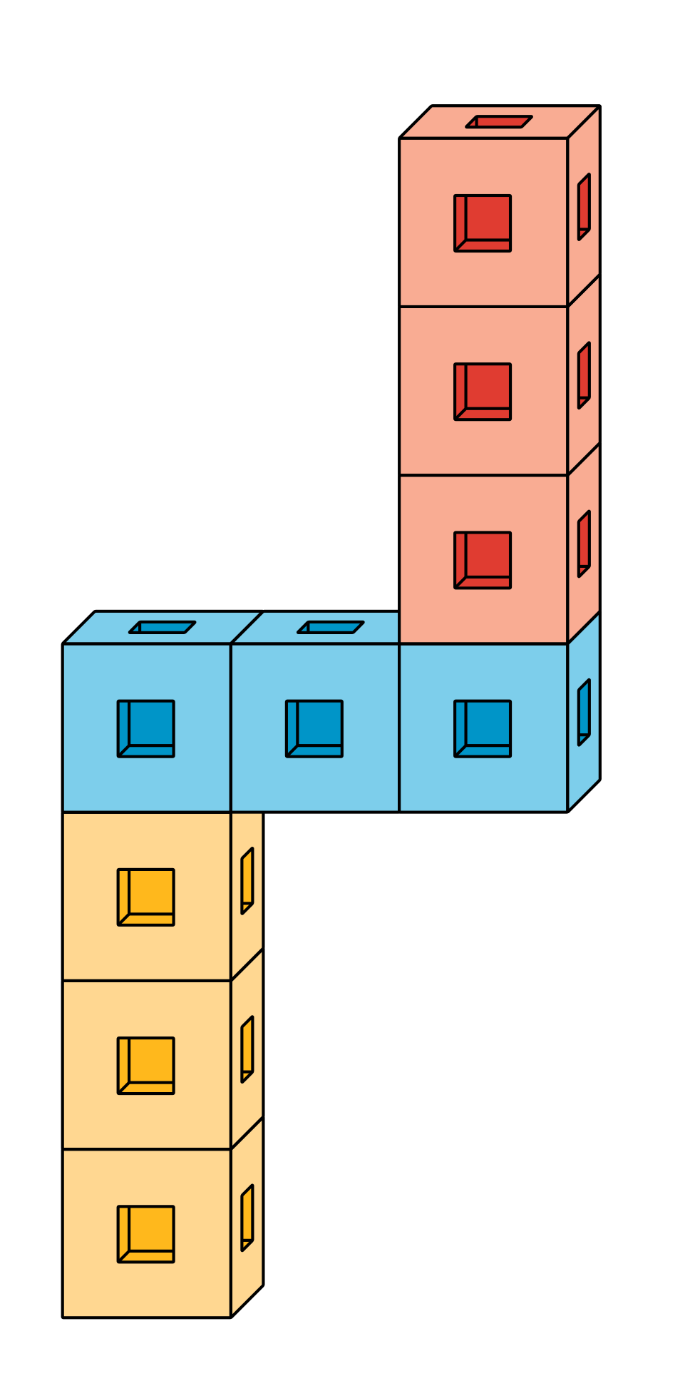

5.2: Introduce Pattern Blocks, Puzzles
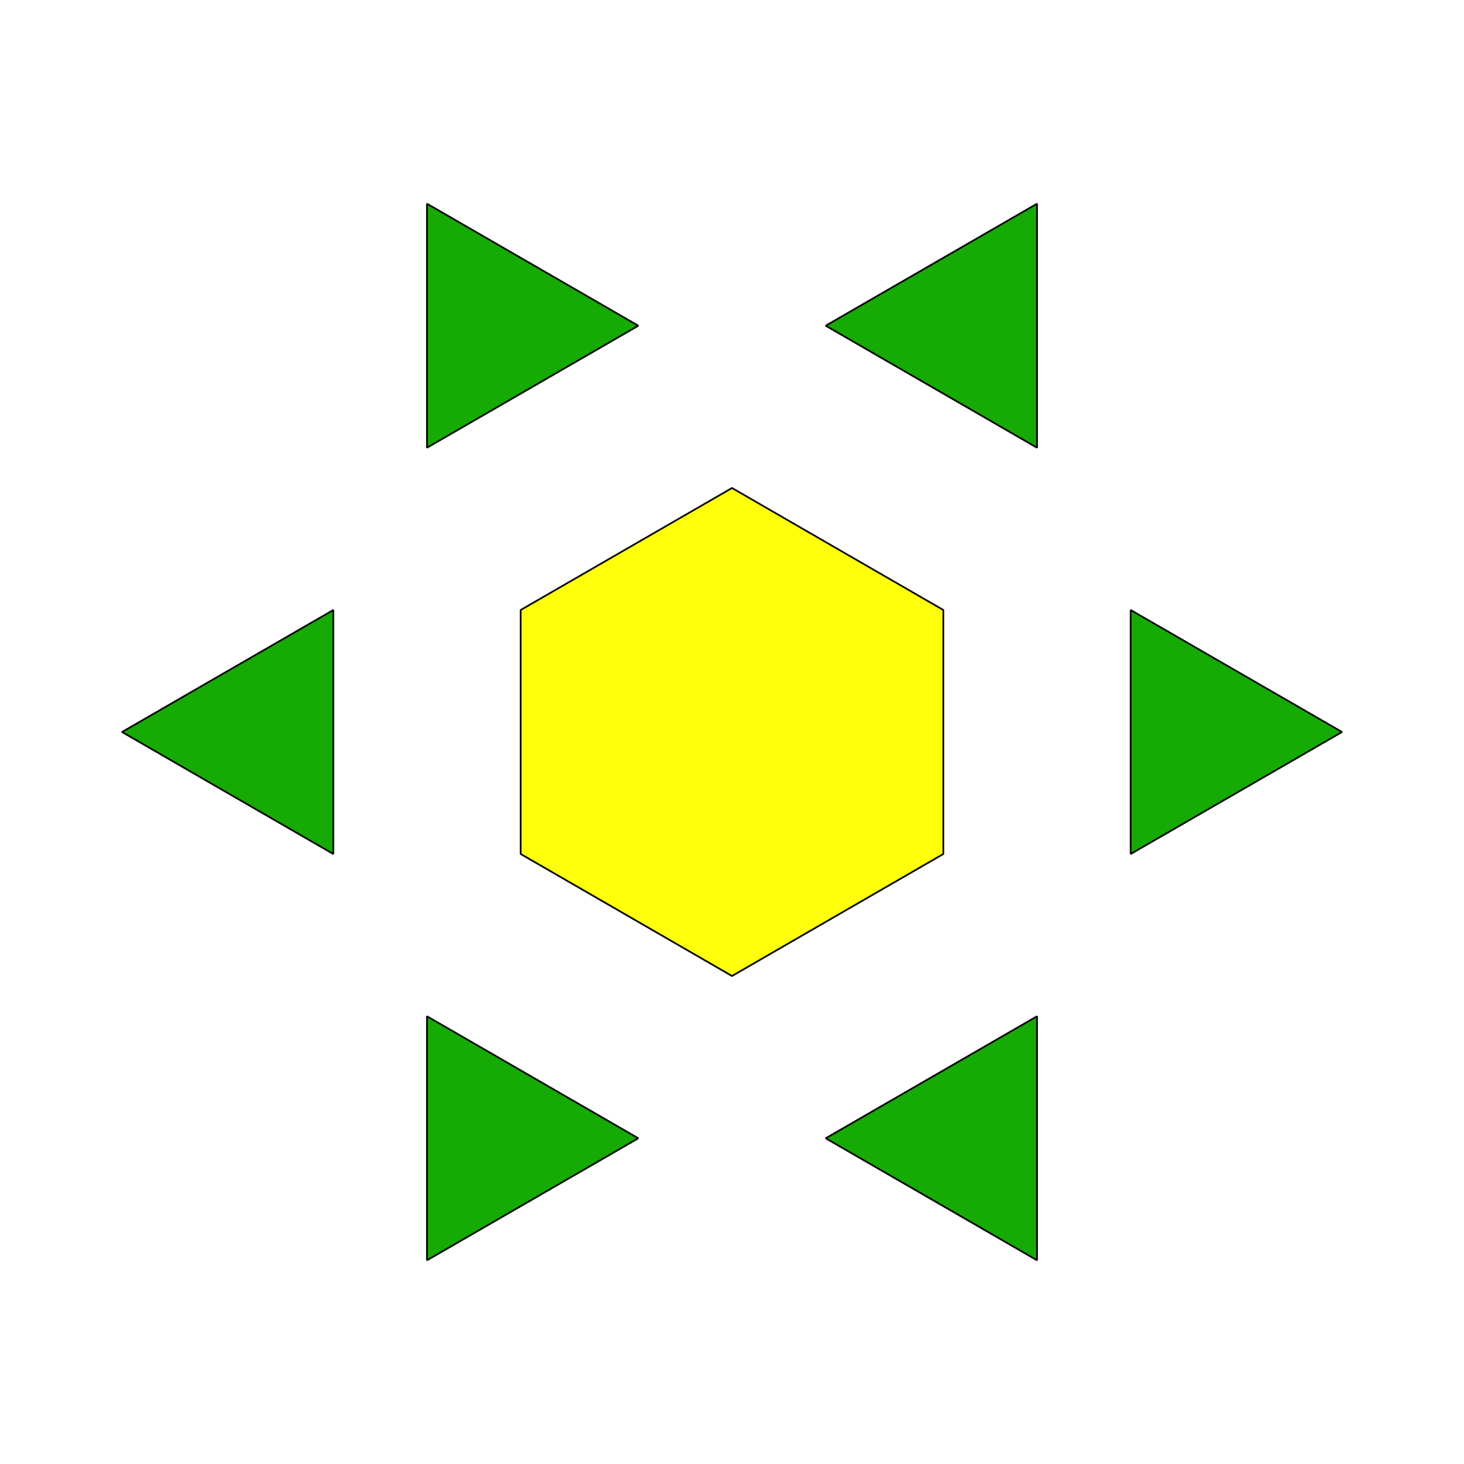

5.3: Centers: Choice Time
Choose a center.
Geoblocks
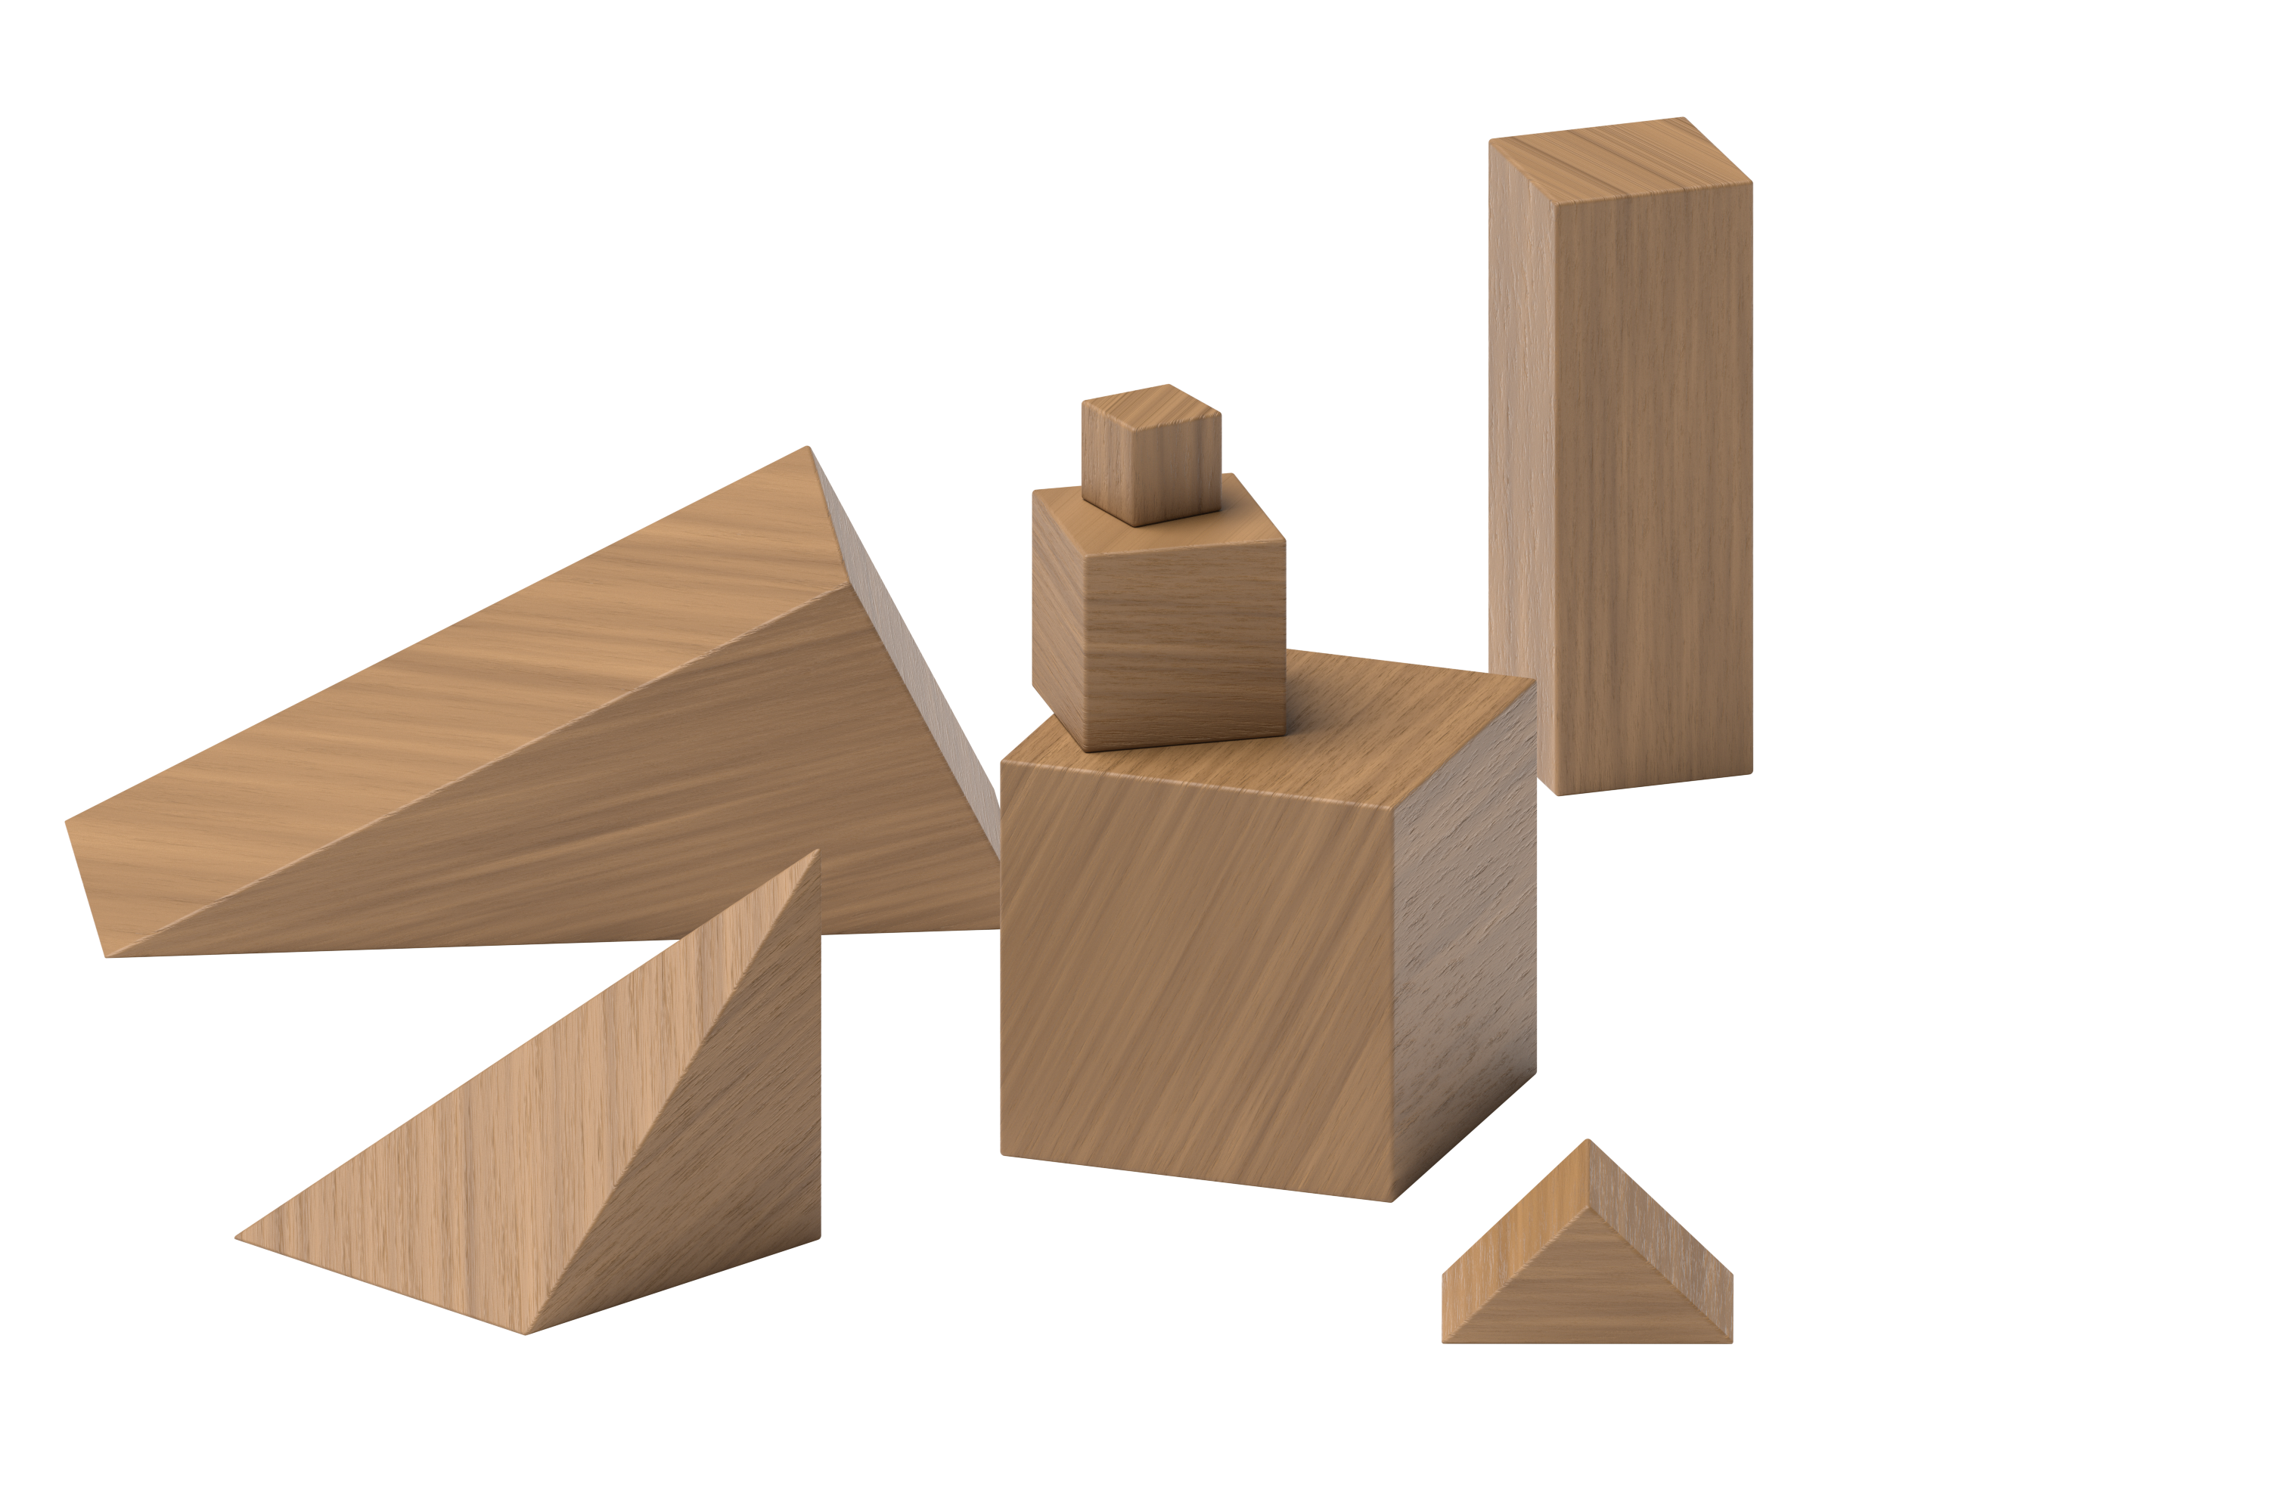
Connecting Cubes
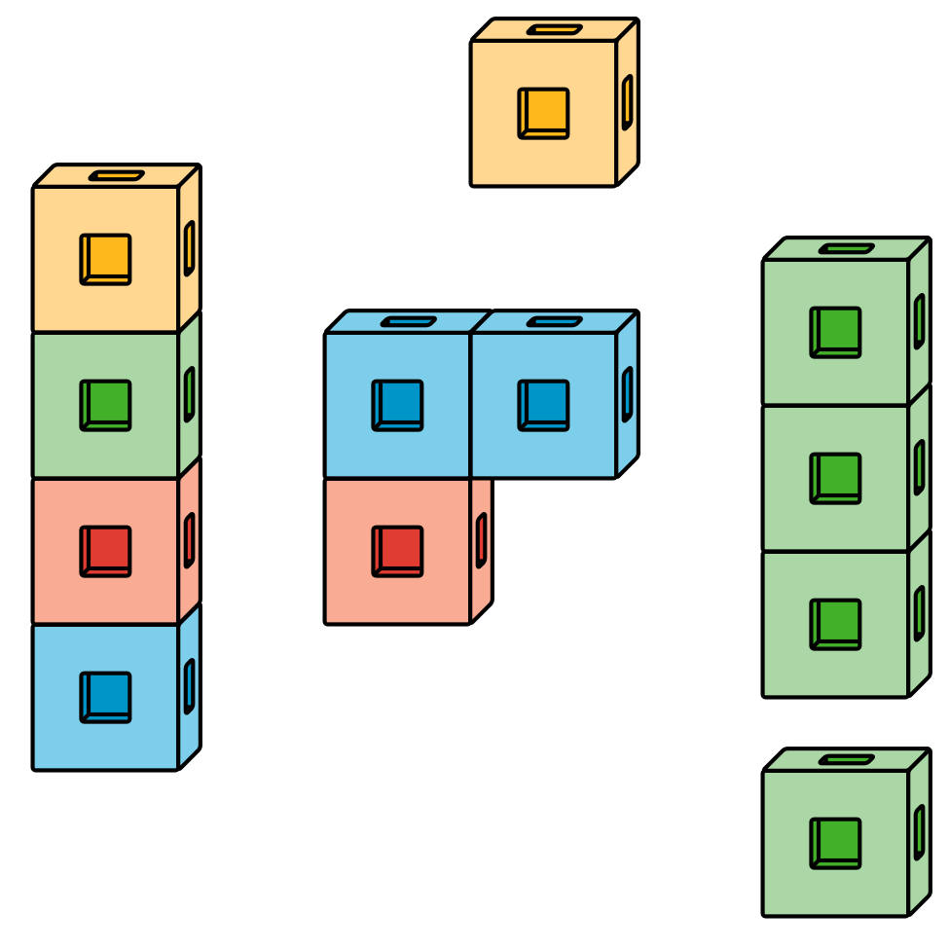
Pattern Blocks
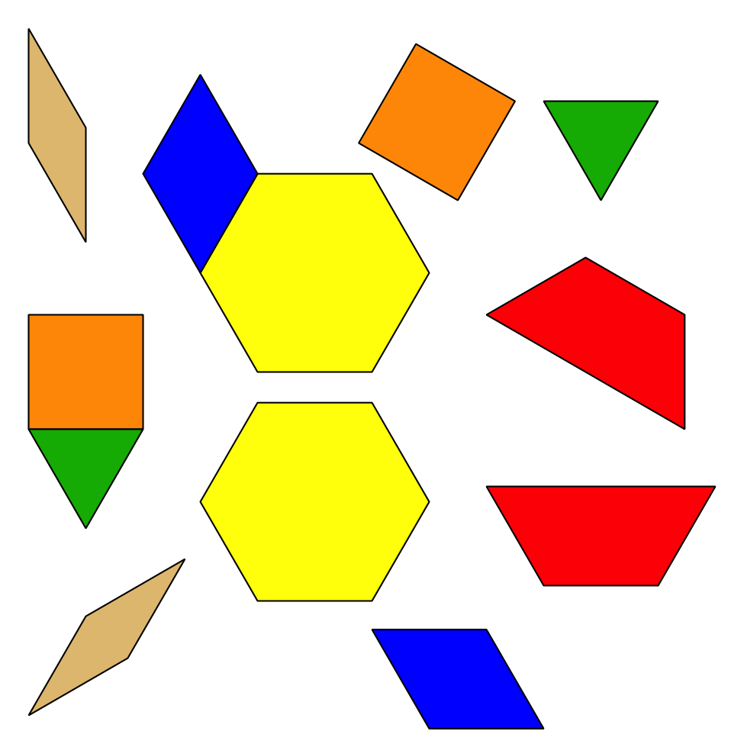

Section Summary
Section Summary
We explored many math tools.
Connecting cubes
Pattern blocks
Geoblocks
Two-color counters
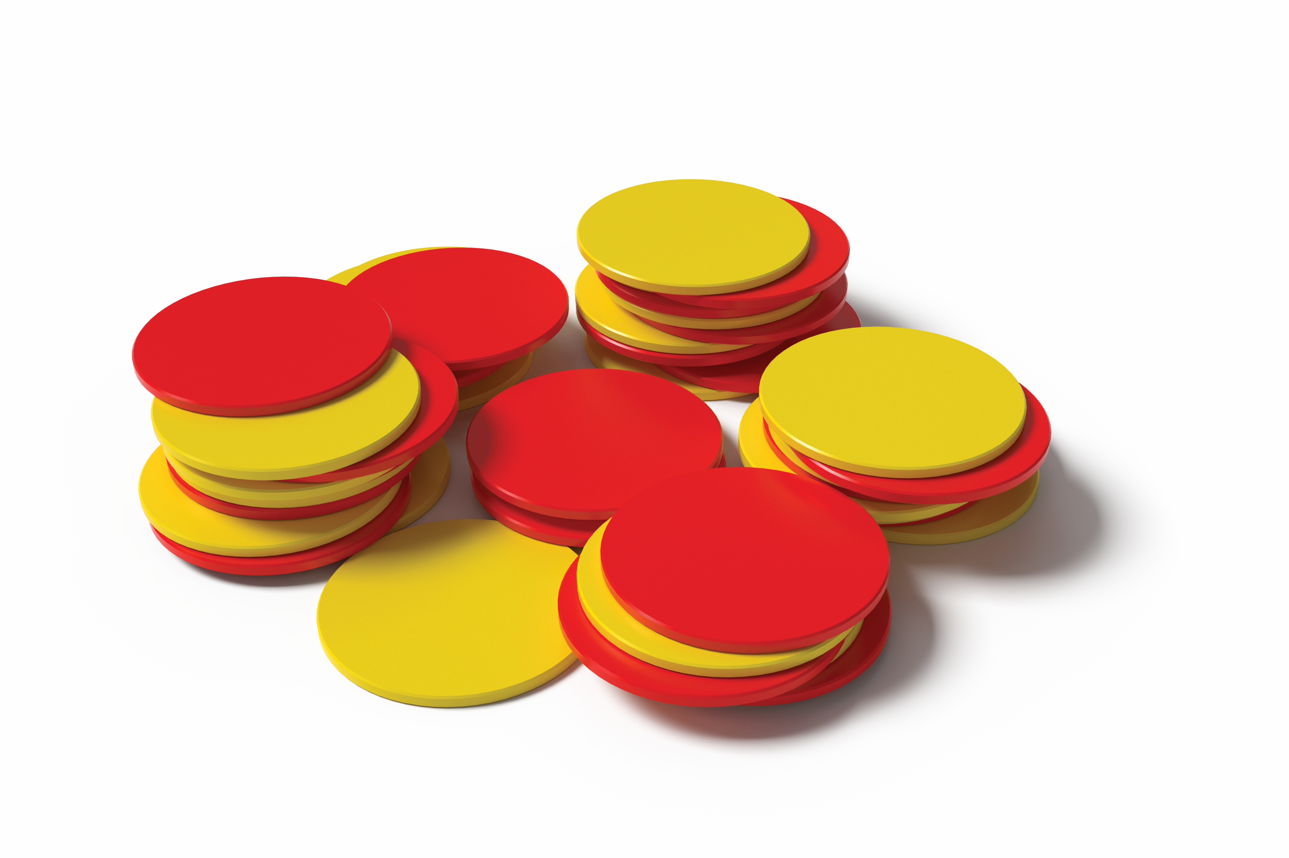
5-frames
© CC BY 2021 Illustrative Mathematics®

