Lesson 12: Defining Translations
- Let’s translate some figures.

12.1: Notice and Wonder: Two Triangles and an Arrow
What do you notice? What do you wonder?
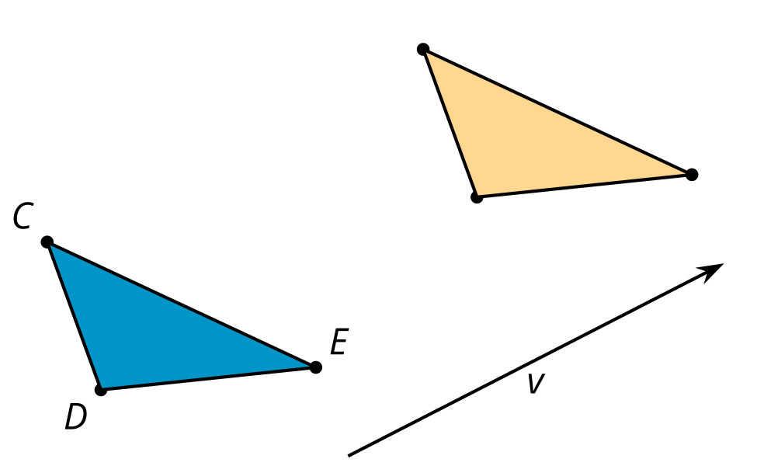

12.2: What’s the Point: Translations
- After a translation, the image of $V$ is $W$. Find at least 3 other points that are taken to a labeled point by that translation.
- Write at least 1 conjecture about translations.
- In a new translation, the image of $V$ is $Z$. Find at least 3 other points that are taken to a labeled point by the new translation.
- Are your conjectures still true for the new translation?

12.3: Translating Triangles
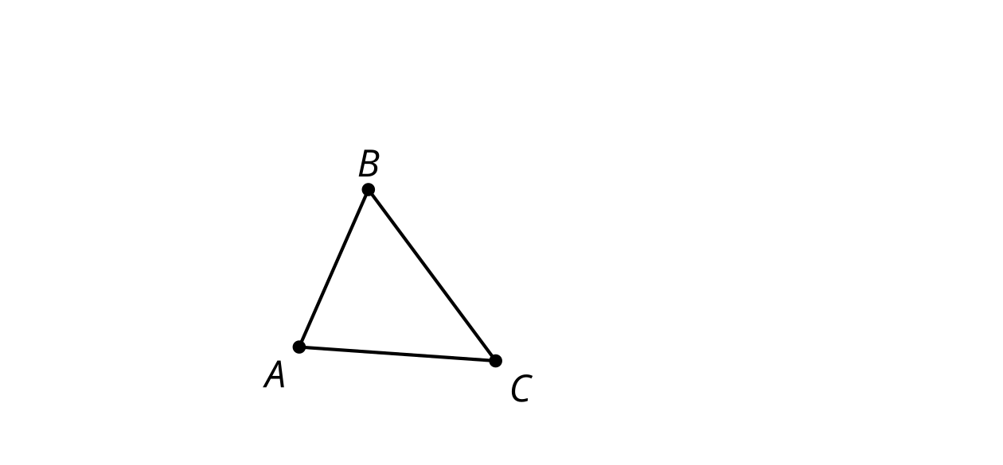
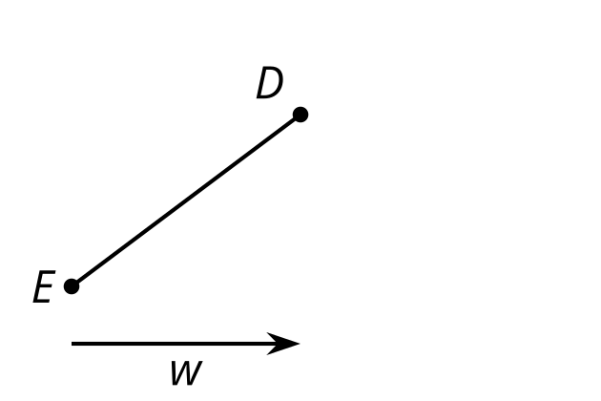
- Translate triangle $ABC$ by the directed line segment from $A$ to $C$.
  - What is the relationship between line $BC$ and line $B^{′}C^{′}$? Explain your reasoning.
  - How does the length of segment $BC$ compare to the length of segment $B^{′}C^{′}$? Explain your reasoning.
- Translate segment $DE$ by directed line segment $w$. Label the new endpoints $D^{′}$ and $E^{′}$.
  - Connect $D$ to $D^{′}$ and $E$ to $E^{′}$.
  - What kind of shape did you draw? What properties does it have? Explain your reasoning.

Are you ready for more?
- On triangle $ABC$ in the task, use a straightedge and compass to construct the line which passes through $A$ and is perpendicular to $AC$. Label it $ℓ$. Then, construct the perpendicular bisector of $AC$ and label it $m$. Draw the reflection of $ABC$ across the line $ℓ$. Since the label $A^{′}B^{′}C^{′}$ is used already, label it $DEF$ instead.
- What is the reflection of $DEF$ across the line $m$?
- Explain why this is cool.

Lesson 12 Summary
A translation slides a figure in a given direction for a given distance with no rotation. The distance and direction is given by a directed line segment. The arrow of the directed line segment specifies the direction of the translation, and the length of the directed line segment specifies how far the figure gets translated.
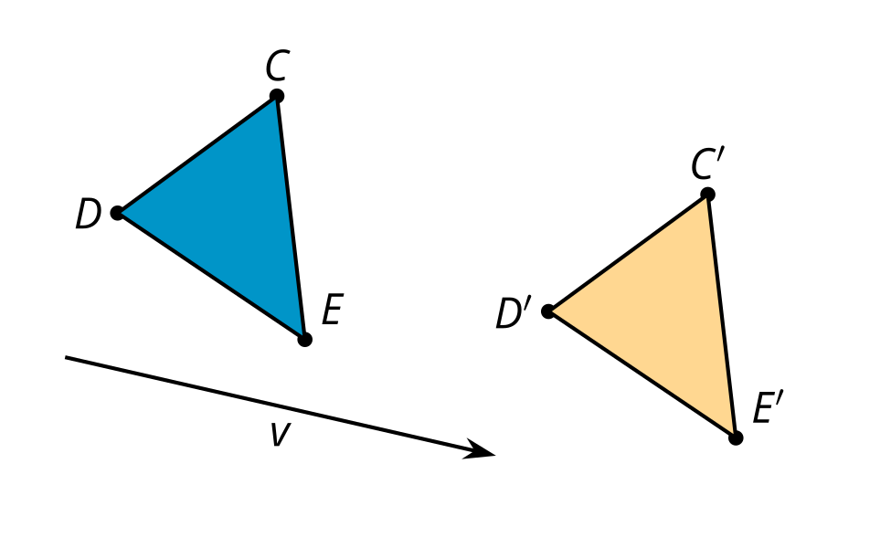
More precisely, a translation of a point $A$ along a directed line segment $t$ is a transformation that takes $A$ to $A^{′}$ so that the directed line segment $AA^{′}$ is parallel to $t$, goes in the same direction as $t$, and is the same length as $t$.
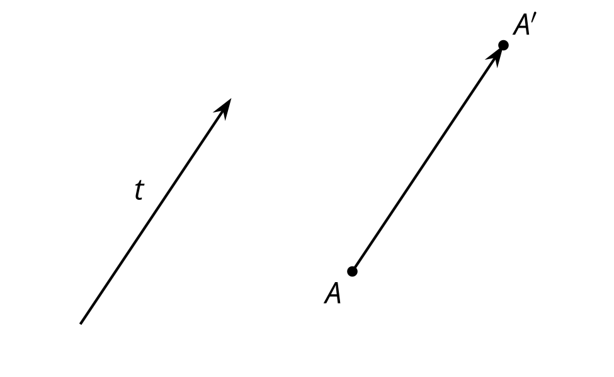
Here is a translation of 3 points. Notice that the directed line segments $CC^{′}$, $DD^{′}$, and $EE^{′}$ are each parallel to $v$, going in the same direction as $v$, and the same length as $v$.
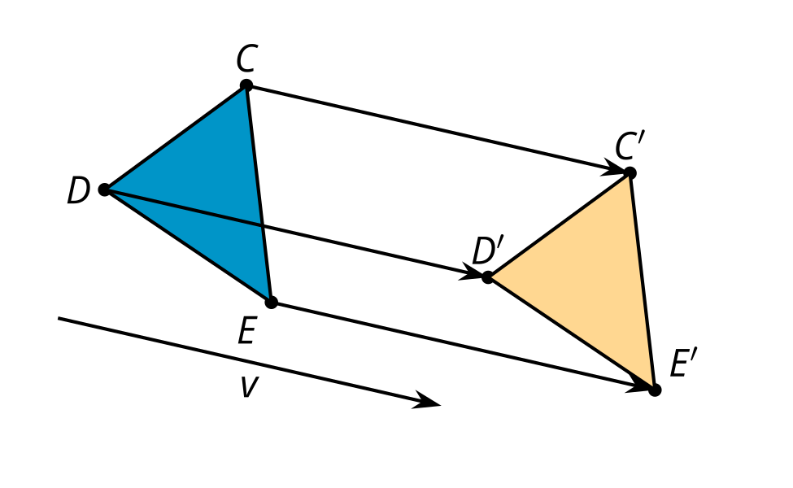
© CC BY 2019 by Illustrative Mathematics®

