Unit 2 Lesson 2: Introducing Proportional Relationships with Tables

1 Notice and Wonder: Paper Towels by the Case (Warm up)

Student Task Statement
Here is a table that shows how many rolls of paper towels a store receives when they order different numbers of cases.
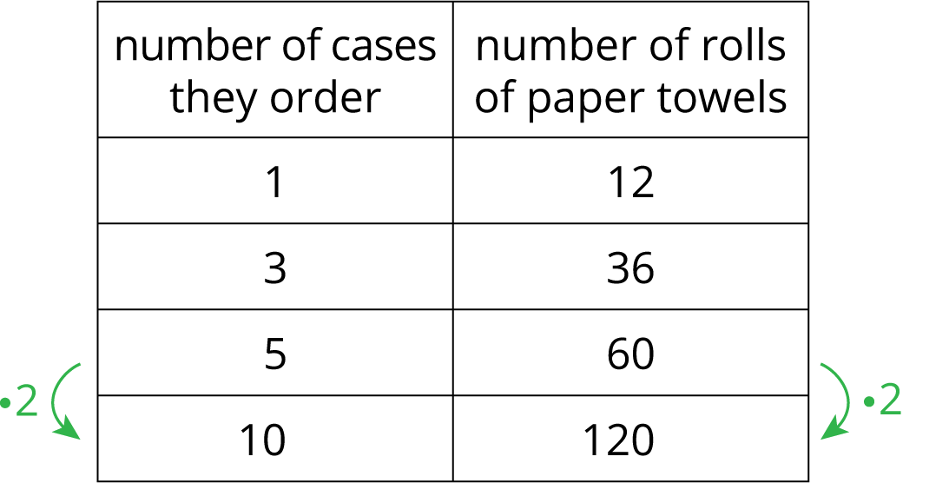
What do you notice about the table? What do you wonder?

2 Feeding a Crowd

Images for Launch
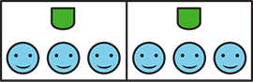

Student Task Statement
- A recipe says that 2 cups of dry rice will serve 6 people. Complete the table as you answer the questions. Be prepared to explain your reasoning.
  - How many people will 10 cups of rice serve?
  - How many cups of rice are needed to serve 45 people?
- cups of rice | - number of people
- 2 | - 6
- 3 | - 9
- 10
 | - 45
- A recipe says that 6 spring rolls will serve 3 people. Complete the table.
- number of spring rolls | - number of people
- 6 | - 3
- 30
- 40
 | - 28

3 Making Bread Dough

Student Task Statement
A bakery uses 8 tablespoons of honey for every 10 cups of flour to make bread dough. Some days they bake bigger batches and some days they bake smaller batches, but they always use the same ratio of honey to flour. Complete the table as you answer the questions. Be prepared to explain your reasoning.
- How many cups of flour do they use with 20 tablespoons of honey?
- How many cups of flour do they use with 13 tablespoons of honey?
- How many tablespoons of honey do they use with 20 cups of flour?
- What is the proportional relationship represented by this table?
honey (tbsp) | flour (c)
8 | 10
20
13
 | 20

4 Quarters and Dimes (Optional)

Student Task Statement
4 quarters are equal in value to 10 dimes.
- How many dimes equal the value of 6 quarters?
- How many dimes equal the value of 14 quarters?
- What value belongs next to the 1 in the table? What does it mean in this context?
number of  quarters | number of  dimes
1
4 | 10
6
14
© CC BY Open Up Resources. Adaptations CC BY IM.

