Lesson 2: Explore Pattern Blocks
- Let’s explore pattern blocks.

Warm-up: Notice and Wonder: Pattern Blocks
What do you notice?
What do you wonder?
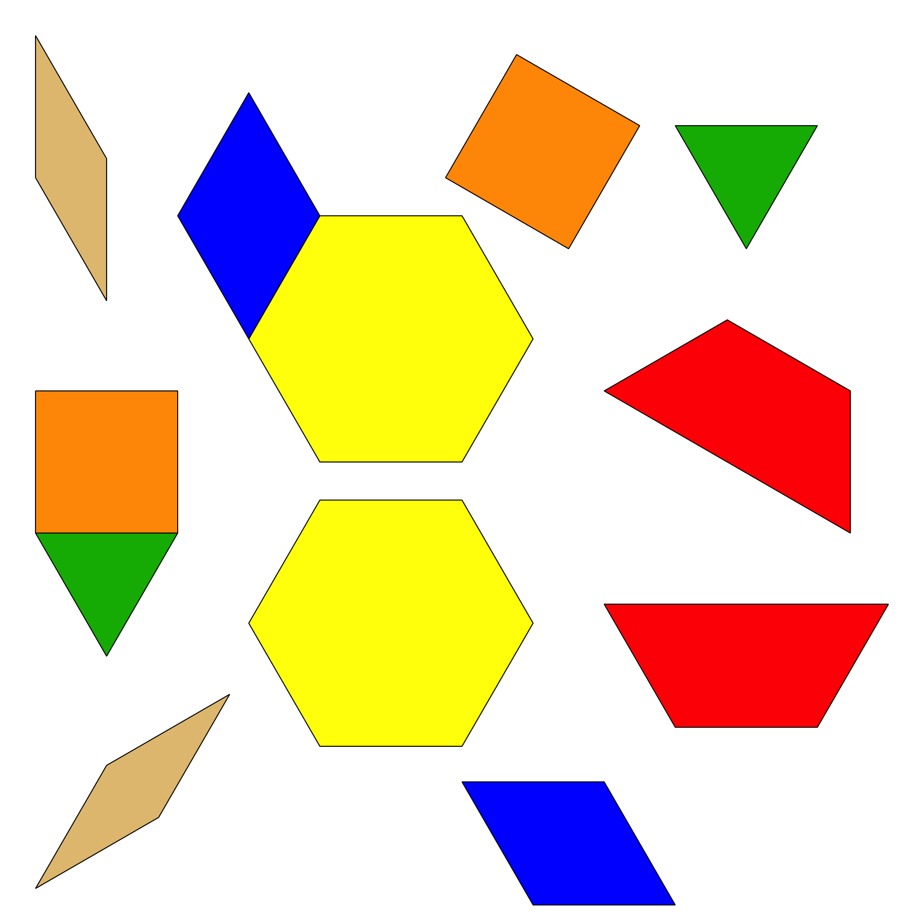
© CC BY 2021 Illustrative Mathematics®

