Unit 2 Lesson 22: The Pizzeria

WU Notice and Wonder: Pizza Toppings (Warm up)

Student Task Statement
What do you notice?
What do you wonder?
Jada's Pizza
Diego's Pizza
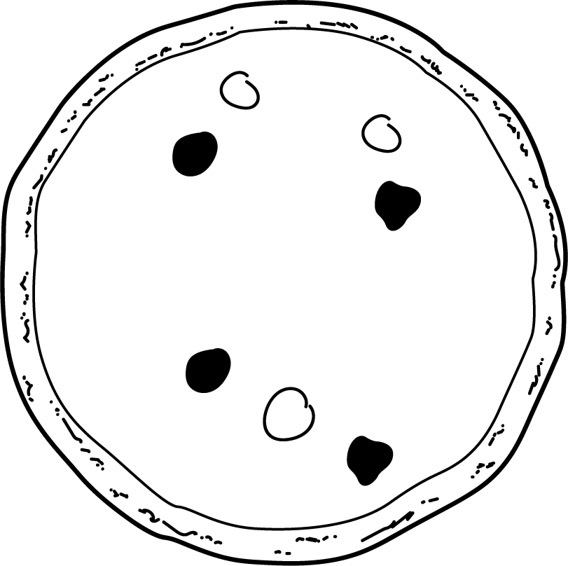
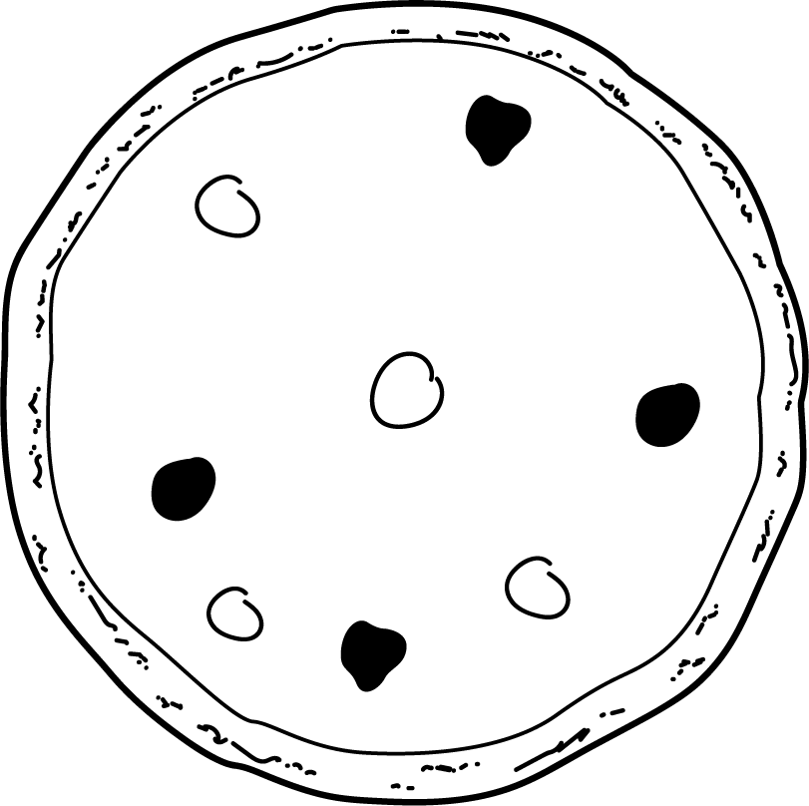

1 Class Pizza Order

Student Task Statement
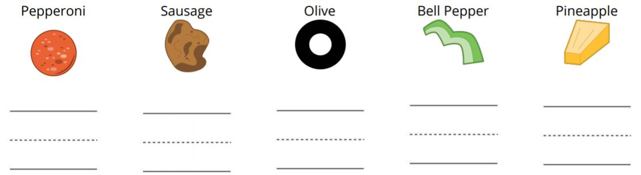
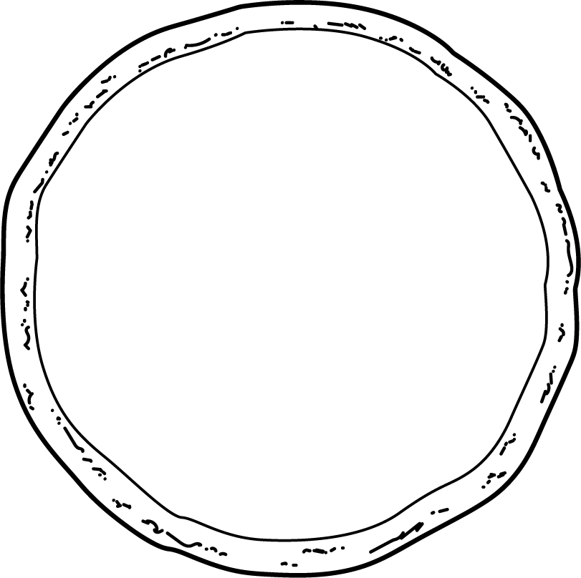

2 More Pizza Orders

Student Task Statement
© CC BY 2021 Illustrative Mathematics®

