Lesson 11: A New Way to Measure Angles
- Let’s look at a new way to measure angles.

11.1: A One-Unit Radius
A circle has radius 1 unit. Find the length of the arc defined by each of these central angles. Give your answers in terms of $π$.
- 180 degrees
- 45 degrees
- 270 degrees
- 225 degrees
- 360 degrees

11.2: A Constant Ratio
Diego and Lin are looking at 2 circles.
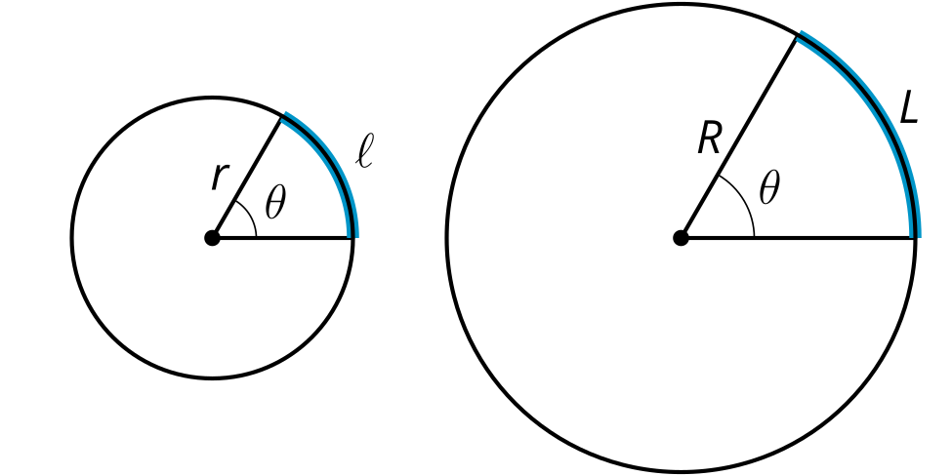
Diego says, “It seems like for a given central angle, the arc length is proportional to the radius. That is, the ratio $\frac{ℓ}{r}$ has the same value as the ratio $\frac{L}{R}$ because they have the same central angle measure. Can we prove that this is true?”
Lin says, “The big circle is a dilation of the small circle. If $k$ is the scale factor, then $R=kr$.”
Diego says, “The arc length in the small circle is $ℓ=\frac{θ}{360}⋅2πr$. In the large circle, it’s $L=\frac{θ}{360}⋅2πR$. We can rewrite that as $L=\frac{θ}{360}⋅2πrk$. So $L=kℓ$.”
Lin says, “Okay, from here I can show that $\frac{ℓ}{r}$ and $\frac{L}{R}$ are equivalent.”
- How does Lin know that the big circle is a dilation of the small circle?
- How does Lin know that $R=kr$?
- Why could Diego write $ℓ=\frac{θ}{360}⋅2πr$?
- When Diego says that $L=kℓ$, what does that mean in words?
- Why could Diego say that $L=kℓ$?
- How can Lin show that $\frac{ℓ}{r}=\frac{L}{R}$?

11.3: Defining Radians
Suppose we have a circle that has a central angle. The radian measure of the angle is the ratio of the length of the arc defined by the angle to the circle’s radius. That is, $θ=\frac{\text{arc length}}{\text{radius}}$.
- The image shows a circle with radius 1 unit.
- 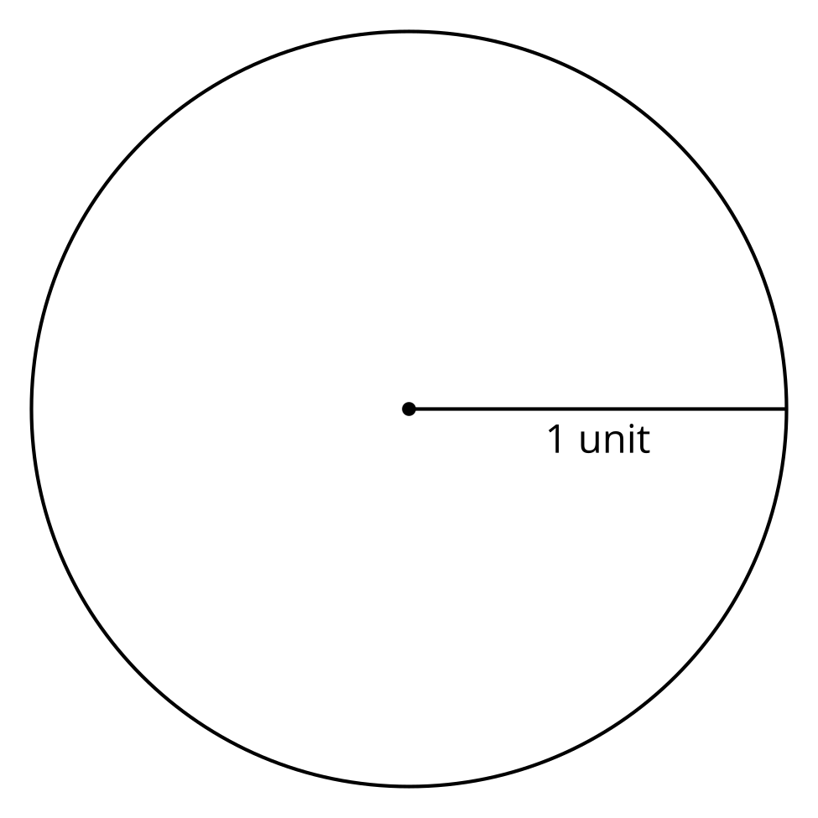
  - Cut a piece of string that is the length of the radius of this circle.
  - Use the string to mark an arc on the circle that is the same length as the radius.
  - Draw the central angle defined by the arc.
  - Use the definition of radian to calculate the radian measure of the central angle you drew.
- Draw a 180 degree central angle (a diameter) in the circle. Use your 1-unit piece of string to measure the approximate length of the arc defined by this angle.
- Calculate the radian measure of the 180 degree angle. Give your answer both in terms of $π$ and as a decimal rounded to the nearest hundredth.
- Calculate the radian measure of a 360 degree angle.

Are you ready for more?
Research where the “360” in 360 degrees comes from. Why did people choose to define a degree as $\frac{1}{360}$ of the circumference of a circle?

Lesson 11 Summary
Degrees are one way to measure the size of an angle. Radians are another way to measure angles. Assume an angle’s vertex is the center of a circle. The radian measure of the angle is the ratio between the length of the arc defined by the angle and the radius of the circle. We can write this as $θ=\frac{\text{arc length}}{\text{radius}}$. This ratio is constant for a given angle, no matter the size of the circle.
Consider a 180 degree central angle in a circle with radius 3 units. The arc length defined by the angle is $3π$ units. The radian measure of the angle is the ratio of the arc length to the radius, which is $π$ radians because $\frac{3π}{3}=π$.
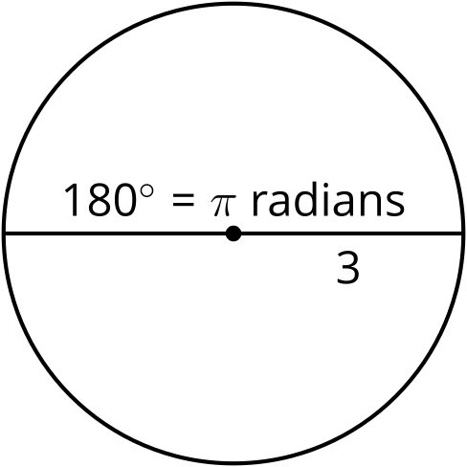
Another way to think of the radian measure of the angle is that it measures the number of radii that would make up the length of the arc defined by the angle. For example, if we draw an arc that is the same length as the radius, both the arc length and the radius are 1 unit. The radian measure of the central angle that defines this arc is the quotient of those values, or 1 radian.
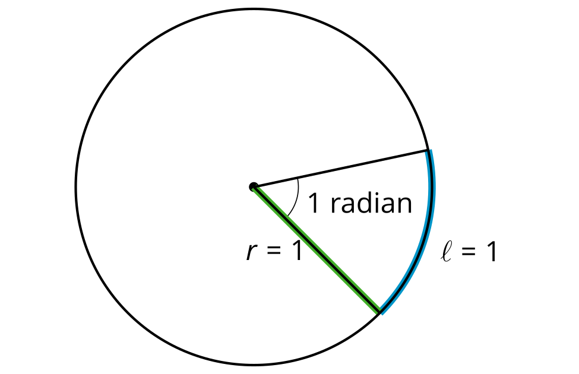
© CC BY 2019 by Illustrative Mathematics®

