Lesson 7: Sort Math Tools
- Let’s sort objects and describe how many.

Warm-up: Notice and Wonder: Math Tools
What do you notice?
What do you wonder?
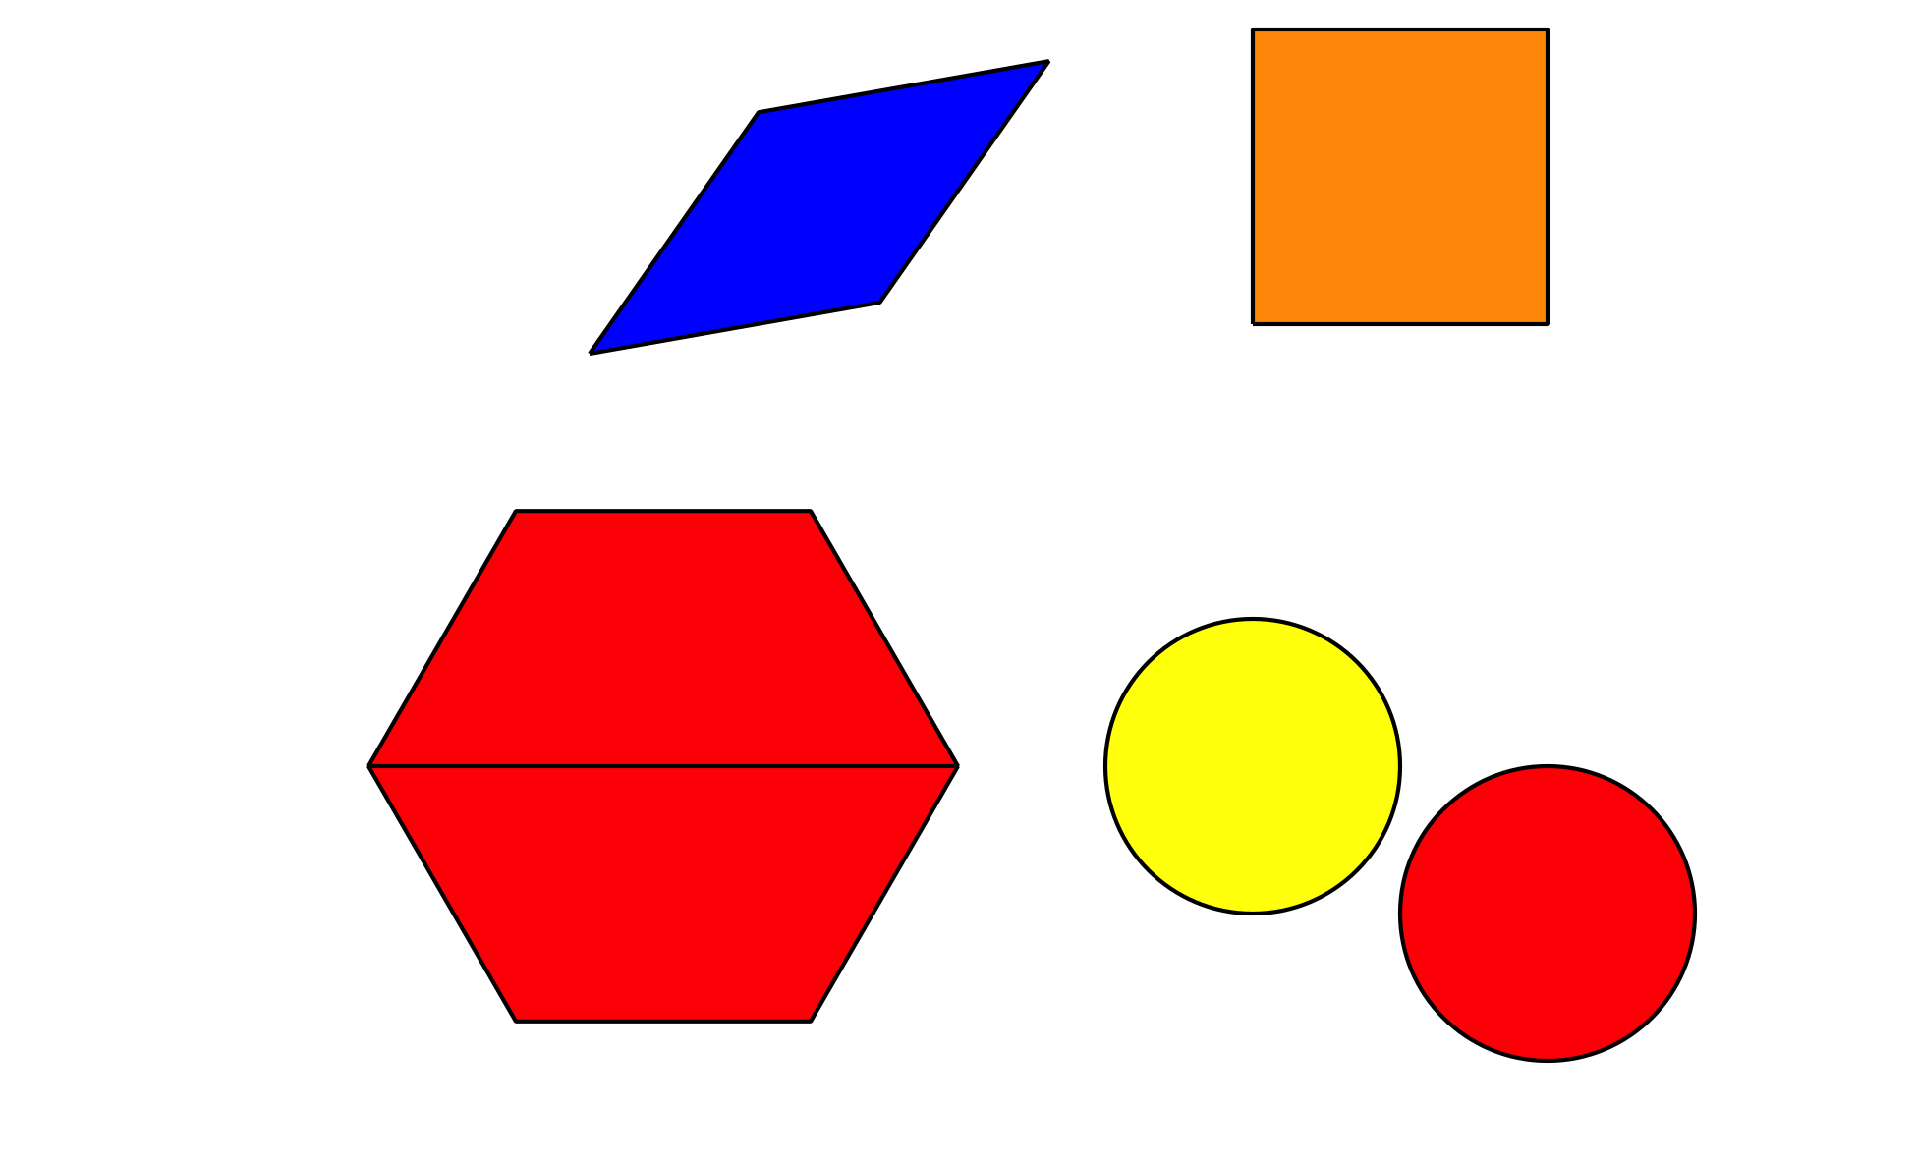

7.3: Centers: Choice Time
Choose a center.
Counting Collections
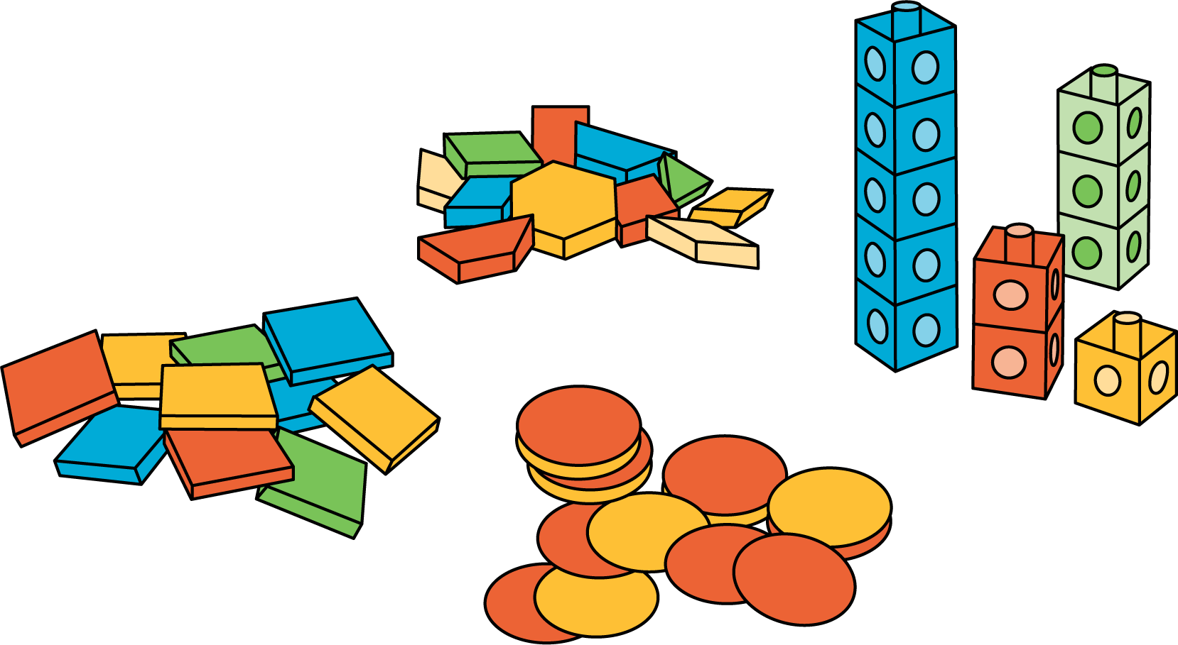
Number Race
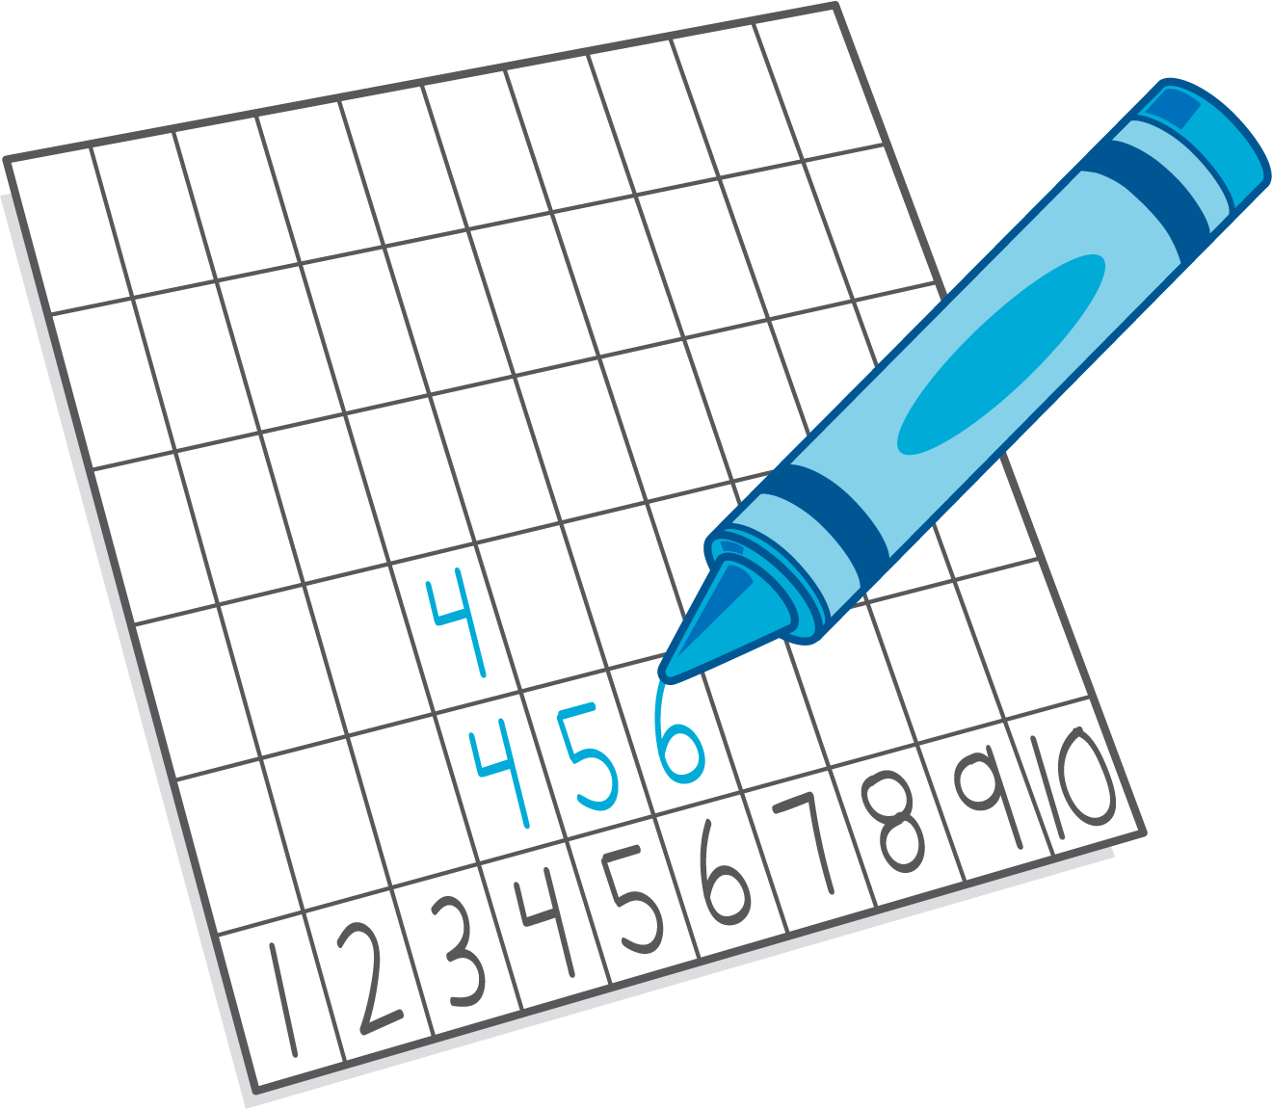
Check it Off
Five in a Row: Addition and Subtraction
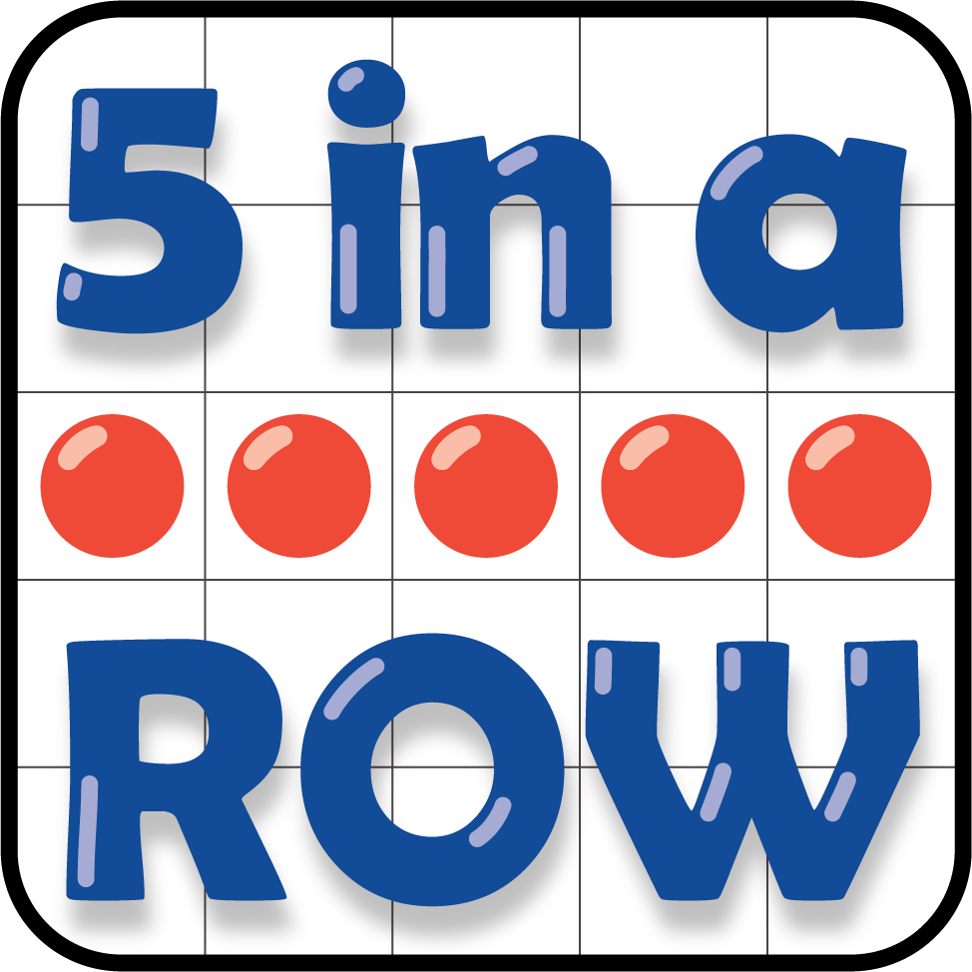
Find the Pair
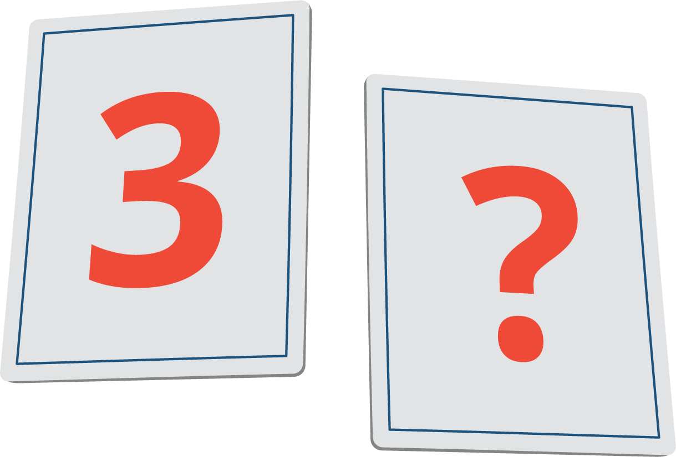
© CC BY 2021 Illustrative Mathematics®

