Unit 4 Lesson 9: Comparing Graphs

1 Population Growth (Warm up)

Student Task Statement
This graph shows the populations of Baltimore and Cleveland in the 20th century. $B(t)$ is the population of Baltimore in year $t$. $C(t)$ is the population of Cleveland in year $t$.
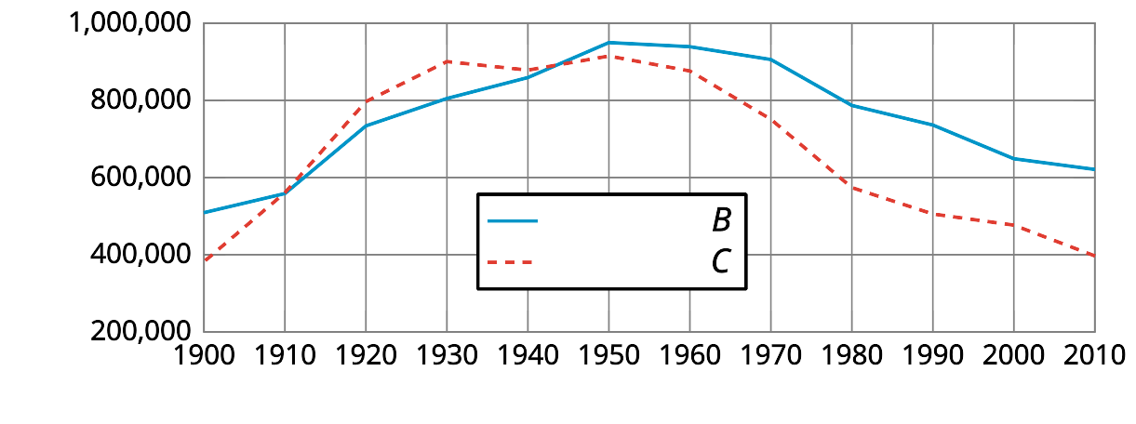
- Estimate $B(1930)$ and explain what it means in this situation.
- Here are pairs of statements about the two populations. In each pair, which statement is true? Be prepared to explain how you know.
  - $B(2000)>C(2000)$ or $B(2000)<C(2000)$
  - $B(1900)=C(1900)$ or $B(1900)>C(1900)$
- Were the two cities’ populations ever the same? If so, when?

2 Wired or Wireless?

Student Task Statement
$H(t)$ is the percentage of homes in the United States that have a landline phone in year $t$. $C(t)$ is the percentage of homes with only a cell phone. Here are the graphs of $H$ and $C$.
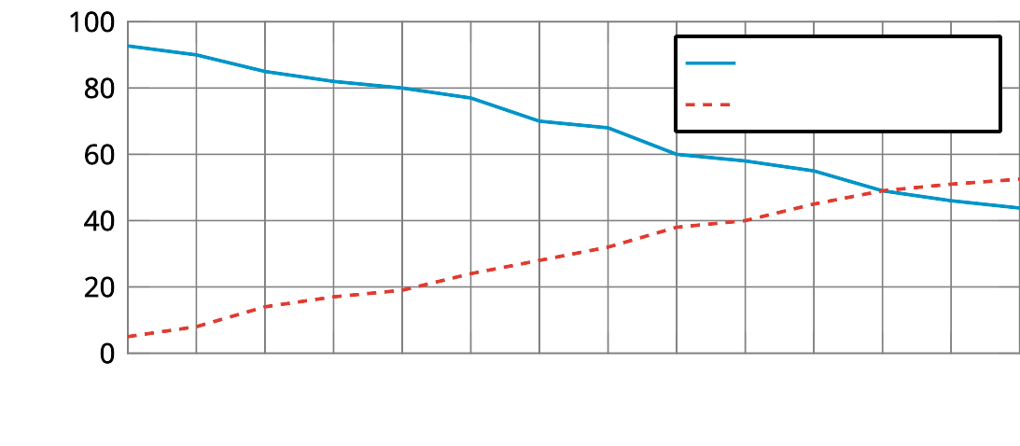
- Estimate $H(2006)$ and $C(2006)$. Explain what each value tells us about the phones.
- What is the approximate solution to $C(t)=20$? Explain what the solution means in this situation.
- Determine if each equation is true. Be prepared to explain how you know.
  - $C(2011)=H(2011)$
  - $C(2015)=H(2015)$
- Between 2004 and 2015, did the percentage of homes with landlines decrease at the same rate at which the percentage of cell-phones-only homes increased? Explain or show your reasoning.

3 Audience of TV Shows (Optional)

Student Task Statement
The number of people who watched a TV episode is a function of that show’s episode number. Here are three graphs of three functions—$A,B$, and $C$—representing three different TV shows.

Show A
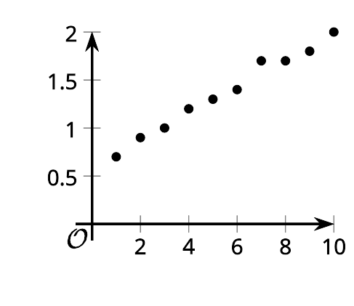

Show B
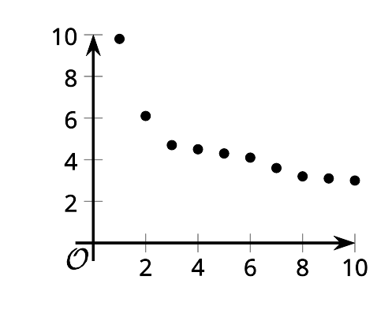

Show C
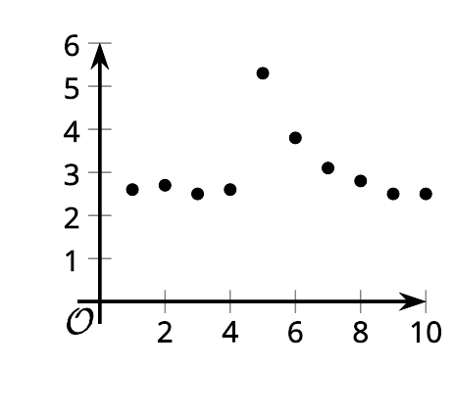
- Match each description with a graph that could represent the situation described. One of the descriptions has no corresponding graph.
  - This show has a good core audience. They had a guest star in the fifth episode that brought in some new viewers, but most of them stopped watching after that.
  - This show is one of the most popular shows, and its audience keeps increasing.
  - This show has a small audience, but it’s improving, so more people are noticing.
  - This show started out huge. Even though it feels like it crashed, it still has more viewers than another show.
- Which is greatest, $A(7)$, $B(7)$, or $C(7)$? Explain what the answer tells us about the shows.
- Sketch a graph of the viewership of the fourth TV show that did not have a matching graph.
- 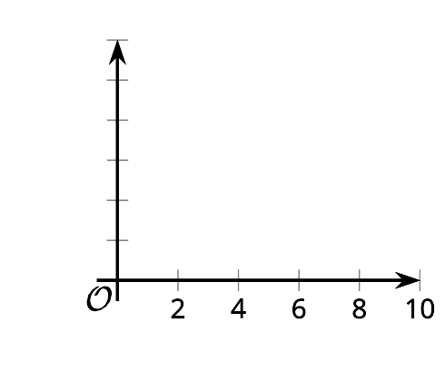

4 Functions $f$ and $g$

Student Task Statement
- Here are graphs that represent two functions, $f$ and $g$.
- Decide which function value is greater for each given input. Be prepared to explain your reasoning.
  - $f(2)$ or $g(2)$
  - $f(4)$ or $g(4)$
  - $f(6)$ or $g(6)$
  - $f(8)$ or $g(8)$
- 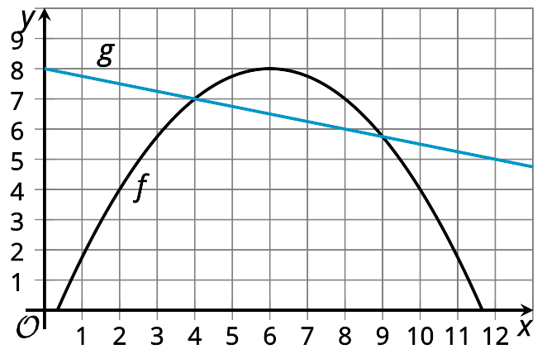
- ​​​​​
- Is there a value of $x$ at which the equation $f(x)=g(x)$ is true? Explain your reasoning.
- Identify at least two values of $x$ at which the inequality $f(x)<g(x)$ is true.

Images for Activity Synthesis
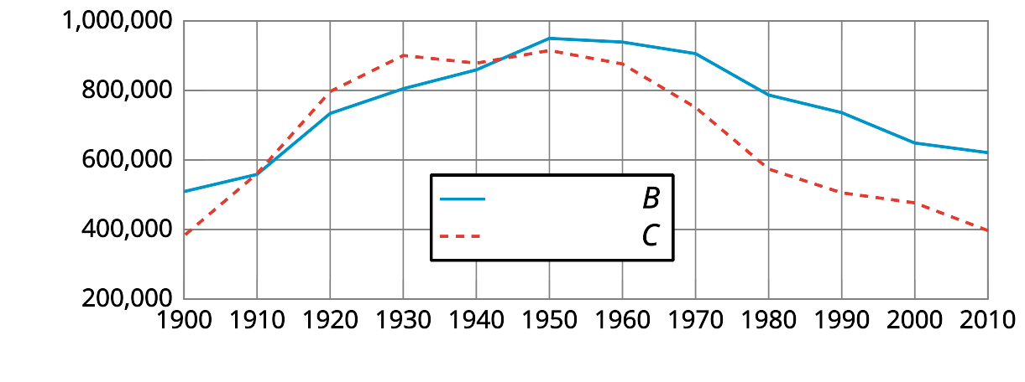
© CC BY 2019 by Illustrative Mathematics

