Unit 5 Lesson 4: Build Fractions from Unit Fractions

WU Number Talk: 3 and Another Factor (Warm up)

Student Task Statement
Find the value of each expression mentally.
- $3×3$
- $7×3$
- $10×3$
- $3×17$

1 Introduce Secret Fractions

Student Task Statement
The goal of the game is to be the first to build 2 secret fractions with unit fractions.
- Make two stacks: one for secret fractions and one for unit fractions. Place all cards face down.
- Each player draws 2 secret fraction cards. These are the fractions you are trying to make with your unit fractions.
- On your turn, you can make one of these moves:
  - Pick up 1 unit fraction card.
  - Trade both of your secret fractions for 2 new secret fractions from the stack.
- When you have enough unit fractions to make one of your secret fractions, shade your gameboard to represent your secret fraction. Then, pick a new secret fraction.
- The first player to make 2 secret fractions wins.
Gameboard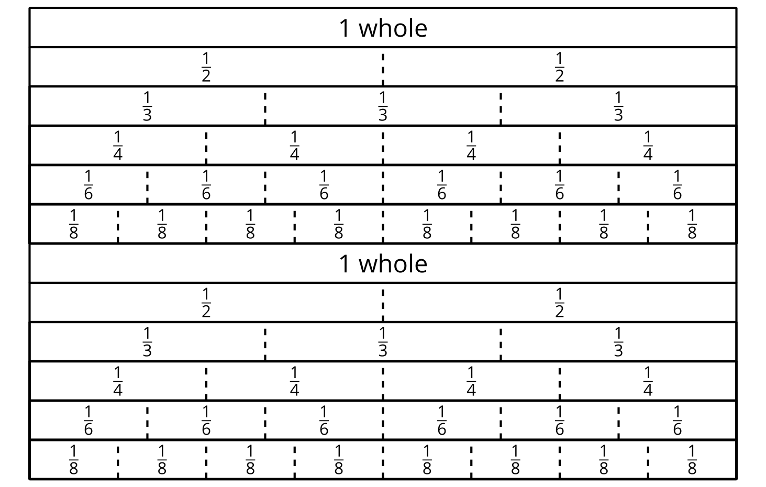

2 Represent Fraction Situations

Student Task Statement
Here are four situations about playing Pilolo and four diagrams. Each diagram represents the length of a street where the game is played.
Represent each situation on a diagram. Be prepared to explain your reasoning.
- A student walks $\frac{4}{8}$ the length of the street and hides a rock.
- A student walks $\frac{2}{3}$ the length of the street and hides a penny.
- A student walks $\frac{3}{4}$ the length of the street and hides a stick.
- A student walks $\frac{5}{6}$ the length of the street and hides a penny.
- This diagram represents the location of a hidden stick.
- About what fraction of the length of the street did the student walk to hide it? Be prepared to explain how you know.
© CC BY 2021 Illustrative Mathematics®

