Unit 2 Lesson 7: Different Square Units (Part 2)

WU Notice and Wonder: A Bigger Square (Warm up)

Student Task Statement
What do you notice? What do you wonder?
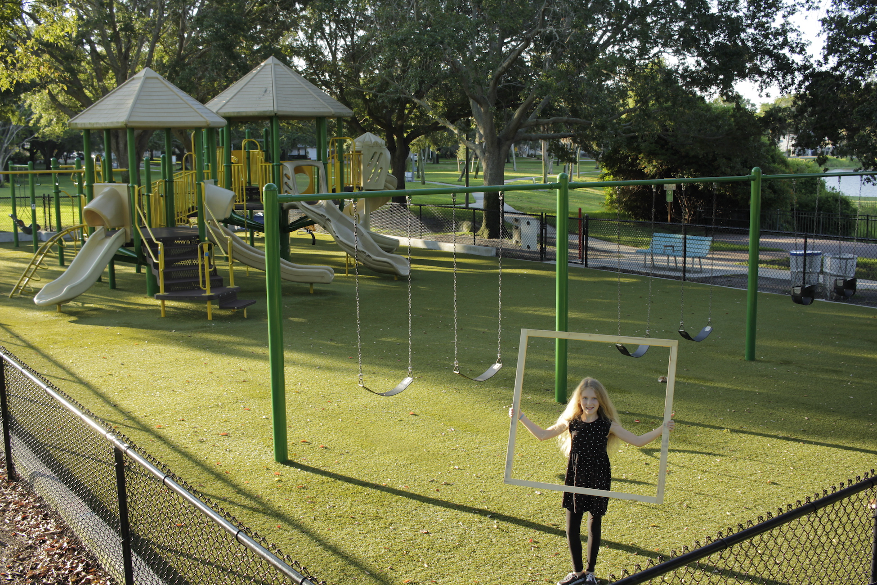

1 Square Feet and Square Meters

Student Task Statement
- This is a square meter.
- 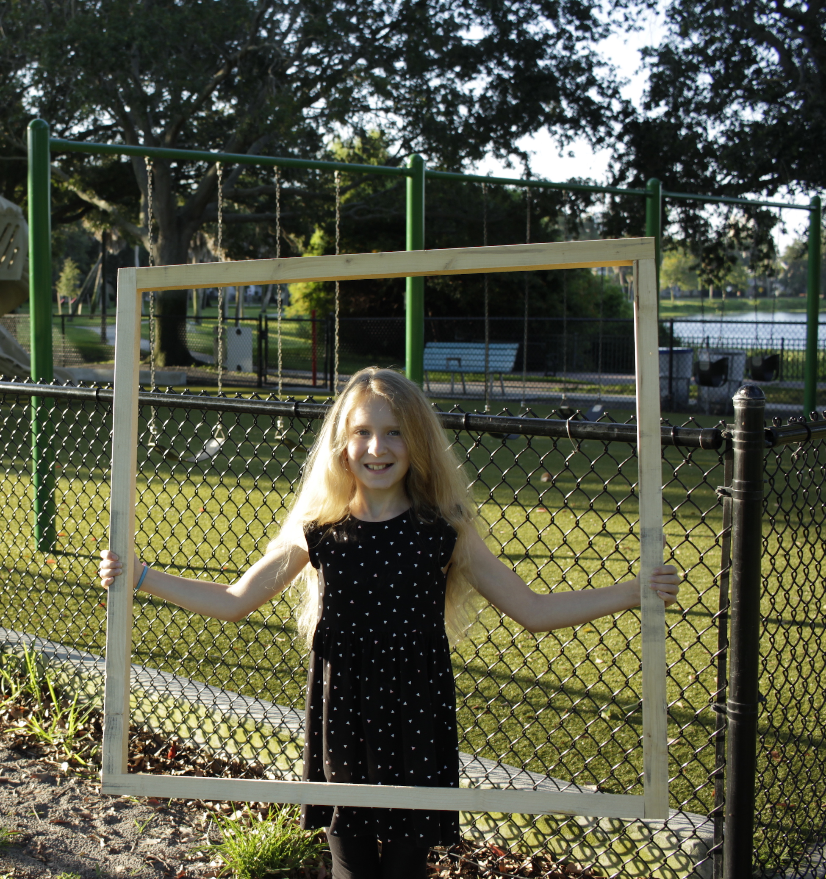
- What kinds of areas would make sense to measure with square meters? Be ready to explain your reasoning.
- This is a square foot.
- 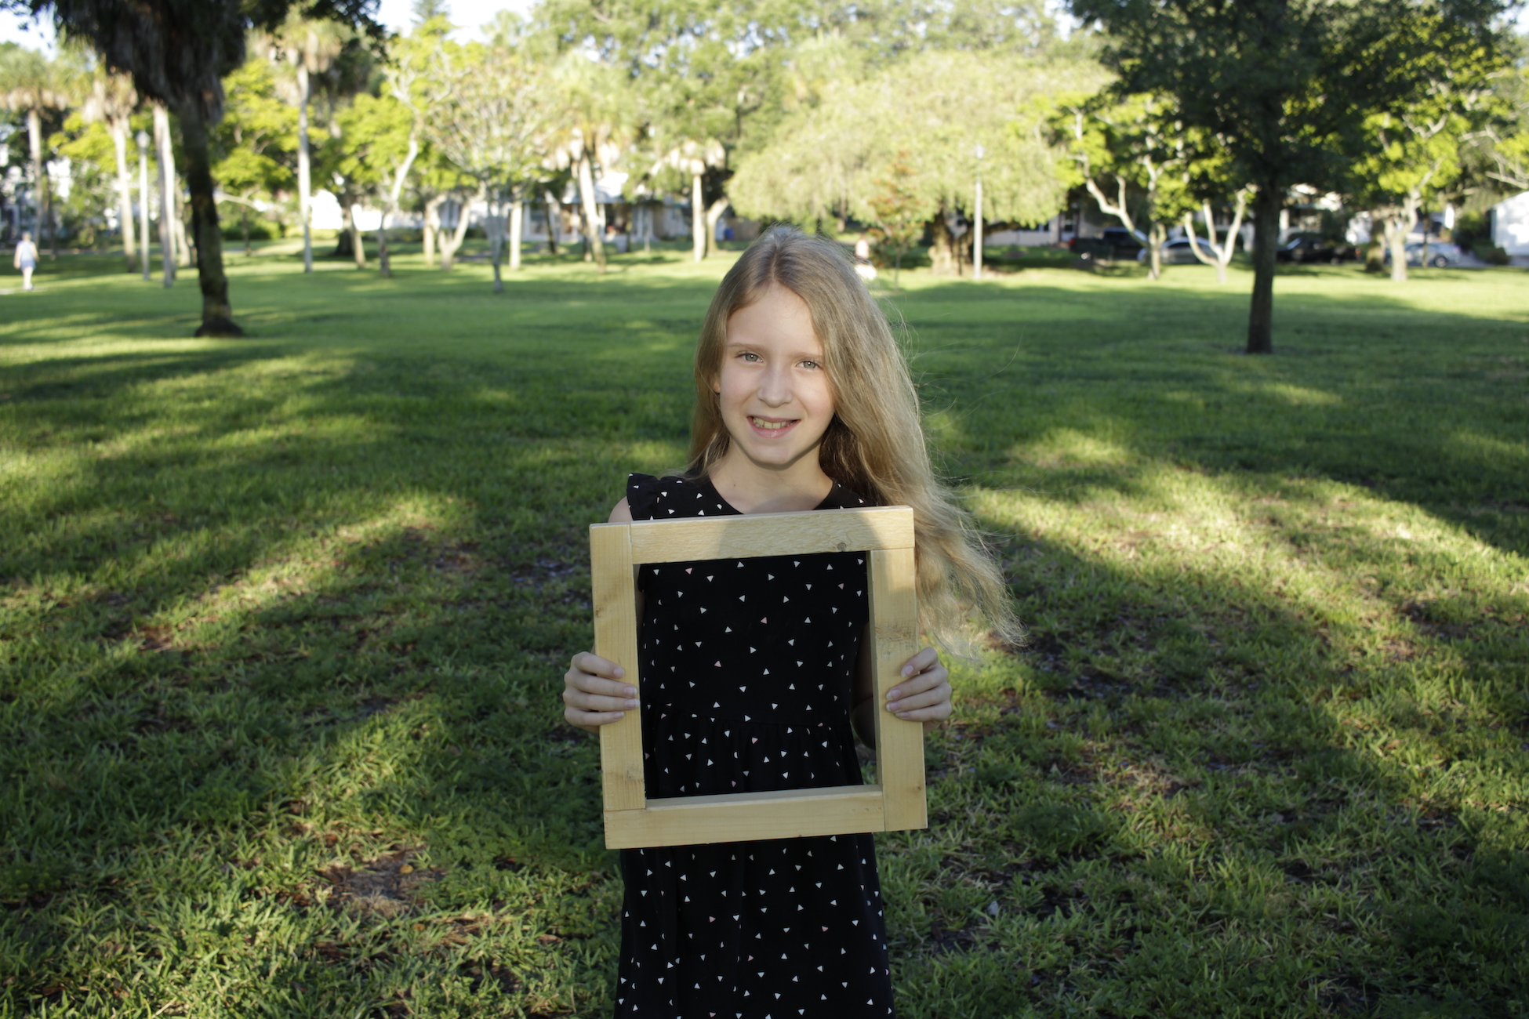
- What kinds of areas would make sense to measure with square feet? Be ready to explain your reasoning.

2 Which Square Unit?

Student Task Statement
- For each area tell if you would use square centimeters, square inches, square feet, or square meters to measure it and why you chose that unit.
  - The area of a baseball field
  - The area of a cover of a book you’re reading
  - The area of our classroom
  - The area of a piece of paper
  - The area of the top of a table
  - The area of the screen on a phone
- Choose the area that best matches each item. Be ready to explain your reasoning.
  - About 9 square inches
  - About 3 square feet
  - About 55 square centimeters
  - About 55 square meters
  - A playing card
  - The floor of a classroom
  - A sticky note
  - The top of a student desk

3 Area Scavenger Hunt (Optional)

Student Task Statement
Find some object or space that you would measure with square inches, square centimeters, square feet, and square yards.
area | square unit and reasoning
Example: a piece of paper | Example: “I think it can fit about 8 inches across and 10 inches down, so square inches work well. It can be measured in square centimeters, too, but would just take a lot more squares. Square feet and square meters would be too large.”
© CC BY 2021 Illustrative Mathematics®

