Lesson 3: Comparing Positive and Negative Numbers
Let’s compare numbers on the number line.

3.1: Which One Doesn’t Belong: Inequalities
Which inequality doesn’t belong?
- $\frac{5}{4}<2$
- $8.5>0.95$
- $8.5<7$
- $10.00<100$

3.2: Comparing Temperatures
Here are the low temperatures, in degrees Celsius, for a week in Anchorage, Alaska.
day | Mon | Tues | Weds | Thurs | Fri | Sat | Sun
temperature | 5 | -1 | -5.5 | -2 | 3 | 4 | 0
- Plot the temperatures on a number line. Which day of the week had the lowest low temperature?
- The lowest temperature ever recorded in the United States was -62 degrees Celsius, in Prospect Creek Camp, Alaska. The average temperature on Mars is about -55 degrees Celsius.
  - Which is warmer, the coldest temperature recorded in the USA, or the average temperature on Mars? Explain how you know.
  - Write an inequality to show your answer.
- On a winter day the low temperature in Anchorage, Alaska, was -21 degrees Celsius and the low temperature in Minneapolis, Minnesota, was -14 degrees Celsius.
- Jada said, “I know that 14 is less than 21, so -14 is also less than -21. This means that it was colder in Minneapolis than in Anchorage.”
- Do you agree? Explain your reasoning.

Are you ready for more?
Another temperature scale frequently used in science is the Kelvin scale. In this scale, 0 is the lowest possible temperature of anything in the universe, and it is -273.15 degrees in the Celsius scale. Each $1\text{ K}$ is the same as $1^{∘}\text{C}$, so $10\text{ K}$ is the same as $\text{-}{263.15}^{∘}\text{C}$.
- Water boils at ${100}^{∘}\text{C}$. What is this temperature in $\text{K}$?
- Ammonia boils at $\text{-}{35.5}^{∘}\text{C}$. What is the boiling point of ammonia in $\text{K}$?
- Explain why only positive numbers (and 0) are needed to record temperature in $\text{K}$.

3.3: Rational Numbers on a Number Line
- Plot the numbers -2, 4, -7, and 10 on the number line. Label each point with its numeric value.
- Decide whether each inequality statement is true or false. Be prepared to explain your reasoning.
  - $\text{-}2<4$
  - $\text{-}2<\text{-}7$
  - $4>\text{-}7$
  - $\text{-}7>10$
- Andre says that $\frac{1}{4}$ is less than $\text{-}\frac{3}{4}$ because, of the two numbers, $\frac{1}{4}$ is closer to 0. Do you agree? Explain your reasoning.
- Answer each question. Be prepared to explain how you know.
  - Which number is greater: $\frac{1}{4}$ or $\frac{5}{4}$?
  - Which is farther from 0: $\frac{1}{4}$ or $\frac{5}{4}$?
  - Which number is greater: $\text{-}\frac{3}{4}$ or $\frac{5}{8}$?
  - Which is farther from 0: $\text{-}\frac{3}{4}$ or $\frac{5}{8}$?
  - Is the number that is farther from 0 always the greater number? Explain your reasoning.

Lesson 3 Summary
We use the words greater than and less than to compare numbers on the number line. For example, the numbers -2.7, 0.8, and -1.3, are shown on the number line.
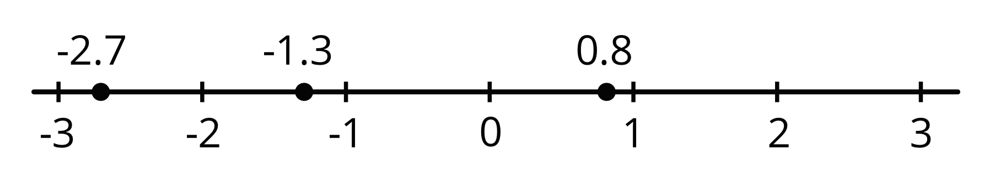
Because -2.7 is to the left of -1.3, we say that -2.7 is less than -1.3. We write:
$\text{-}2.7<\text{-}1.3$
In general, any number that is to the left of a number $n$ is less than $n$.
We can see that -1.3 is greater than -2.7 because -1.3 is to the right of -2.7. We write:
$\text{-}1.3>\text{-}2.7$
In general, any number that is to the right of a number $n$ is greater than $n$
We can also see that $0.8>\text{-}1.3$ and $0.8>\text{-}2.7$. In general, any positive number is greater than any negative number.
© CC BY Open Up Resources. Adaptations CC BY IM.

