Lesson 6: Absolute Value of Numbers

6.1: Number Talk: Closer to Zero
For each pair of expressions, decide mentally which one has a value that is closer to 0.
$\frac{9}{11}$ or $\frac{15}{11}$
$\frac{1}{5}$ or $\frac{1}{9}$
$1.25$ or $\frac{5}{4}$
$0.01$ or $0.001$

6.2: Jumping Flea
- A flea is jumping around on a number line.
- 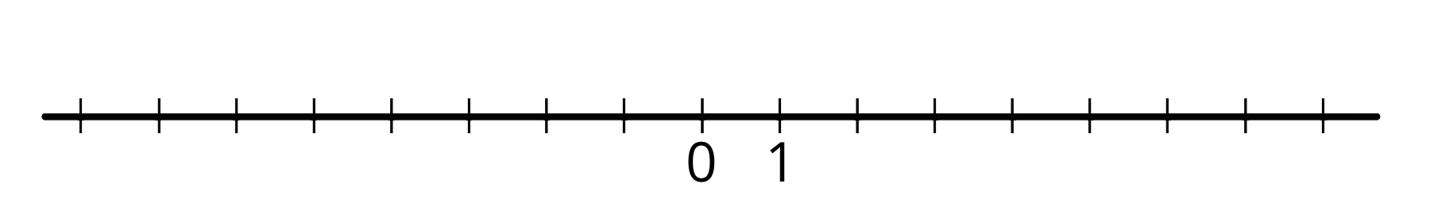
  - If the flea starts at 1 and jumps 4 units to the right, where does it end up? How far away from 0 is this?
  - If the flea starts at 1 and jumps 4 units to the left, where does it end up? How far away from 0 is this?
  - If the flea starts at 0 and jumps 3 units away, where might it land?
  - If the flea jumps 7 units and lands at 0, where could it have started?
  - The absolute value of a number is the distance it is from 0. The flea is currently to the left of 0 and the absolute value of its location is 4. Where on the number line is it?
  - If the flea is to the left of 0 and the absolute value of its location is 5, where on the number line is it?
  - If the flea is to the right of 0 and the absolute value of its location is 2.5, where on the number line is it?
- We use the notation $|\text{-}2|$ to say "the absolute value of -2," which means "the distance of -2 from 0 on the number line."
  - What does $|\text{-}7|$ mean and what is its value?
  - What does $|1.8|$ mean and what is its value?

6.3: Absolute Elevation and Temperature
- A part of the city of New Orleans is 6 feet below sea level. We can use “-6 feet” to describe its elevation, and “$|\text{-}6|$ feet” to describe its vertical distance from sea level. In the context of elevation, what would each of the following numbers describe?
  - 25 feet
  - $|25|$ feet
  - -8 feet
  - $|\text{-}8|$ feet
- The elevation of a city is different from sea level by 10 feet. Name the two elevations that the city could have.
- We write “$\text{-}5^{∘}\text{C}$” to describe a temperature that is 5 degrees Celsius below freezing point and “$5^{∘}\text{C}$” for a temperature that is 5 degrees above freezing. In this context, what do each of the following numbers describe?
  - $1^{∘}\text{C}$
  - $\text{-}4^{∘}\text{C}$
  - $|12|^{∘}\text{C}$
  - $|\text{-}7|^{∘}\text{C}$
  - Which temperature is colder: $\text{-}6^{∘}\text{C}$ or $3^{∘}\text{C}$?
  - Which temperature is closer to freezing temperature: $\text{-}6^{∘}\text{C}$ or $3^{∘}\text{C}$?
  - Which temperature has a smaller absolute value? Explain how you know.

Are you ready for more?
At a certain time, the difference between the temperature in New York City and in Boston was 7 degrees Celsius. The difference between the temperature in Boston and in Chicago was also 7 degrees Celsius. Was the temperature in New York City the same as the temperature in Chicago? Explain your answer.

Lesson 6 Summary
We compare numbers by comparing their positions on the number line: the one farther to the right is greater; the one farther to the left is less.
Sometimes we wish to compare which one is closer to or farther from 0. For example, we may want to know how far away the temperature is from the freezing point of $0^{∘}\text{C}$, regardless of whether it is above or below freezing.
The absolute value of a number tells us its distance from 0.
The absolute value of -4 is 4, because -4 is 4 units to the left of 0. The absolute value of 4 is also 4, because 4 is 4 units to the right of 0. Opposites always have the same absolute value because they both have the same distance from 0.
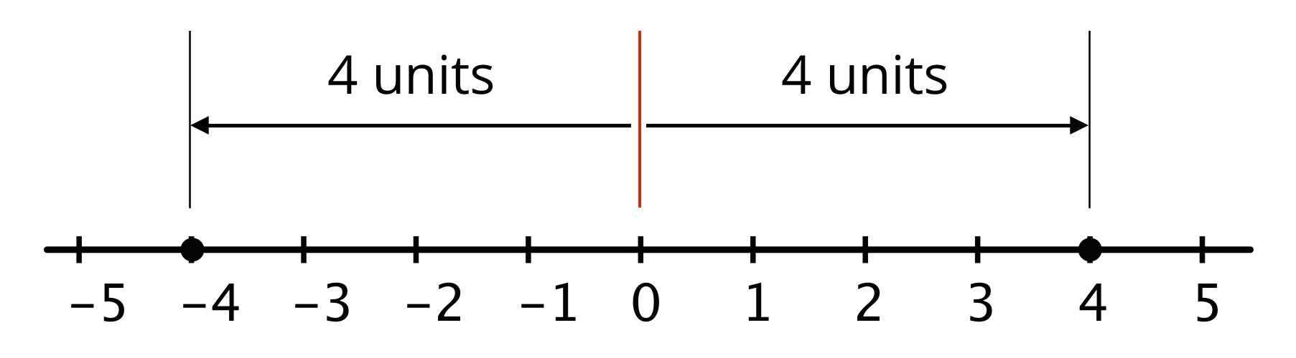
The distance from 0 to itself is 0, so the absolute value of 0 is 0. Zero is the only number whose distance to 0 is 0. For all other absolute values, there are always two numbers—one positive and one negative—that have that distance from 0.
To say “the absolute value of 4,” we write: $|4|$
To say that “the absolute value of -8 is 8,” we write: $|\text{-}8|=8$
© CC BY Open Up Resources. Adaptations CC BY IM.

