Lesson 8: Diferentes maneras de descomponer

Standards Alignments
Addressing | 2.NBT.B.5, 2.NBT.B.9

Teacher-facing Learning Goals
- Describe how methods of subtraction are the same and different when subtracting a one-digit number from a two-digit number.

Student-facing Learning Goals
- Comparemos diferentes maneras de restar.

Lesson Purpose
The purpose of this lesson is for students to make sense of different methods for subtracting a two-digit number from a two-digit number and describe how the methods are the same and different.
In previous lessons, students used their own methods for subtracting a two-digit number from a two-digit number. In this lesson, students make sense of different subtraction methods that use base-ten drawings to represent decomposing a ten to subtract by place. Students connect base-ten drawings to equations that represent the steps of a subtraction method. Throughout the lesson, students share claims and justify how methods are the same and how they are different with an emphasis on describing how tens are subtracted from tens and ones from ones and deepening their understanding of the properties of operations (MP3, MP7).
Students should have access to base-ten blocks throughout the lesson and cool-down as they make sense of and try different methods and representations.

Access for:

Students with Disabilities
- Engagement (Activity 1)

English Learners
- MLR8 (Activity 2)

Instructional Routines
Number Talk (Warm-up)

Materials to Gather
- Base-ten blocks: Activity 1, Activity 2

Lesson Timeline
Warm-up | 10 min
Activity 1 | 15 min
Activity 2 | 20 min
Lesson Synthesis | 10 min
Cool-down | 5 min

Teacher Reflection Question
What did you say, do, or ask to support students in trying each method for subtracting two-digit numbers from two-digit numbers? What will you do in upcoming lessons to help students make sense of and connect different methods?

Cool-down
(to be completed at the end of the lesson) 5min
Una historia de dos métodos

Standards Alignments
Addressing | 2.NBT.B.5, 2.NBT.B.9

Student-facing Task Statement
A Mai y a Lin les pidieron encontrar el valor de $63−18$. Compara sus métodos.
Método de Mai
Método de Lin
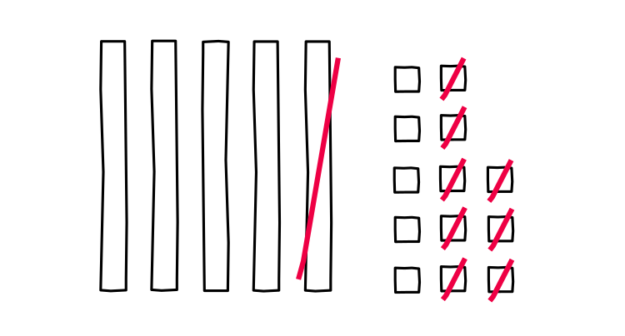
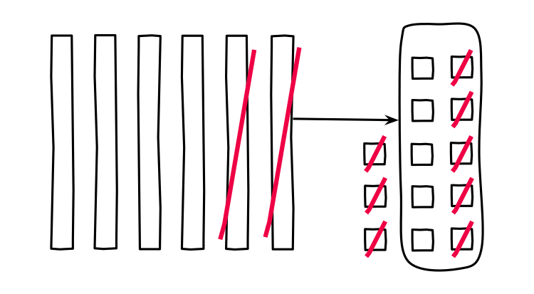
- Menciona 1 cosa en la que se parecen los métodos de Mai y de Lin.
- Menciona 1 cosa en la que son diferentes los métodos de Mai y de Lin.

Student Responses
Sample responses:
- They both used base-ten diagrams and crossed out 18 in all.
- Lin decomposed a ten while solving, but Mai represented 63 with 5 tens and 13 ones so she had all the ones she needed.

