Lesson 10: Rigid Transformations
- Let’s draw some transformations.

10.1: Notice and Wonder: Transformed
What do you notice? What do you wonder?
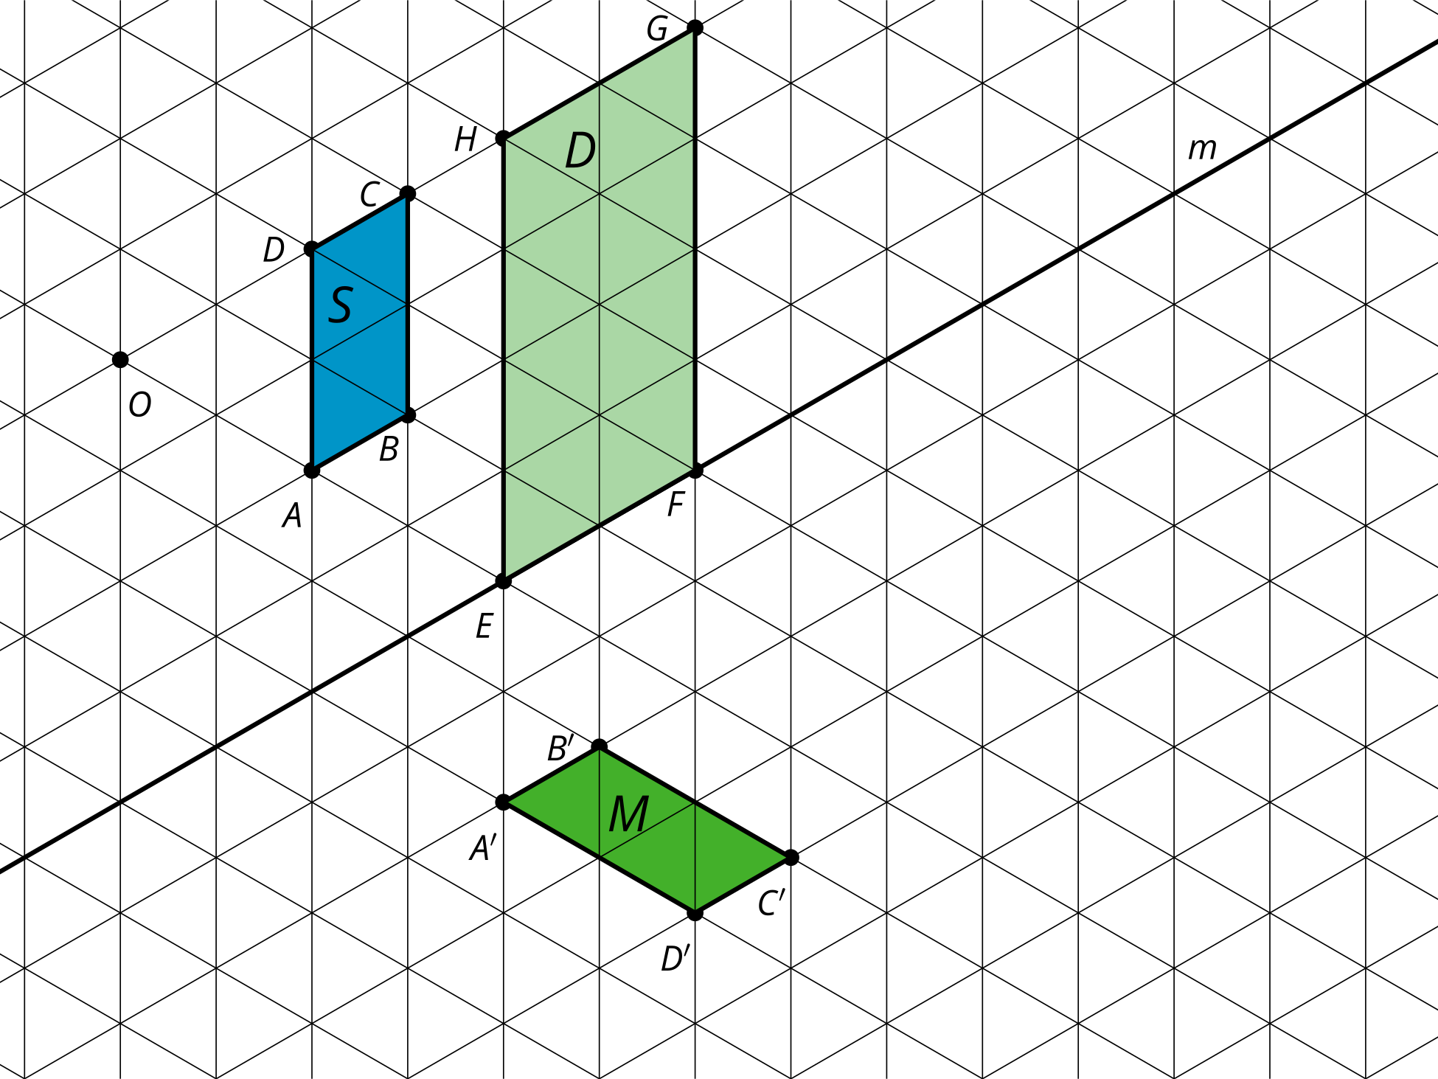

10.2: What’s the Same?
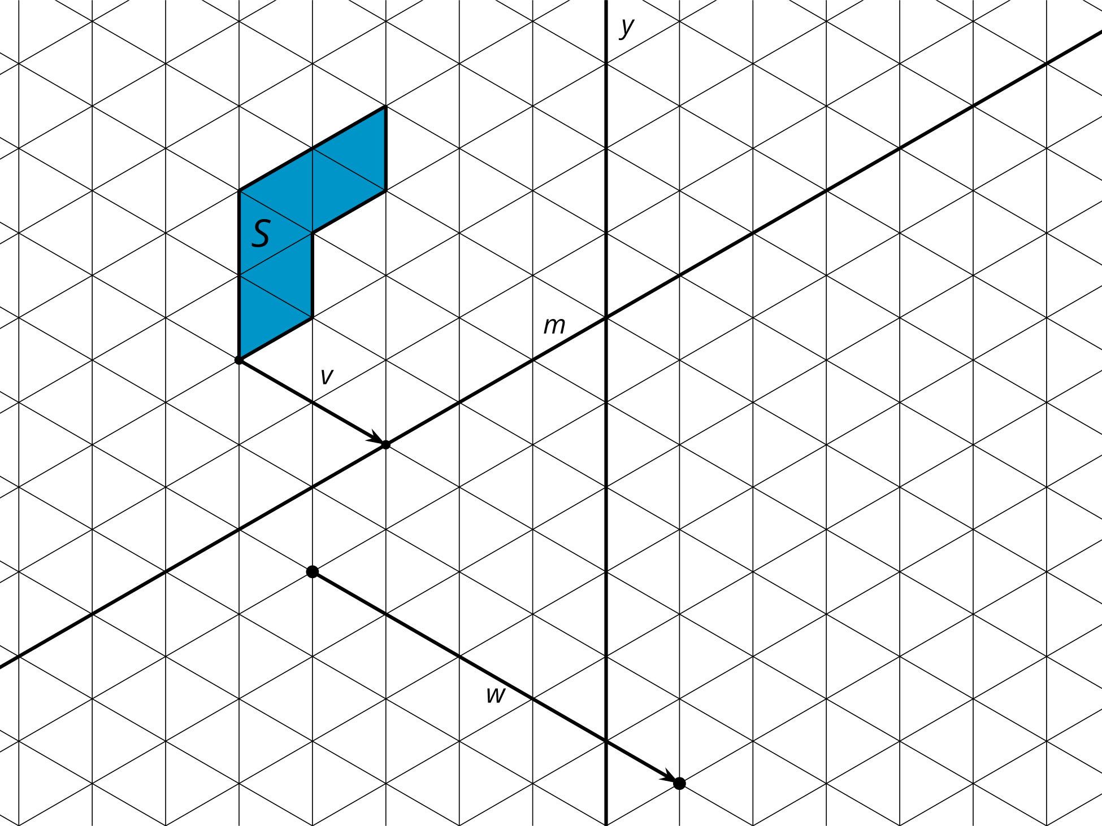
Draw each rigid transformation in a different color.
- Translate figure $S$ along the line segment $v$ in the direction shown by the arrow. Color: _____________
- Reflect figure $S$ across line $y$. Color: _____________
- Reflect figure $S$ across line $m$. Color: _____________
- Translate figure $S$ along the line segment $w$ in the direction shown by the arrow. Reflect this image across line $y$. Color: _____________
- How are the images the same? How are they different?

10.3: Does Order Matter?
Here are 3 congruent L shapes on a grid.
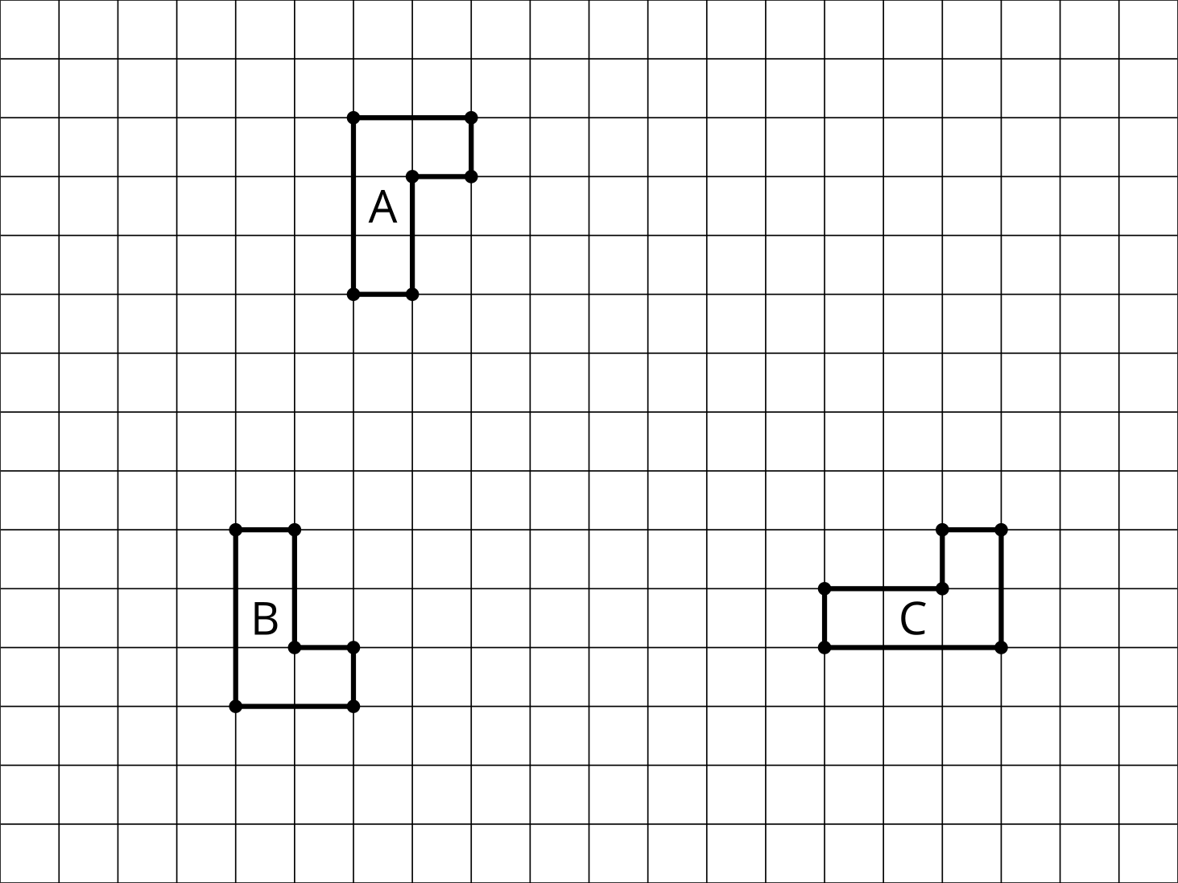
- Describe a sequence of transformations that will take Figure $A$ onto Figure $B$.
- If you reverse the order of your sequence, will the reverse sequence still take $A$ onto $B$?
- Describe a sequence of transformations that will take Figure $A$ onto Figure $C$.
- If you reverse the order of your sequence, will the reverse sequence still take $A$ onto $C$?

Are you ready for more?
- Construct some examples of sequences of two rigid transformations that take Figure $A$ to a new Figure $D$ where reversing the order of the sequence also takes Figure $A$ to Figure $D$.
- Make some conjectures about when reversing the order of a sequence of two rigid transformations still takes a figure to the same place.

Lesson 10 Summary
A figure is called congruent to another figure if there is a sequence of translations, rotations, and reflections that takes one of the figures onto the other. This is because translations, rotations, and reflections are rigid motions. Any sequence of rigid motions is called a rigid transformation. A rigid transformation is a transformation that doesn’t change measurements on any figure. With a rigid transformation, figures like polygons have corresponding sides of the same length and corresponding angles of the same measure.
The result of any transformation is called the image. The points in the original figure are the inputs for the transformation sequence and are named with capital letters. The points in the image are the outputs and are named with capital letters and an apostrophe, which is referred to as “prime.”
There are many ways to show that 2 figures are congruent since many sequences of transformations take a figure to the same image. However, order matters in a set of instructions. Sometimes we can switch 2 steps in a sequence and get the same output, but other times, switching 2 steps results in a different image. These 2 sequences of transformations both have the points $A$, $B$, and $C$ as inputs and points $A^{″}$, $B^{″}$, and $C^{″}$ as outputs. Each step in the sequences of rigid transformations creates a triangle that is congruent to triangle $ABC$.
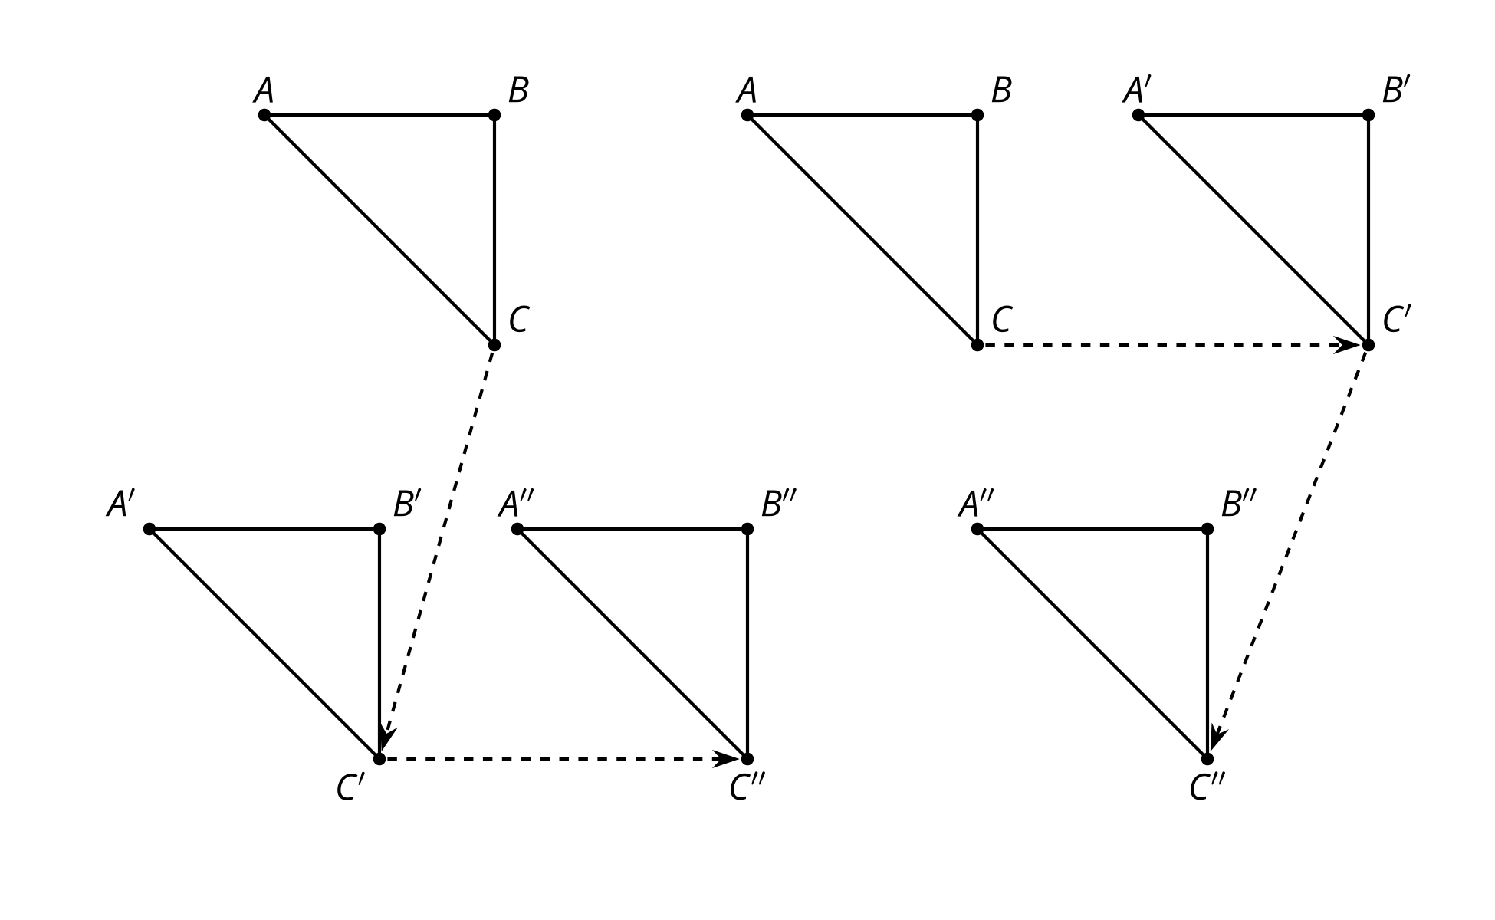
© CC BY 2019 by Illustrative Mathematics®

