Lesson 12: Radian Sense
- Let’s get a sense for the sizes of angles measured in radians.

12.1: Which One Doesn’t Belong: Angle Measures
Which one doesn’t belong?

A
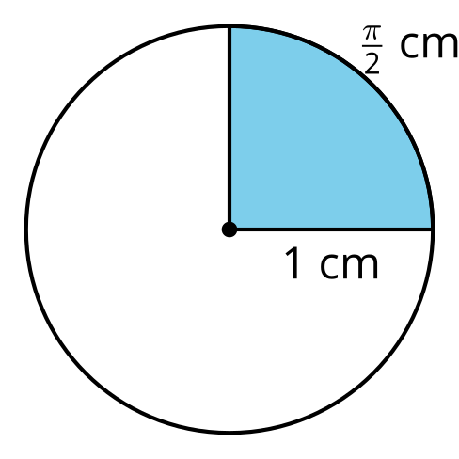

B
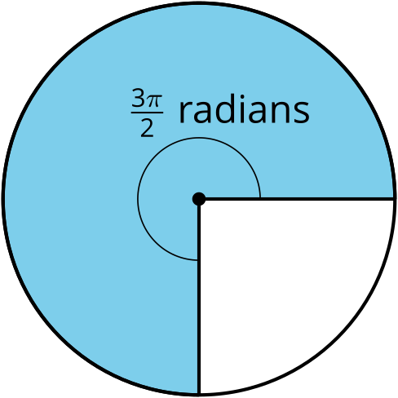

C
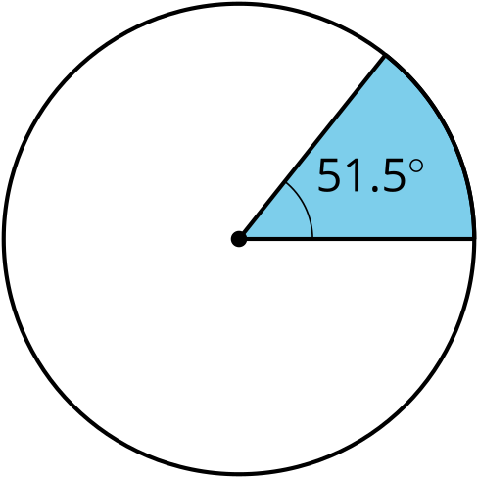

D
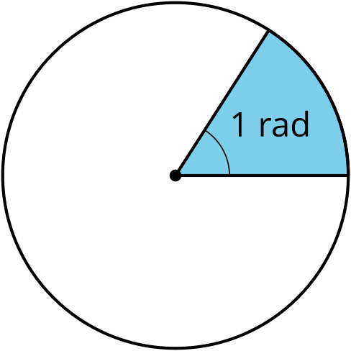

12.2: Degrees Versus Radians
This double number line shows degree measurements on one line and radians on another.
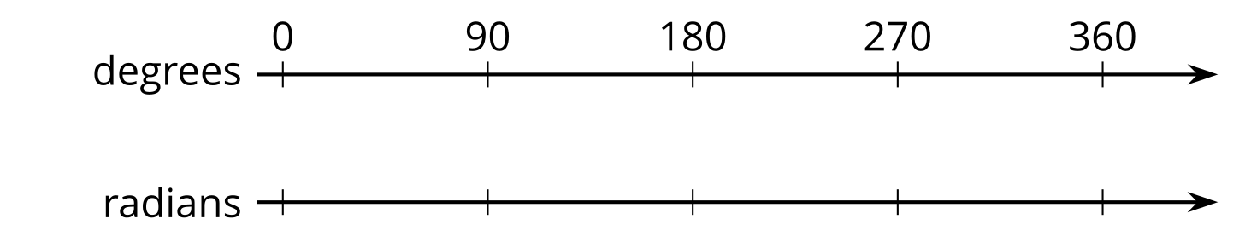
- Fill in the radian measures on the bottom line for 0$​^{∘}$, 90$​^{∘}$, 180$​^{∘}$, 270$​^{∘}$, and 360$​^{∘}$.
- Express each radian measurement in degrees.
  - $\frac{π}{3}$ radians
  - $\frac{5π}{4}$ radians
- Express each degree measurement in radians.
  - 30$​^{∘}$
  - 120$​^{∘}$

Are you ready for more?
Your boat is heading due south when you hear that you must head north-east to return home. You turn the boat, traveling in a counterclockwise circular path until you’re facing north-east.
- Sketch the path of the boat.
- If the circle you traced had a radius of 40 feet, what distance did you travel?

12.3: Pie Coloring Contest
Your teacher will give you a set of cards with angle measures on them. Place the cards upside down in a pile. Choose 1 student to go first. This student should draw a card, then on either circle shade a sector of the circle whose central angle is the measure on the card that was drawn.
Take turns repeating these steps. If you are shading in a circle that already has a shaded sector, choose a spot next to the already-shaded sectors—don’t leave any gaps. You might have to draw additional lines to break the sectors into smaller pieces.
Continue until an angle is drawn that won’t fit in any of the sectors that are still blank.
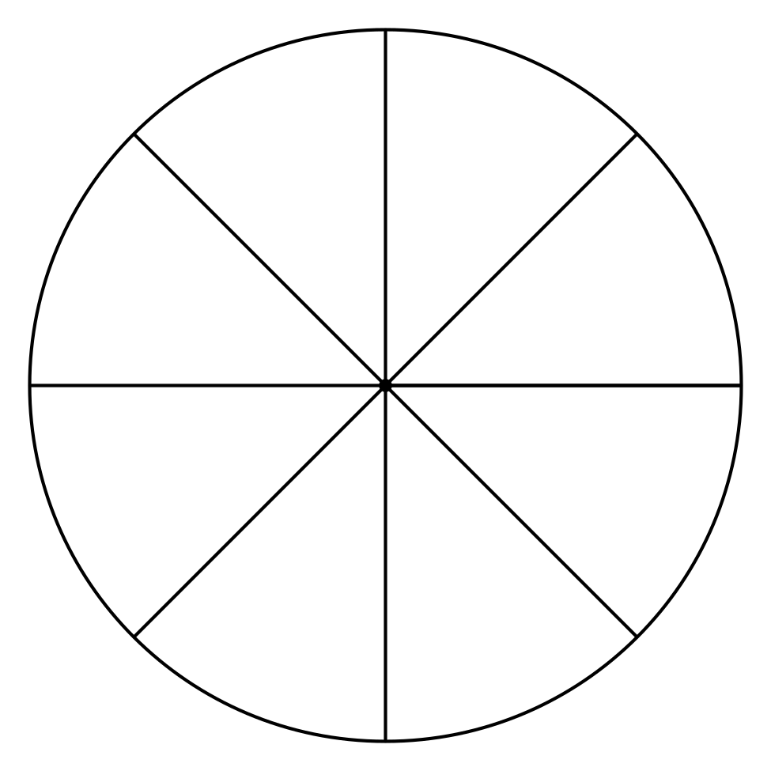
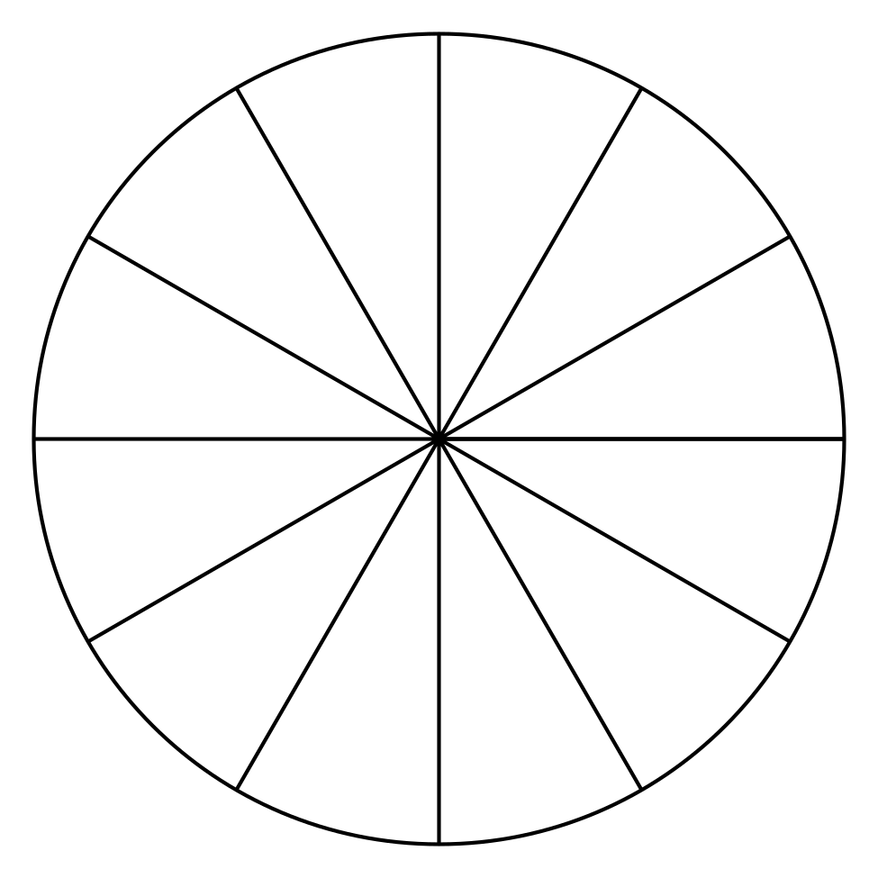
When you’re finished, answer these questions about each circle:
- What is the central angle measure for the remaining unshaded sector?
- What is the central angle measure for the block of shaded sectors?

Lesson 12 Summary
We can divide circles into congruent sectors to get a sense for the size of an angle measured in radians.
Suppose we want to draw an angle that measures $\frac{2π}{3}$ radians. We know that $π$ radians is equivalent to 180 degrees. If we divide a sector with a central angle of $π$ radians into thirds, we can shade in 2 of them to create an angle measuring $\frac{2π}{3}$ radians.
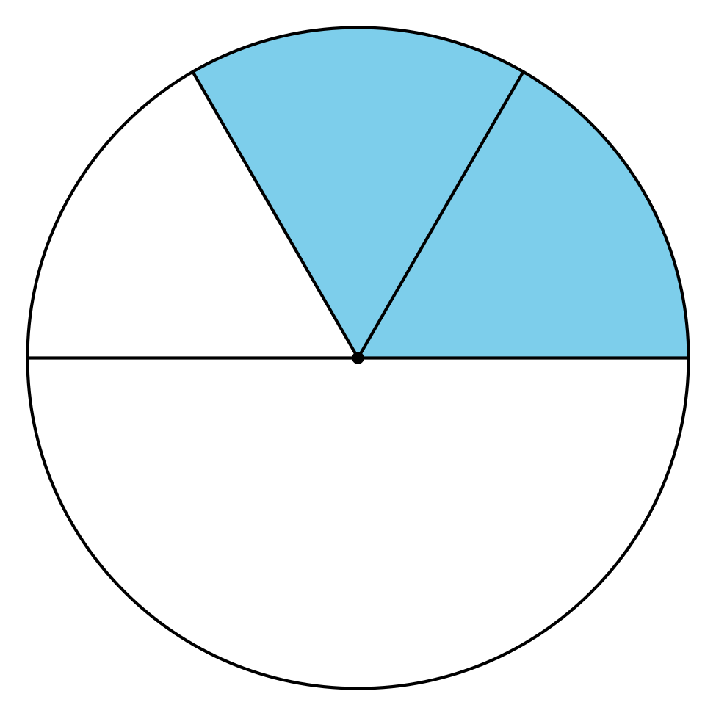
Another way to understand the size of an angle measured in radians is to create a double number line with degrees on one line and radians on the other. On the double number line in the image, the degree measurements are aligned with their equivalent radian measures. For example, $π$ radians is equivalent to 180$​^{∘}$.
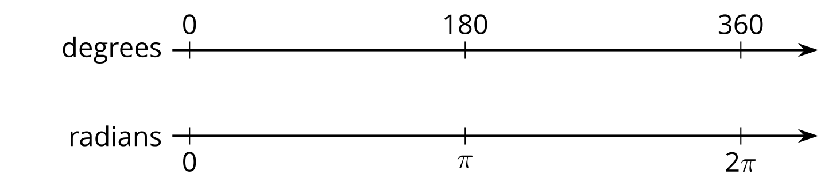
Suppose we need to know the size of an angle that measures $\frac{3π}{4}$ radians. The left half of the double number line represents $π$ radians. Divide the left half of the top and bottom number lines into fourths, then count out 3 of them on the radians line to land on $\frac{3π}{4}$. On the top line, each interval we drew represents 45 degrees because $180÷4=45$. If we count 3 of those intervals, we find that $\frac{3π}{4}$ radians is equivalent to 135 degrees because $45⋅3=135$.
© CC BY 2019 by Illustrative Mathematics®

