Unit 5 Lesson 4 Cumulative Practice Problems
- The graph and the table show the high temperatures in a city over a 10-day period.
- 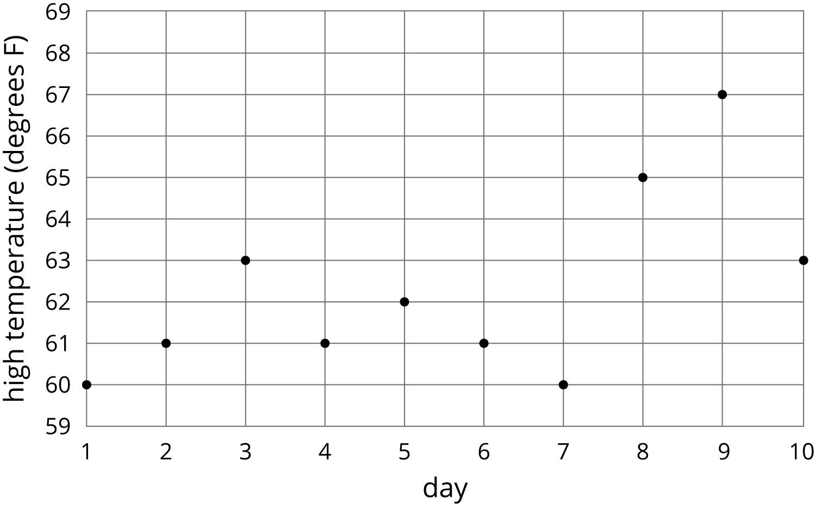
- day | - 1 | - 2 | - 3 | - 4 | - 5 | - 6 | - 7 | - 8 | - 9 | - 10
- temperature (degrees F) | - 60 | - 61 | - 63 | - 61 | - 62 | - 61 | - 60 | - 65 | - 67 | - 63
  - What was the high temperature on Day 7?
  - On which days was the high temperature 61 degrees?
  - Is the high temperature a function of the day? Explain how you know.
  - Is the day a function of the high temperature? Explain how you know.
- The amount Lin’s sister earns at her part-time job is proportional to the number of hours she works. She earns $9.60 per hour.
  - Write an equation in the form $y=kx$ to describe this situation, where $x$ represents the hours she works and $y$ represents the dollars she earns.
  - Is $y$ a function of $x$? Explain how you know.
  - Write an equation describing $x$ as a function of $y$.
- Use the equation $2m+4s=16$ to complete the table, then graph the line using $s$ as the dependent variable.
- $m$ | - 0 |  | - -2
- $s$ |  | - 3 |  | - 0
- 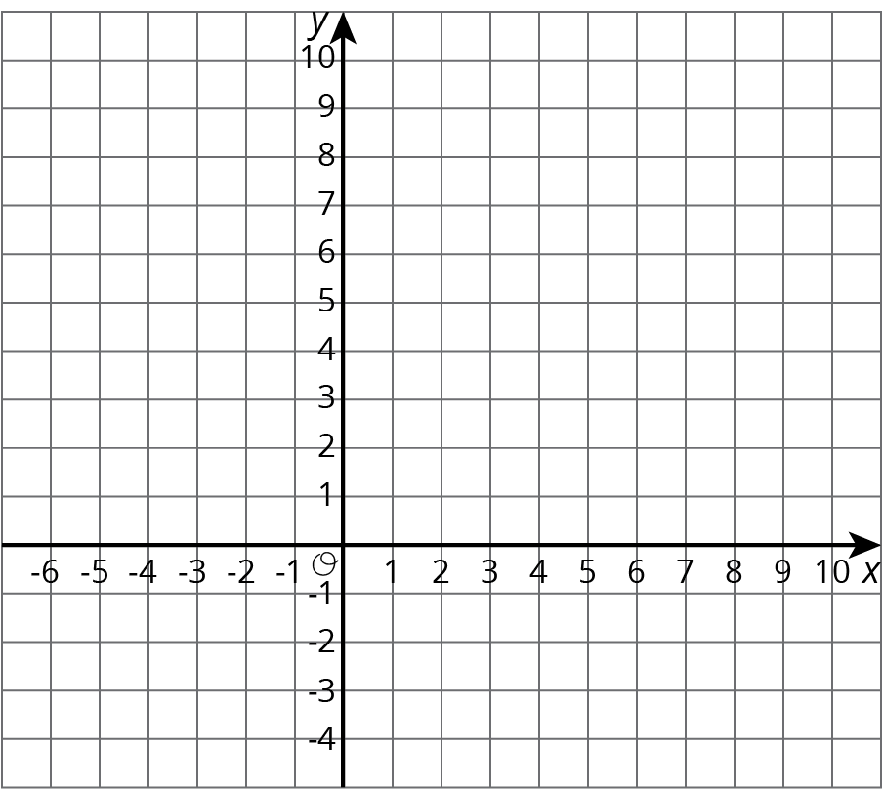
- Solve the system of equations: $\left\{\begin{matrix}y=7x+10 \\ y=\text{-}4x−23\end{matrix}\right.$
- (From Unit 4, Lesson 13.)
© CC BY Open Up Resources. Adaptations CC BY IM.

