Lesson 8: Sort Triangles

Standards Alignments
Addressing | 5.G.B, 5.G.B.3, 5.G.B.4

Teacher-facing Learning Goals
- Classify triangles based on angle measurements and side lengths.

Student-facing Learning Goals
- Let’s sort triangles.

Lesson Purpose
The purpose of this lesson is for students to classify triangles using angle measures and side lengths.
The purpose of this lesson is to sort triangles into categories, recognizing right triangles as a category. Students also examine side lengths and notice that sometimes all 3 side lengths are different, sometimes 2 side lengths are equal, and sometimes all 3 side lengths are equal. Students identify right triangles and examine the possible angles that a triangle can have. For example, there are triangles with 3 acute angles but a triangle can only have one right or obtuse angle. Students should have access to straight edges, protractors, and patty paper throughout this lesson.
This lesson has a Student Section Summary.

Access for:

Students with Disabilities
- Engagement (Activity 1)

English Learners
- MLR7 (Activity 2)

Instructional Routines
Estimation Exploration (Warm-up)

Materials to Copy
- Card Sort Triangles (Grade 5) (groups of 2): Activity 1

Lesson Timeline
Warm-up | 10 min
Activity 1 | 20 min
Activity 2 | 15 min
Lesson Synthesis | 10 min
Cool-down | 5 min

Teacher Reflection Question
How are students applying what they learned about the hierarchy of quadrilaterals to help them make sense of classifying triangles?

Cool-down
(to be completed at the end of the lesson) 5min
All, Some, None of the Triangles

Standards Alignments
Addressing | 5.G.B.4

Student-facing Task Statement
Complete the statements about the triangles below.
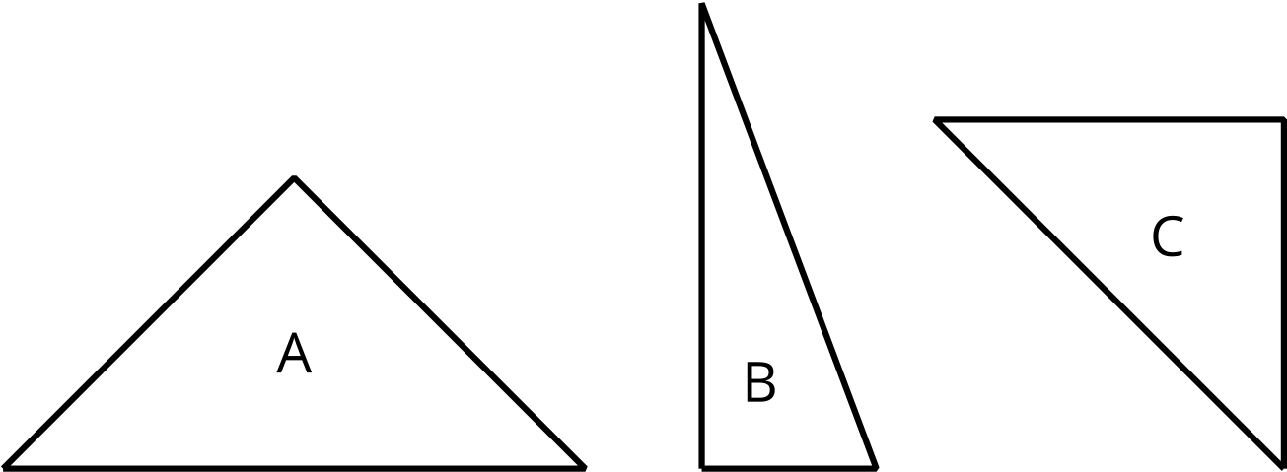
- All of the triangles ______________________________________________________________.
- Some of the triangles __________________________________________________________.
- None of the triangles ___________________________________________________________.

Student Responses
- All of the triangles have a right angle or an angle that measures 90 degrees. All of the triangles have a horizontal side.
- Some of the triangles have two sides that are the same. Some of the triangles have a vertical side.
- None of the triangles have an angle greater than 90 degrees. None of the triangles have all 3 side lengths the same.

