Lesson 20: How Much in the Group? (Optional)

Standards Alignments
Addressing | 5.NF.B.7.b

Teacher-facing Learning Goals
- Represent and solve problems involving division of a whole number by a unit fraction.

Student-facing Learning Goals
- Let’s solve more problems involving multiplication and division with fractions.

Lesson Purpose
The purpose of this lesson is for students to solve fraction division problems that ask: “How many in one group?”
In this optional lesson, students solve problems where a whole number quantity is a unit fraction of an unknown whole number. In these situations students may rely on their understanding of the relationship between multiplication and division. For example, if 8 ounces is $\frac{1}{4}$ of the amount of water in a bottle, students might represent this with a tape diagram:
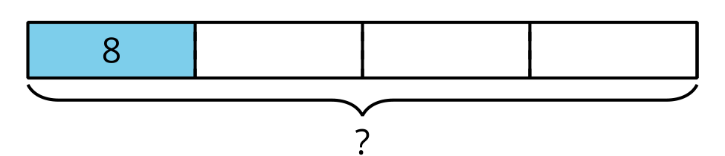
The tape diagram suggests the equation $8=\frac{1}{4}×?$ which students will likely solve by seeing that $?=4×8$. The equation $8=\frac{1}{4}×?$ can also be written using division with the equation $?÷4=8$.

Access for:

Students with Disabilities
- Engagement (Activity 2)

English Learners
- MLR8 (Activity 1)

Instructional Routines
Estimation Exploration (Warm-up)

Lesson Timeline
Warm-up | 10 min
Activity 1 | 20 min
Activity 2 | 10 min
Activity 3 | 10 min
Lesson Synthesis | 10 min
Cool-down | 5 min

Teacher Reflection Question
What do you love most about math? How are you sharing that joy with your students and encouraging them to think about what they love about math?

Cool-down
(to be completed at the end of the lesson) 5min
Drive to School

Standards Alignments
Addressing | 5.NF.B.7.b

Student-facing Task Statement

  - If $\frac{1}{3}$ of the drive to Han’s school is 2 miles, how long is the whole drive to school? Draw a diagram and explain your reasoning.
  - Write a division equation that represents this situation.

Student Responses

  - The drive is 6 miles. The diagram shows each $\frac{1}{3}$ of the drive is 2 miles, and that makes the whole drive 6 miles long since it's 3 groups of 2.
  - 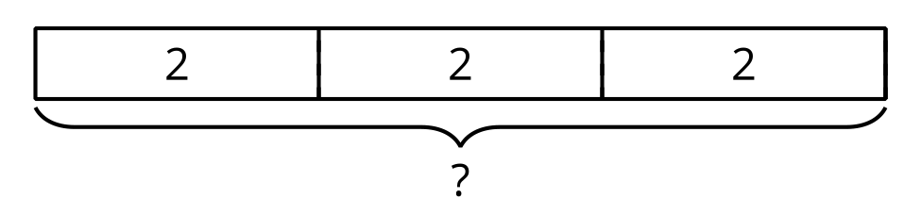
  - $2÷\frac{1}{3}=6$

