Lesson 8: Sort and Count Shape Cards
- Let’s sort shapes and show how many.

Warm-up: Which One Doesn’t Belong: Show Quantities
Which one doesn’t belong?
A
B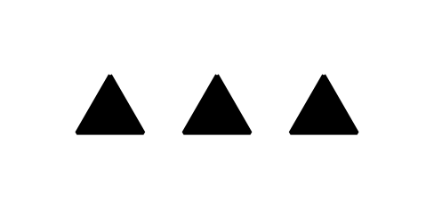
C
D

8.2: Show Your Sort
- Show how you sorted the shape cards.
Be sure that someone else who looks at your paper can see how many shapes are in each category.
- Complete the sentences:
  - The first category has ____________ shapes.
  - The second category has ____________ shapes.
  - The third category has ____________ shapes.
  - There are ____________ shapes all together.
© CC BY 2021 Illustrative Mathematics®

