Lesson 19: Situations and Equations
- Let’s represent and solve problems.

Warm-up: Notice and Wonder: The Unknown
What do you notice? What do you wonder?
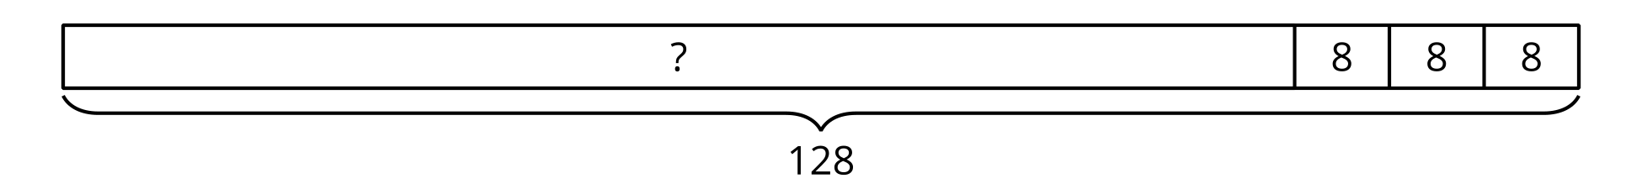
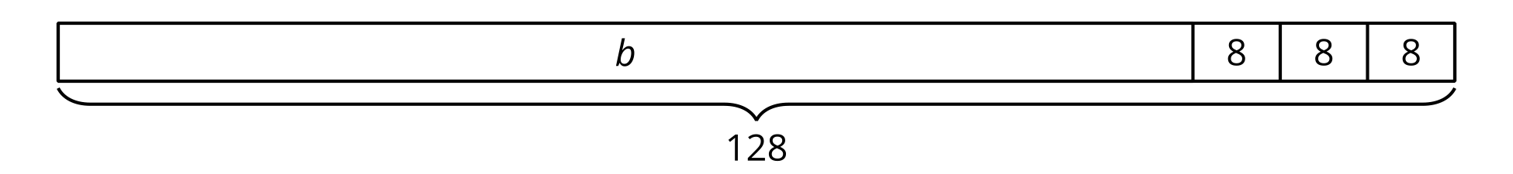

19.1: Mai’s Beads
Part 1
Match each diagram with a situation. Be ready to explain your reasoning.
- Situation 1: Mai had 104 beads. She bought two packs of beads and now she has 124 beads. How many beads were in each pack?
- Situation 2: Mai had some beads. She bought 2 more packs of beads and each pack has 10 beads in it. Now she has 124 beads. How many beads did Mai have before?
- Situation 3: Mai had 104 beads. She bought 2 more packs of beads and each pack has 10 beads in it. How many beads does she have now?
A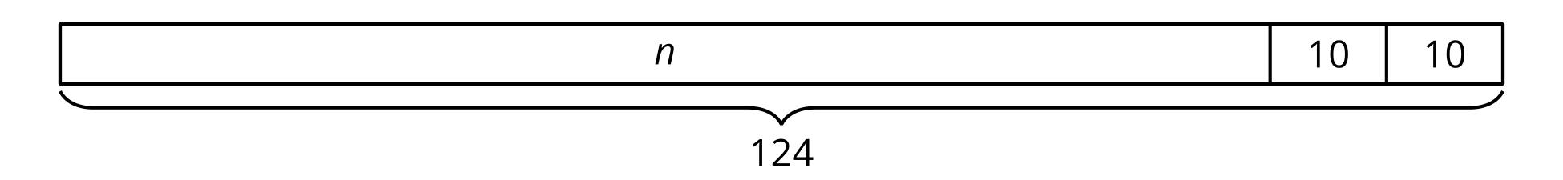
B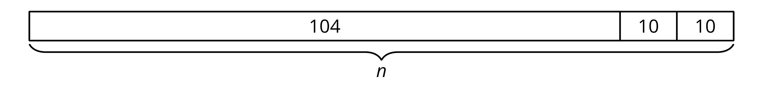
C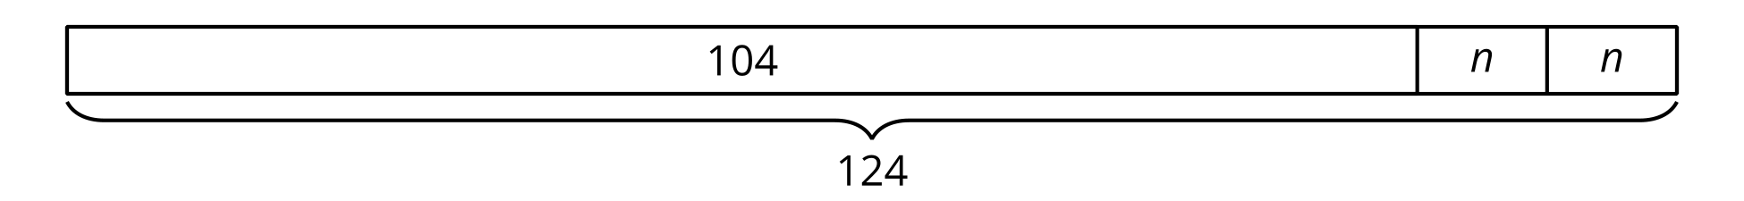
Part 2
Match each equation with a letter for the unknown quantity to a situation in Part 1.
- $104+2×10=n$
- $104+\left(2×n\right)=124$
- $n+10+10=124$

19.2: Represent, Solve, Explain
Kiran is setting up a game of mancala. He has a jar of 104 stones.
From the jar, he takes 3 stones for each of the 6 pits on his side of the board.
How many stones are in the jar now?
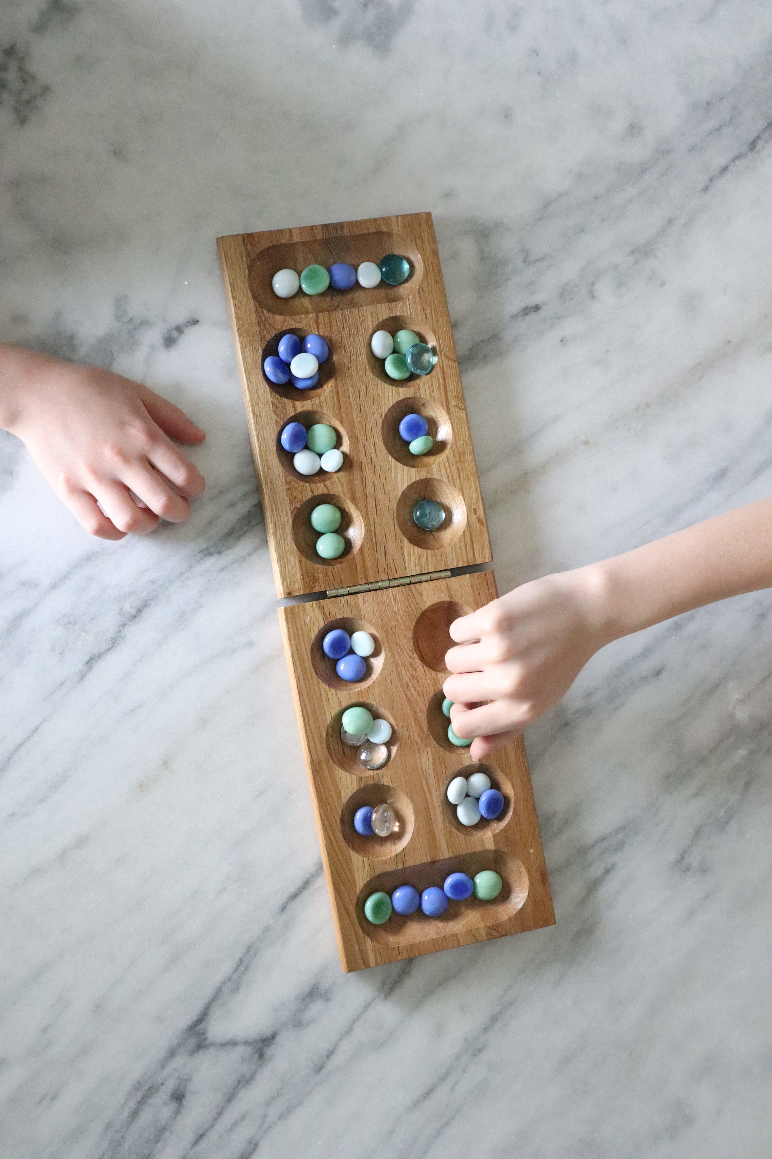
- Write an equation to represent the situation. Use a letter for the unknown quantity.
- Solve the problem. Explain or show your reasoning.
- Explain how you know your answer makes sense.
© CC BY 2021 Illustrative Mathematics®

