Lesson 14: Solving Systems of Equations

14.1: True or False: Two Lines
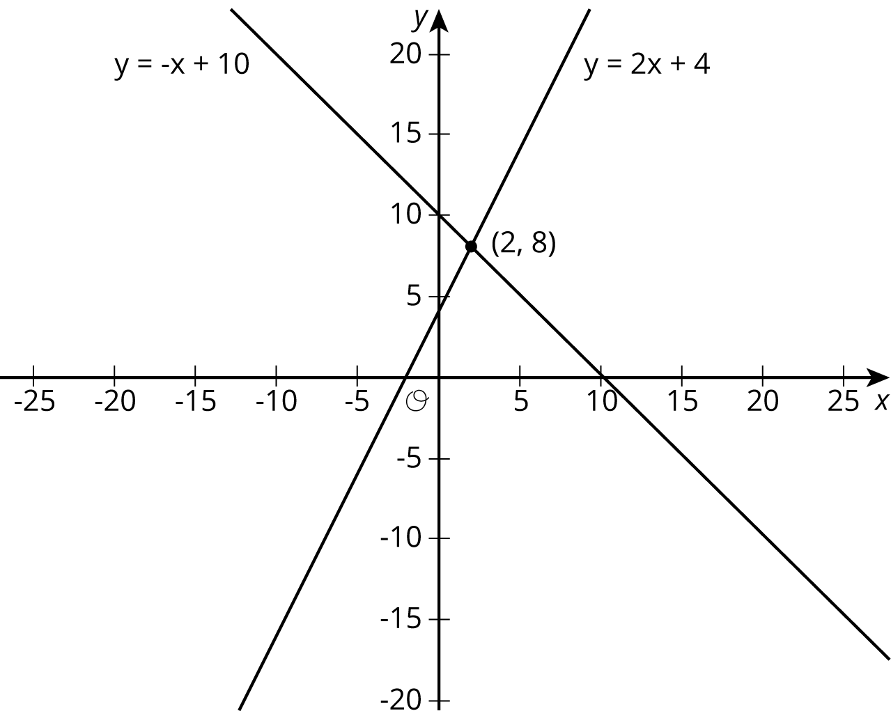
Use the lines to decide whether each statement is true or false. Be prepared to explain your reasoning using the lines.
- A solution to $8=\text{-}x+10$ is 2.
- A solution to $2=2x+4$ is 8.
- A solution to $\text{-}x+10=2x+4$ is 8.
- A solution to $\text{-}x+10=2x+4$ is 2.
- There are no values of $x$ and $y$ that make $y=\text{-}x+10$ and $y=2x+4$ true at the same time.

14.2: Matching Graphs to Systems
Here are three systems of equations graphed on a coordinate plane:
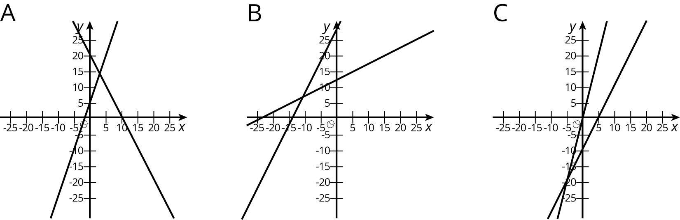
- Match each figure to one of the systems of equations shown here.
  - $\left\{\begin{matrix}y=3x+5 \\ y=\text{-}2x+20\end{matrix}\right.$
  - $\left\{\begin{matrix}y=2x−10 \\ y=4x−1\end{matrix}\right.$
  - $\left\{\begin{matrix}y=0.5x+12 \\ y=2x+27\end{matrix}\right.$
- Find the solution to each system and check that your solution is reasonable based on the graph.

14.3: Different Types of Systems
Your teacher will give you a page with some systems of equations.
- Graph each system of equations carefully on the provided coordinate plane.
- Describe what the graph of a system of equations looks like when it has . . .
  - 1 solution
  - 0 solutions
  - infinitely many solutions

Are you ready for more?
The graphs of the equations $Ax+By=15$ and $Ax−By=9$ intersect at $(2,1)$. Find $A$ and $B$. Show or explain your reasoning.

Lesson 14 Summary
Sometimes it is easier to solve a system of equations without having to graph the equations and look for an intersection point. In general, whenever we are solving a system of equations written as
$\left\{\begin{matrix}y=\text{[some stuff]} \\ y=\text{[some other stuff]}\end{matrix}\right.$
we know that we are looking for a pair of values $(x,y)$ that makes both equations true. In particular, we know that the value for $y$ will be the same in both equations. That means that
$\text{[some stuff]}=\text{[some other stuff]}$
For example, look at this system of equations:
$\left\{\begin{matrix}y=2x+6 \\ y=\text{-}3x−4\end{matrix}\right.$
Since the $y$ value of the solution is the same in both equations, then we know $2x+6=\text{-}3x−4$
We can solve this equation for $x$:
$\begin{matrix}2x+6 & =\text{-}3x−4 & & \\ 5x+6 & =\text{-}4 & & \text{add }3x\text{ to each side} \\ 5x & =\text{-}10 & & \text{subtract 6 from each side} \\ x & =\text{-}2 & & \text{divide each side by 5} \end{matrix}$
But this is only half of what we are looking for: we know the value for $x$, but we need the corresponding value for $y$. Since both equations have the same $y$ value, we can use either equation to find the $y$-value:
$y=2(\text{-}2)+6$
Or
$y=\text{-}3(\text{-}2)−4$
In both cases, we find that $y=2$. So the solution to the system is $(\text{-}2,2)$. We can verify this by graphing both equations in the coordinate plane.
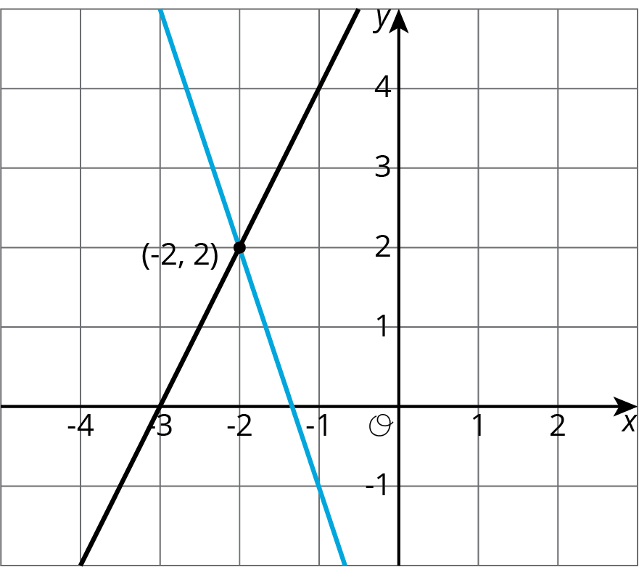
In general, a system of linear equations can have:
- No solutions. In this case, the lines that correspond to each equation never intersect.
- Exactly one solution. The lines that correspond to each equation intersect in exactly one point.
- An infinite number of solutions. The graphs of the two equations are the same line!
© CC BY Open Up Resources. Adaptations CC BY IM.

