Lesson 1: Encontremos el producto más grande

Standards Alignments
Addressing | 5.NBT.B.5

Teacher-facing Learning Goals
- Fluently multiply multi-digit whole numbers using the standard algorithm.

Student-facing Learning Goals
- Busquemos patrones cuando multiplicamos números de varios dígitos.

Lesson Purpose
The purpose of this lesson is for students to recognize and explain place value patterns as they find products using the standard algorithm they learned in Unit 4.
In previous units, students learned the standard algorithm for multiplying whole numbers. In this lesson, students compare and contrast different products that can be made with the same set of 3 or 4 digits. They look for patterns in the arrangement of the digits and explain those patterns in terms of place value. For example, students might notice that the product of 2 two-digit numbers results in a greater product than that of a three-digit number and 1 one-digit number. If students need additional support with the concepts in this lesson, refer back to Unit 4, Section A in the curriculum materials.

Access for:

Students with Disabilities
- Action and Expression (Activity 1)

English Learners
- MLR8 (Activity 1)

Instructional Routines
Notice and Wonder (Warm-up)

Lesson Timeline
Warm-up | 10 min
Activity 1 | 15 min
Activity 2 | 20 min
Lesson Synthesis | 10 min
Cool-down | 5 min

Teacher Reflection Question
What did you learn about students' understanding of the standard algorithm for multiplication during the lesson today? How can you use what you learned to support students in tomorrow's lesson?

Cool-down
(to be completed at the end of the lesson) 5min
Multiplica 2 dígitos por 2 dígitos

Standards Alignments
Addressing | 5.NBT.B.5

Student-facing Task Statement
Encuentra el valor de cada producto. Explica o muestra cómo razonaste.
- $35×47$
- $37×45$

Student Responses
Sample responses:
- 1,645
- 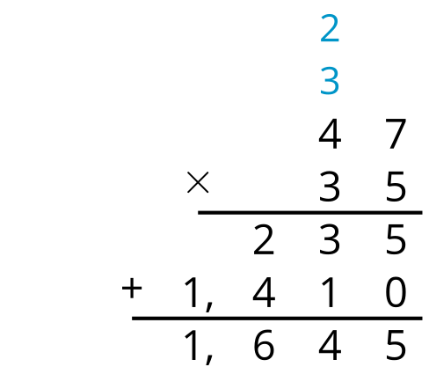
- 1,665
- 