Lesson 4: Explore Geoblocks
- Let’s explore geoblocks.

Warm-up: Notice and Wonder: Geoblocks
What do you notice?
What do you wonder?
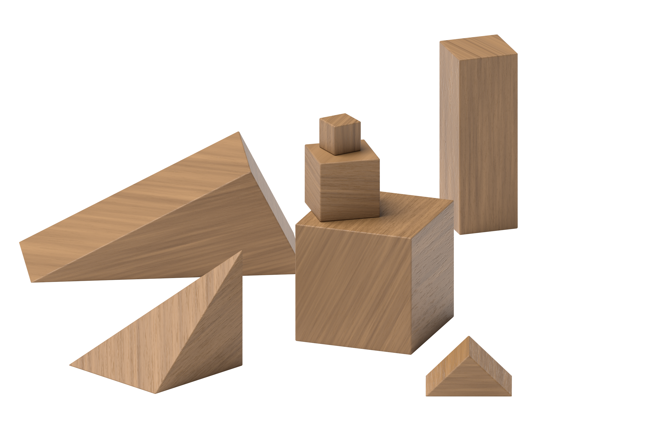

4.2: Introduce Geoblocks, Build to Match
Use blocks to build a house.
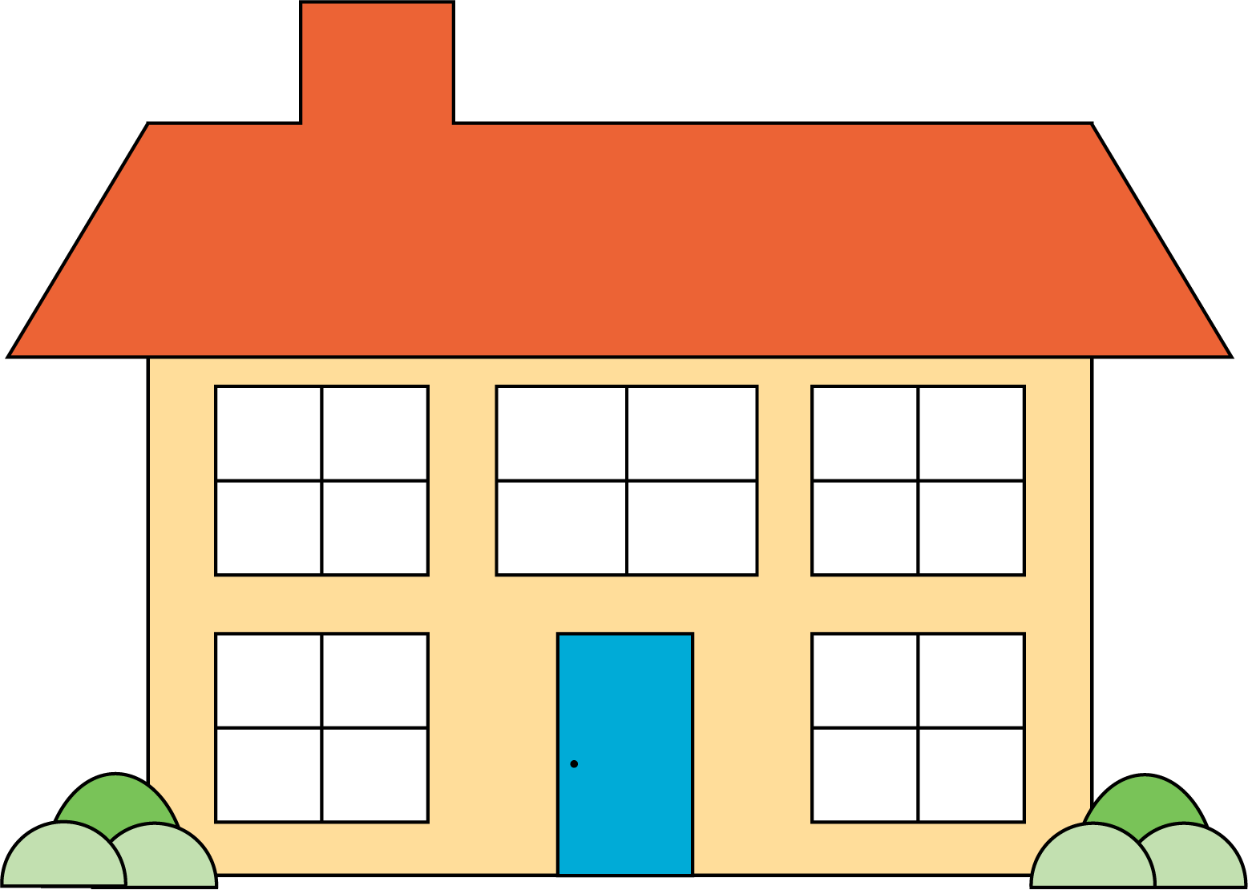
© CC BY 2021 Illustrative Mathematics®

