Unit 4 Lesson 15 Cumulative Practice Problems
- Kiran and his cousin work during the summer for a landscaping company. Kiran's cousin has been working for the company longer, so his pay is 30% more than Kiran's. Last week his cousin worked 27 hours, and Kiran worked 23 hours. Together, they earned $493.85. What is Kiran's hourly pay? Explain or show your reasoning.
- Decide which story can be represented by the system of equations $y=x+6$ and $x+y=100$. Explain your reasoning.
  - Diego’s teacher writes a test worth 100 points. There are 6 more multiple choice questions than short answer questions.
  - Lin and her younger cousin measure their heights. They notice that Lin is 6 inches taller, and their heights add up to exactly 100 inches.
- Clare and Noah play a game in which they earn the same number of points for each goal and lose the same number of points for each penalty. Clare makes 6 goals and 3 penalties, ending the game with 6 points. Noah earns 8 goals and 9 penalties and ends the game with $\text{-}22$ points.
  - Write a system of equations that describes Clare and Noah's outcomes. Use $x$ to represent the number of points for a goal and $y$ to represent the number of points for a penalty.
  - Solve the system. What does your solution mean?
- Solve: $\left\{\begin{matrix}y=6x−8 \\ y=\text{-}3x+10\end{matrix}\right.$
- (From Unit 4, Lesson 14.)
  - Estimate the coordinates of the point where the two lines meet.
  - 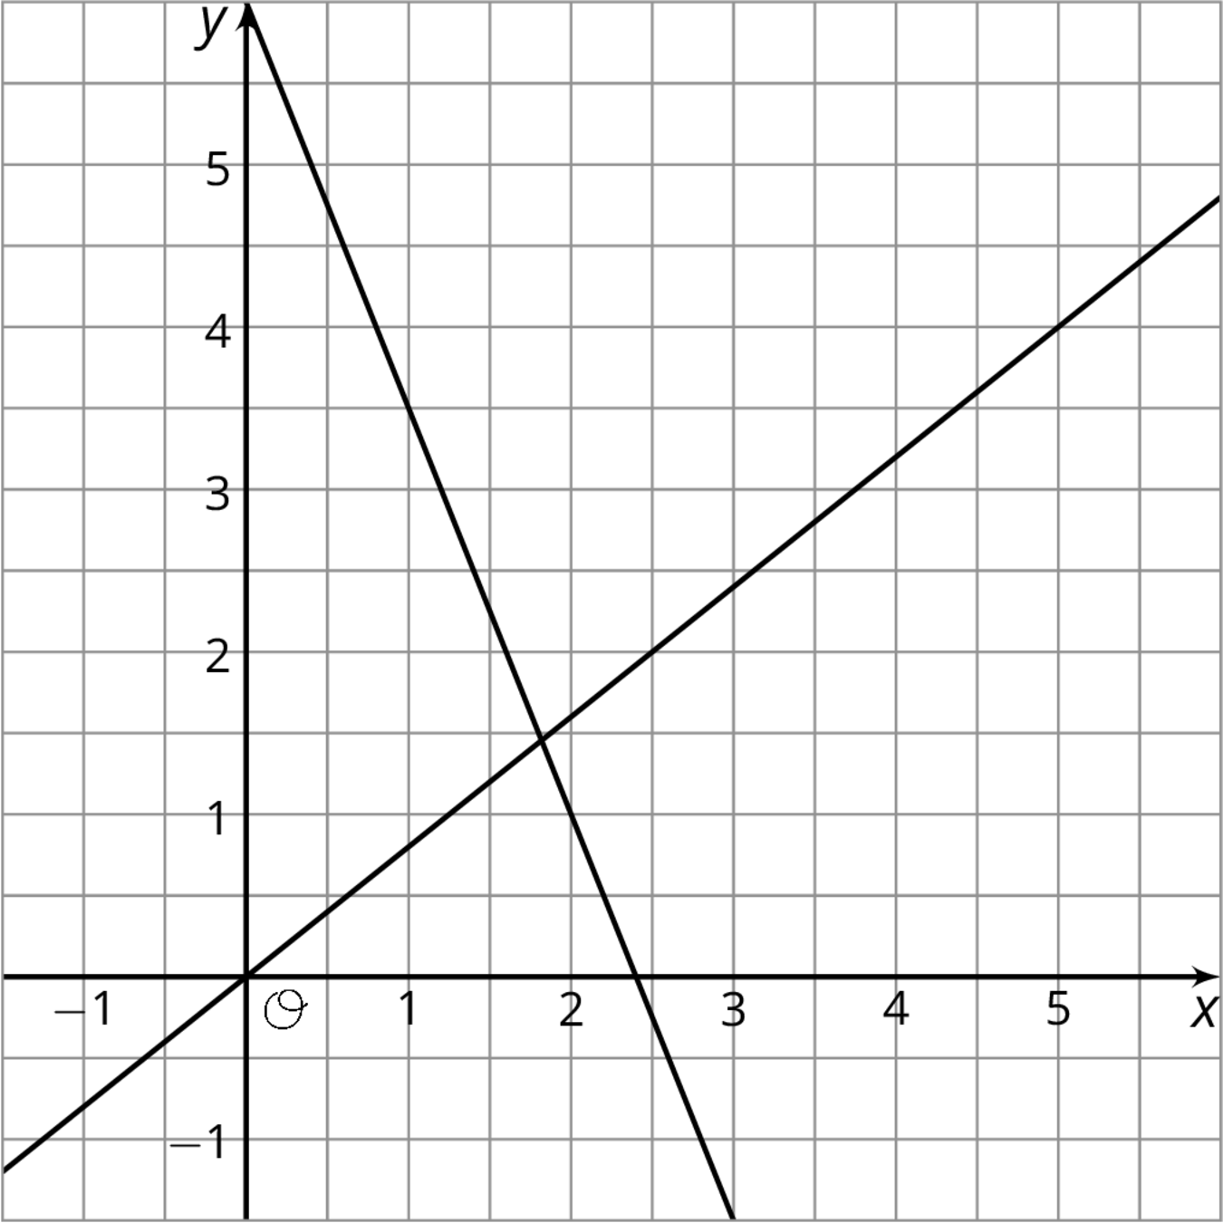
  - Choose two equations that make up the system represented by the graph.
    - $y=\frac{5}{4}x$
    - $y=6−2.5x$
    - $y=2.5x+6$
    - $y=6−3x$
    - $y=0.8x$
  - Solve the system of equations and confirm the accuracy of your estimate.
- (From Unit 4, Lesson 13.)
© CC BY Open Up Resources. Adaptations CC BY IM.

