Lesson 9: What is Your Favorite ______________ ?
- Let’s collect, organize, and show data.

Warm-up: How Many Do You See: Dots and More Dots
How many do you see?
How do you see them?
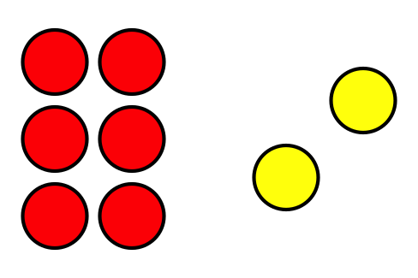
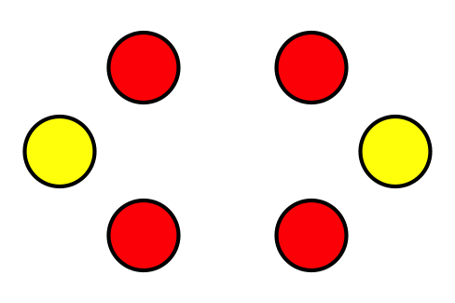
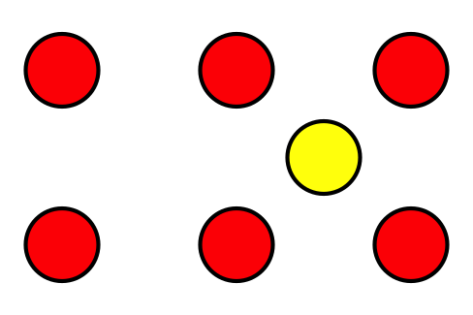

9.1: A Class Survey
What is your favorite ___________________________________________?
If you chose ___________________, take a red cube.
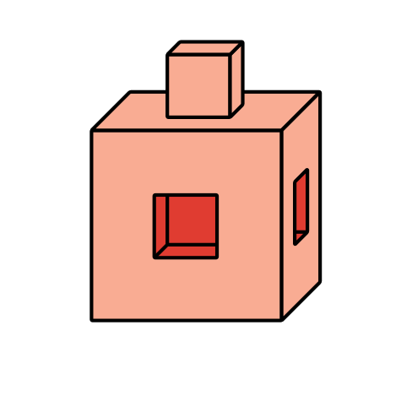
If you chose ___________________, take a blue cube.
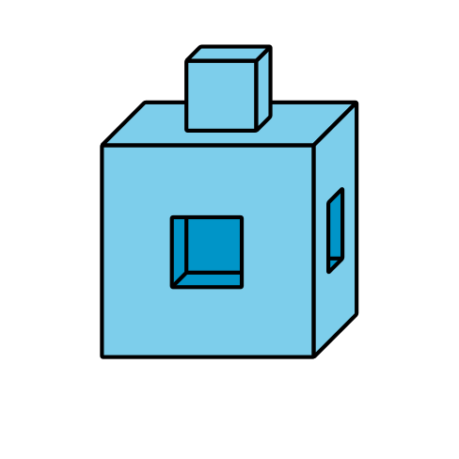
If you chose ___________________, take a yellow cube.
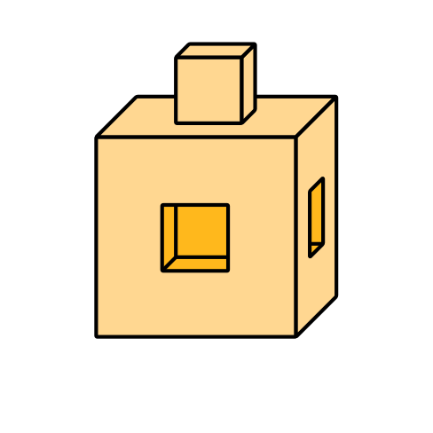

9.2: Show Our Class Data
Show the survey data about our class’s favorite
___________________________________________________.

Section Summary
Section Summary
We sorted objects and shapes.
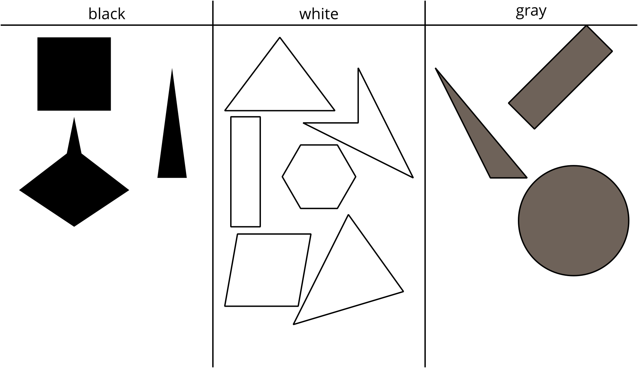
We showed our sorts on paper in different ways.
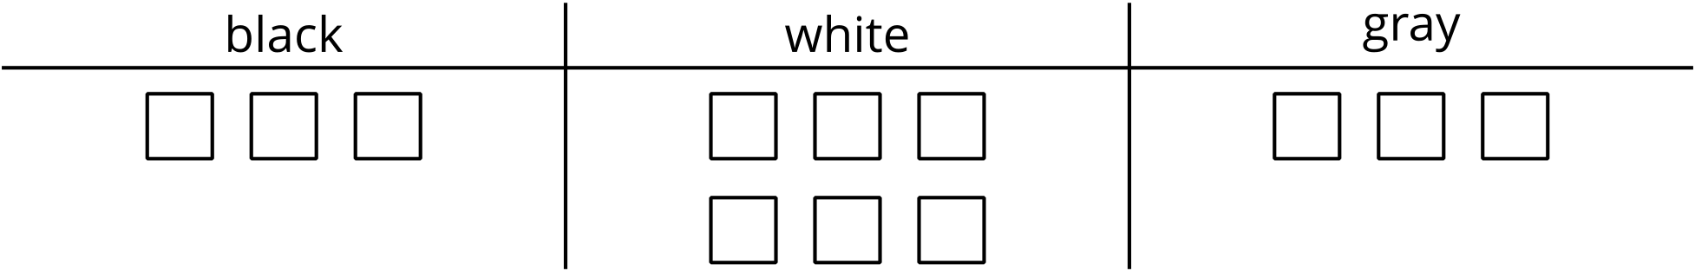
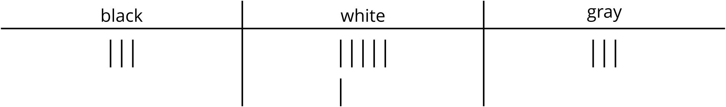
© CC BY 2021 Illustrative Mathematics®

