Lesson 20: More Practice to Represent and Solve
- Let’s represent and solve more problems.

Warm-up: Number Talk: Two Steps
Find the value of each expression mentally.
- $20+\left(2×3\right)$
- $30+\left(4×3\right)$
- $50+\left(8×3\right)$
- $99+\left(8×3\right)$

20.1: Info Gap: Introduction
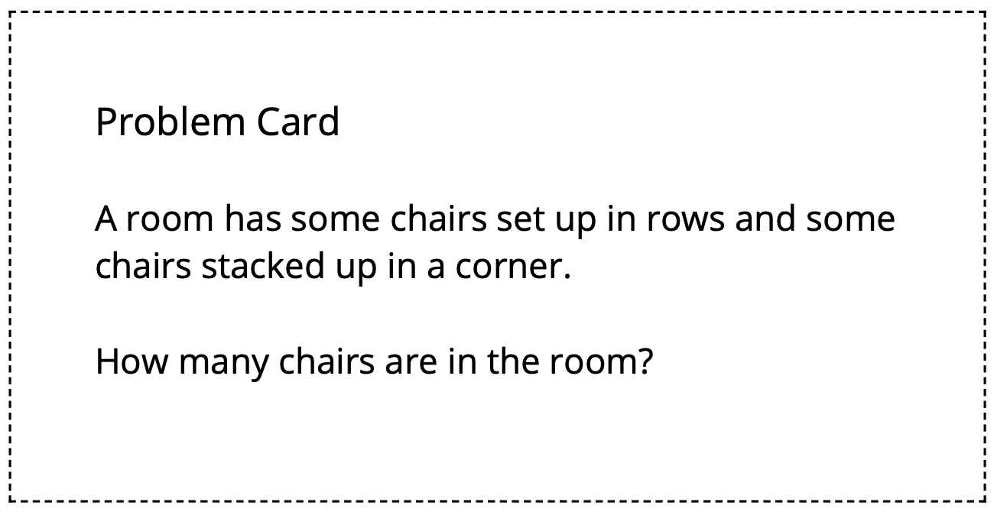

20.2: Info Gap: Bake Sale
Your teacher will give you either a problem card or a data card. Do not show or read your card to your partner.
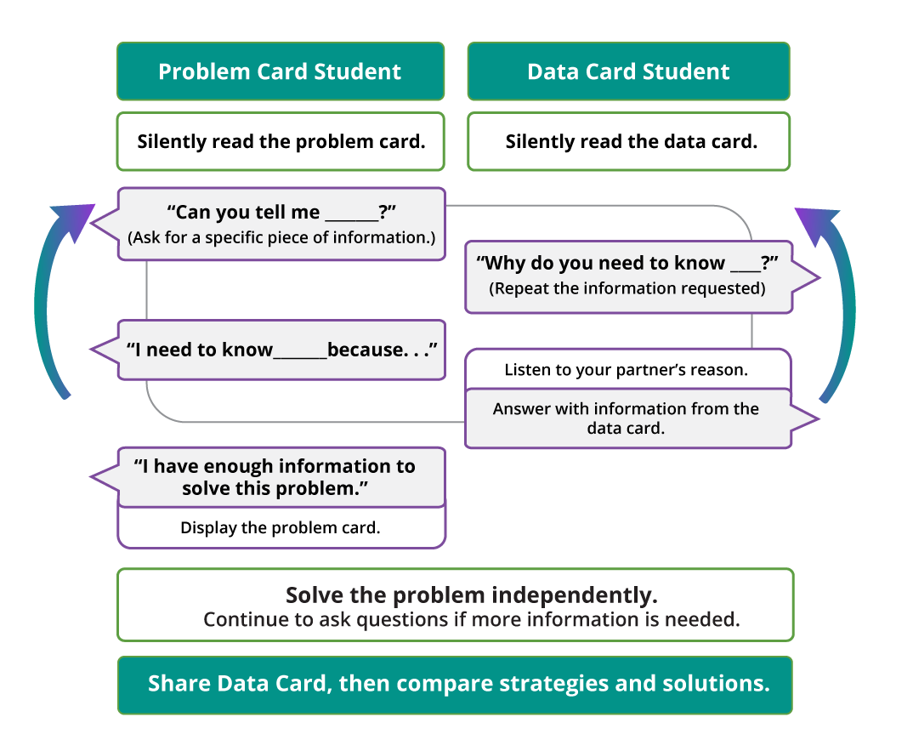
Pause here so your teacher can review your work.
Ask your teacher for a new set of cards and repeat the activity, trading roles with your partner.

Section Summary
Section Summary
In this section, we used rounding to estimate answers to problems. This helped us decide if our answers to problems made sense based on the situation and the numbers in the situation.
We also wrote equations with an unknown and used diagrams to solve for the exact answer in problems.
Situation:
Mai had 104 beads. She bought 2 more packs of beads and each pack has 10 beads in it. How many beads does she have now?
Diagram:
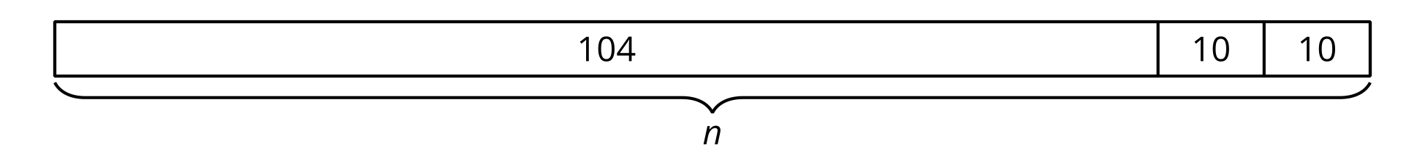
Equation with an unknown:
$104+\left(2×10\right)=n$
© CC BY 2021 Illustrative Mathematics®

